POST-LOCKDOWN OPERATIONS-SOP

It is important to put in place COVID-19 risk mitigation plans. Even post-lockdown it is important to follow guidelines to ensure safety of our employees and stakeholders as well as minimize business risks.

This document chalks out safety guidelines to be followed proactively as well as succession plans to ensure smooth business functioning post-lockdown. Implementation of the same will be responsibility of stations heads. Monitoring to be done by station VP’s and HO.

1.Safety– Guidelines for Staff and Non-Staff
Non-Residents (visitors, daily helps, vendors) | - Temperature screening using thermal guns to be done at the main gate(As per Annex)  - All non-residents to sanitize their hands before entering the project (sanitizer to be made available at all the main gate’s)  - Prohibition on spitting, in common area, after use of tobacco, khaini or gutka  - Non-resident not wearing masks will not be allowed inside the project
Staff (Maintenance and Contractual Staff) | - All personnel to continue the discipline of wearing masks as well as sanitizing / washing hands regularly(As per annex)  - All personnel to maintain social distancing norms both on and off work  - Daily briefing of team on precautionary measures. At 0900 Hrs and 1600 Hrs. To be conducted by Project maint head.  - Fogging to be continued twice a week till further notice  - Covid-19 emergency no’s should be available with staff at all times  - All Project Maintenance Heads to download Aarogya Setu App to stay informed of any incident reported in their area  - Station heads should be in regular touch with the health authorities for updates on initiatives /precautions to be taken  - If experiencing Covid-19 symptoms, immediately consult the assigned health practitioner and follow guidelines as laid down by the health authorities, till health authorities intervention resident to be in strict home isolation.  - Ban on use of tobacco, khaini and gutka; prohibition on spitting
Residents | - All residents to continue the discipline of wearing masks in common areas  - Ensure that before visiting any common areas like kids play area, club house, convenience store etc., residents returning from office / school, should wash / sanitize their hands and change clothes  - Self-Declaration to be submitted by residents who are returning to any of the Ashiana projects, after being stranded at another location because of lockdown. They should also send a prior intimation (atleast 48 hours) to the Maintenance team and RWA of their return to their residence at Ashiana. (As per Annex)  - Prior intimation to the Maintenance team and RWA if any guest is visiting them from a COVID-19 hotspot area  - If experiencing Covid-19 symptoms self-isolate and immediately consult the assigned health practitioner and follow guidelines as laid down by the health authorities.  - Prohibition on spitting, in common area, after use of tobacco, khaini or gutka
2. Safety– Project-Level Residents Covid-19 Committee
Considering the relaxations that will be given after the lockdown, residents will object and resist adhering to guidelines. Therefore, a resident committee must be formed by 25th Apriland this committee should ensure that we handle such objections better and the residents follow the proposed guidelines.

The committee should take into consideration the safety guidelines suggested above (point 1: Safety– Guidelines for Staff and Non-Staff) by Ashiana Maintenance. In cases, where a monthly / social event needs to be organized, the COVID-19 Committee should base their decisions only after consultation with the Maintenance team.

3. Safety – Emergency Response Team (ERT)
ERT will be the first line of response of the organization that will be activated in case of any unlikely incidence. This will ensure a streamlined response in case need arises. The ERT will be led by the ERT Commander (DGM, Estate (Corporate)).

ROLE OF ERT:
Incident Reporter (First Person On-Scene) |  | 1. Take appropriate personal protective measures  2. Notify the ERT Commander on priority  3. Request medical assistance and initiate evacuation procedure
Crisis Management Team (Strategic) |  | 1. Activate the Emergency Response Team*  2. Evaluate the severity, potential impact and safety concerns due to the reported incidence  3. Communicate and provide incident briefings to company superiors, as appropriate  4. Coordinate/complete additional internal and external notifications  5. Design the succession plan^ along with the Station Incident Management Teams
Station Incidence Management Teams |  | 1. Circulate the crisis communication to the Project Response Teams  2. Confirm safety aspects at site, including need for personal protective equipment  3. Liaison with the regional health authorities for additional precautions in line with regional directives
Project Response Teams |  | 1. Circulate the crisis communication to all residents and stakeholders  2. Implement the directions of the ERT at project-level
*Constitution to be decided at the time of incident, keeping in mind the whether the effect of the crisis can be local / regional / all locations
^Succession plan refers to actions to be taken in future to manage crisis. E.g. if a COVID case emerges in one of the projects, succession plan should include informing the authorities, prohibiting any further entry/exit to the project, assessing need to a sanitization drive

4.Maintenance at Projects
Manpower (AMSLL) |  | 1. Plan now so that full strength is available on duty.  2. Health checkup for those who were absent during the lock down; tie-up with doctor's in all locations for health checkups.  3. Convey appreciation and thankfulness to all employees who worked selflessly during the lockdown; announcement of benefit for these frontline warriors.  4. Keep a watch on the overall motivation and morale of the team.  5. Ensure team is following COVID-19 precautionary measures as laid down in point 1.  6. All personnel to provide self-declaration about their health as well as health of their family members.; self-declaration to include information on residential location including whether the neighbourhood is a hotpot or not (As per annex)
Security |  | 1. Availability of manpower, 0 tolerance on absenteeism.  2. Extra deployment of Duty officer's/field officer from vendor side to keep a watch on the guards and processes.  3. Monitoring by our team on all aspects of security.  4. Ensure team is following COVID-19 precautionary measures as laid down in point 1.  5. No laxity on adherence of processes at the main gate particularly visitor verification/management. Other than resident's everyone else to be treated as a visitor.  6. Night vigilance to be tightened to avoid any theft or unwanted intrusion in the project.  7. Functionality of all security apparatus (CCTV, Boom barriers, walkie-talkie, Biometrics*, RFID readers)  8. All vendors to provide self-declaration (from their staff) about their health as well as health of their family members.; self-declaration to include information on residential location including whether the neighbourhood is a hotpot or not(As per annex)  * Use of biometric readers should be avoided for at least a month after opening of lockdown
Housekeeping |  | 1. Availability of manpower, 0 tolerance on absenteeism.  2. Monitoring by our team on all aspects of housekeeping.  3. Ensure team is following COVID-19 precautionary measures as laid down in point 1.  4. Get in complete HK team a day or two in advance for intense deep cleaning and sanitization (esp. lifts, railings, door handles, benches, kids play area, garbage chutes, crowd gathering spots like convenience store, club house, common restrooms, parking areas)  5.Sanitization to be continued twice a day till further notice  4. All vendors to provide self-declaration (from their staff) about their health as well as health of their family members.; self-declaration to include information on residential location including whether the neighbourhood is a hotpot or not (As per annex)
Common Areas |  | 1. Facilities, amenities and fixtures in common areas to be made functional now by executing required repairs and servicing (swimming pool, club, water bodies, kids play area etc.)  2. Detailed audit of all common critical amenities like lifts, DG, pumps, STP, CCTVs, boom barriers etc. to understand requirements of repairs; execute all requirements on priority basis.
Observations |  | We anticipate that there will be a surge in the no. of observations post lock down and managing them right will be very crucial to avoid dissatisfaction. Following are the actionable planned to handle the same:  1.Plan and prepare communication to residents so that we manage expectations if there is a surge in numbers. Communicate that observations will be handled as per priority:  a) P1:Observations related to essential services(water, electricity and gas supply)  b) P2: Related to housekeeping, routine electric and plumbing observations.  c) P3: Observations related to masonry, carpentry and any other civil work  d) P4: Others  2. Technical audits of projects and reports to made with quick fix of issues.  3. Coordinate with AMC and other vendors so that services are available on priority to us.  4. Coordinate help from construction team and prioritize the requirements.  5. Pre-empt no. of observations likely to be received after the lock down; Project Maintenance Heads can understand the requirements during their relationship calls with residents
5. Other Important Areas
Communication & Information Flow |  | Regular flow of information with both external and internal customers will be important. We must follow the under mentioned:  1. Immediate information flow if a case with COVID-19 symptoms is reported.  2. Regular relationship calls with residents by the EO’s must continue.  3. Advisories on COVID-19 precautions must be sent to residents and employees on regular basis(twice a week)  4. Daily one update call by Station heads with EO’s and HO should be done.  5. Daily briefing of staff on COVID-19 precautions should be done.
Centralized Help Desk |  | Centralized help desk was not functional during the lock down, considering that following will be the focus areas:  1. Communication to all residents and regular communication with the team to ensure all calls are landing on the help desk.  2. Training of the team to handle increased traffic  3. Strong follow-up system between the project team and CHD for speedy closure of observation; sharing a daily status MIS with the station heads will help.  4. Random feedbacks from residents to understand satisfaction levels.
Training and Awareness |  | 1. Creating awareness amongst all staff incl. contractual staff members (HK, Security, Horticulture) on use of masks and sanitizers, maintaining social distance. Particularly of security guard’s on process adherence at main gate as per PT 3.  2. Appropriate training of all maintenance incl. contractual staff members (HK, Security, Horticulture) on managing increased work post-lockdown.
Costs |  | Must keep a tab on the expenses with focus on undermentioned:  1. Payouts to contractual vendors will be onthe basis of manpower attendance. Exemptions will only be given to those who are coming from areas which are badly affected/sealed or where we have given instructions to the staff to stay at home.  2. Discussion with AMC vendors will be done, and negotiation will be done for reduced payouts for the duration of lockdown starting 1st April’20; discussions will be done for a reduced payout of 5 to 10%.  3. If anyone from on roll and off roll staff are not turning up for work, Project Maintenance Headwill understand the issues individual wise and take a call for marking them absent/present and accordingly payout’s will be given.  4. While no compromise will be done on safety of residents and creation of safe environment at project level’s, we should be careful of extra costs we are and will be incurring. We should be rationale in spending through effective negotiation with the vendor(s). We must review these expenses fortnightly.

ANNEXURE I
Coronavirus Self-Declaration Form
Due to the ongoing and rapidly changing situation with the novel-coronavirus(COVID-19), we are requiring all staff and residents of Ashiana (those who are returning to any of the Ashiana projects, after being stranded at another location because of lockdown)to fill-out the self-declaration form below.
A. Personal Information:
First Name:
Last Name:
Project Name:
Flat Details (only for residents of Ashiana):
Type of Employee (only for employees of Ashiana):
Employee ID (only for on-roll employees of Ashiana):
Department / Service (only for employees of Ashiana):

B. Location of stay during the last 14 days:
Address:
Duration of Stay:
I have been living in a COVID-19 hotspot area in the last 14 days. | Yes | Hhj No

C. Do you have any of the following flu-like symptoms:
Fever (100.4̊ F or higher) | Yes | No
Cough | Yes | No
Breathlessness | Yes | No
Sore Throat | Yes | No

D. Have you or an immediate family member come in close contact with aconfirmed case of the coronavirus in the last 14 days? (“Close contact” meansbeing at a distance of less than one metre for more than 15 minutes.)
I have been in close contact with a confirmed case of  coronavirus in the last 14 days. | Yes | No

I acknowledge that the information provided by me is accurate and complete.

Signature:_________________________________________________
Date: ____________________________________________________
This document will be retained confidentially by Ashiana.
The health and wellbeing of our community is our first priority therefore Ashiana reserves the right to deny entry to the project sites.
Thank you for your cooperation!

ANNEXURE II
1. Wearing mask, use of sanitizer and forehead thermometer
DO’s | DONT’s
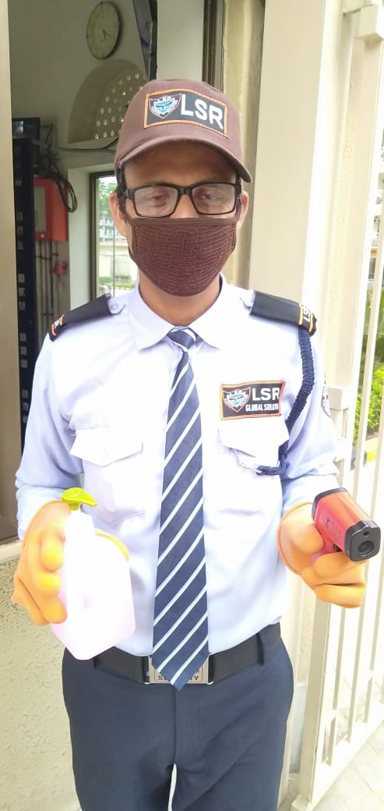 | 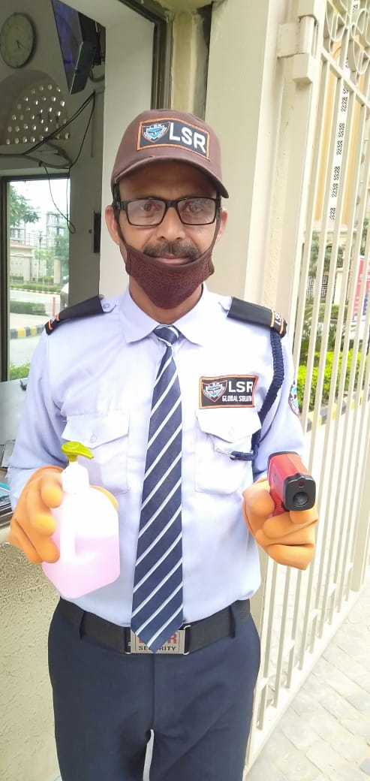
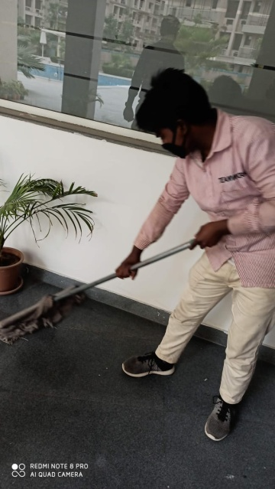 | 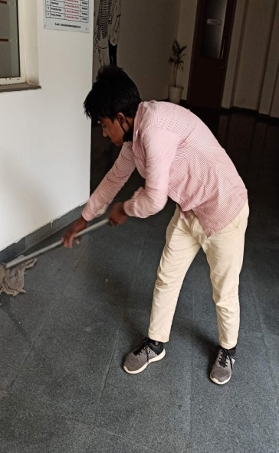
2. Safety Measure at Main Entrance
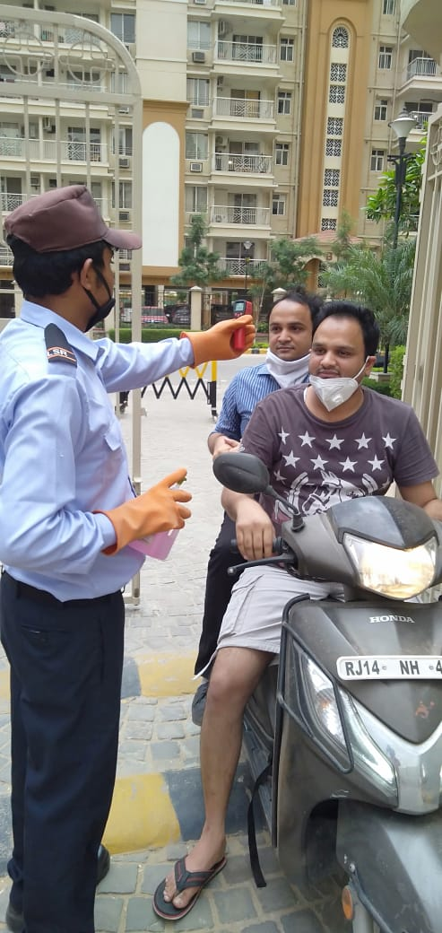
3. Common Area Sanitization
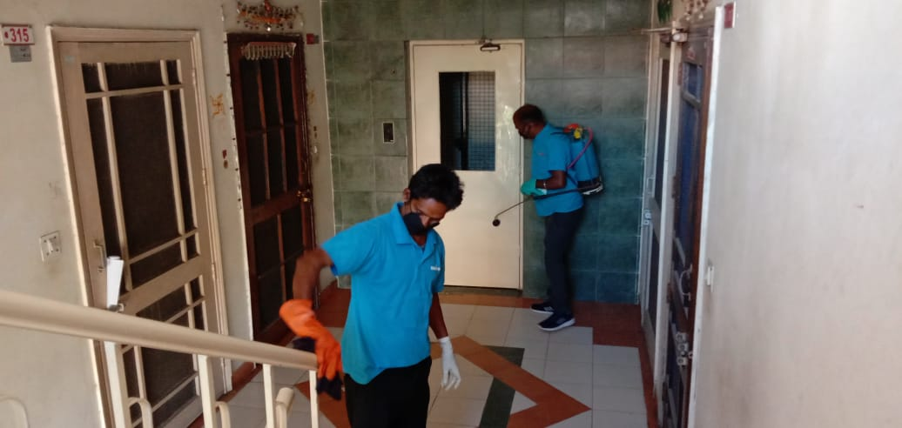
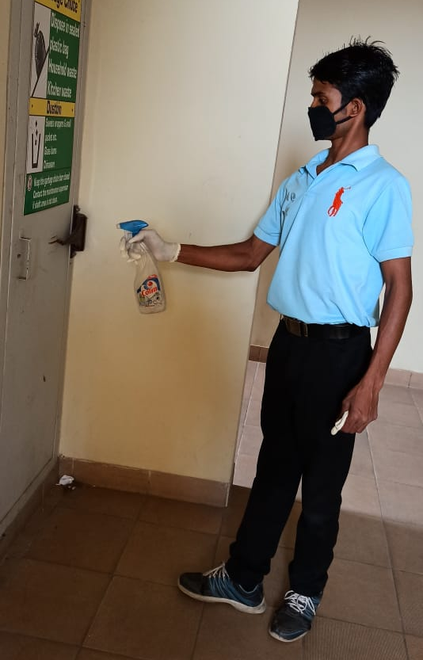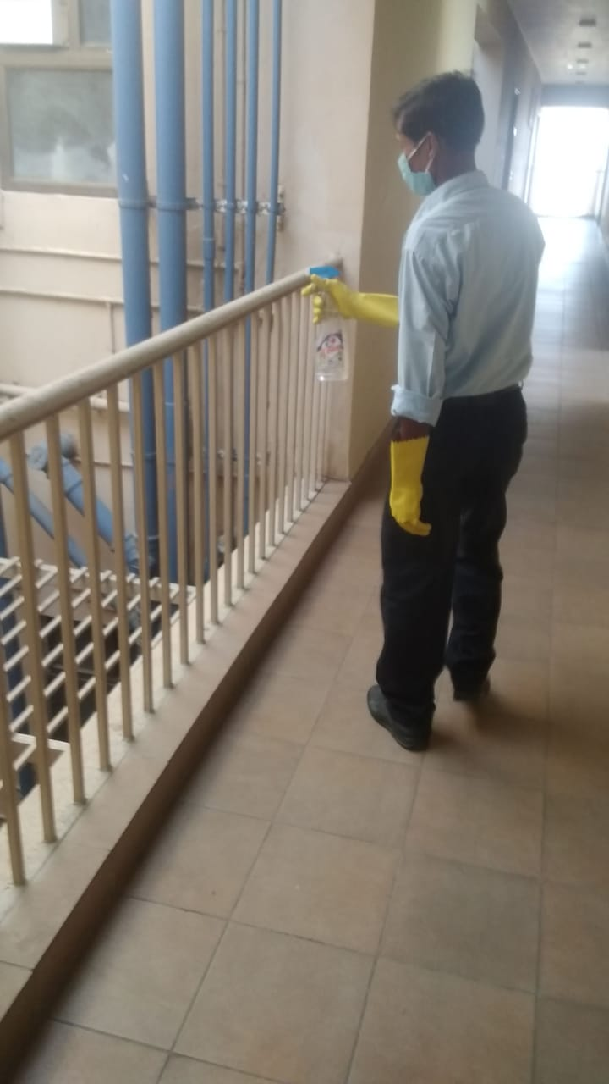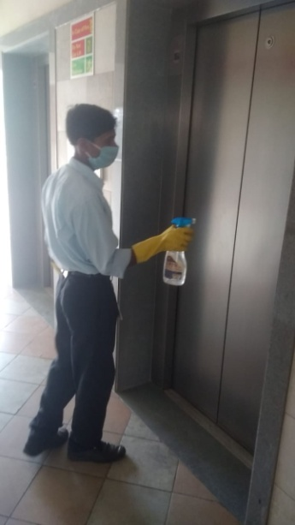

4. Fogging of Common Areas
