AGREEMENT FOR SALE
THIS AGREEMENT FOR SALE (“Agreement”) is executed at Pune, Maharashtra on this day of

BY AND BETWEEN

M/S. ASHIANA HOUSING LIMITED, a Company registered under the Companies Act, 1956, having its Registered Office at 5F, Everest, 46/C, Chowringhee Road, Kolkata – 700071, West Bengal and Local Office at Survey No. 75/ 76, Bhor Wasti, Near Life Republic Township, Village Marunji, Pune – 411057, Maharashtra, through its authorized representative Mr. ___________________ authorized vide Resolution dated ______________passed by the Directors of the Company, (Copy enclosed as ANNEXURE I) [hereinafter referred to as the “Promoter” which expression shall unless it be repugnant to the context or meaning thereof be deemed to mean and include its legal successor(s), administrator(s), executor(s) and permitted assignee(s) including those of the respective partners] of the FIRST PART

AND

MR. MADAN SHANTILAL JAIN son of Shri Shantilal Hastimal Jain, major in age having his address at Lohia Jain House, 893/6, Bhandarkar Road, Pune, Maharashtra - 411 004; represented through his POA holder M/s Ashiana Housing Limited,(Through its Authorised representative ) hereinafter referred to as “Owner No. 1” (which expression unless excluded by or repugnant to the context or meaning thereof, shall mean and include his heirs, executors, administrators, successors-in-interest and legal assignees);

MR. PURUSHOTTAM MUKUNDDAS LOHIA son of Shri Mukunddas Murlidhar Lohia major in age having his address at Lohia Jain House, 893/6, Bhandarkar Road, Pune, Maharashtra - 411 004; represented through his POA holder M/s Ashiana Housing Limited, (Through its Authorised representative ______________________ ) hereinafter referred to as “Owner No. 2” (which expression unless excluded by or repugnant to the context or meaning thereof, shall mean and include his heirs, executors, administrators, successors-in-interest and legal assignees);

MR. VIJAYKUMAR SANTOSHCHAND JAIN son of Shri Santosh Chand Punamchand Jain major in age residing at 182, Mont Blanc Co-Operative Housing Society, Dadi Seth Hill, August Kranti Marg, Kemps Corner, Mumbai, Maharashtra – 400 026; represented through his POA holder M/s Ashiana Housing Limited, (Through its Authorised representative ______________________) hereinafter referred to as “Owner No. 3” (which expression unless excluded by or repugnant to the context or meaning thereof, shall mean and include his heirs, executors, administrators, successors-in-interest and legal assignees);

M/S. HINDUMAL BALMUKUND INVESTMENT CO. PVT. LTD., a Company incorporated under the Companies Act, 1956 and having its Registered Office at Lohia Jain House, 893/6, Bhandarkar Road, Goodluck Chowk, Deccan Gymkhana, Pune, Maharashtra, represented through its POA holder M/s Ashiana Housing Limited, (Through its Authorised representative _____________________- hereinafter referred to as “Owner No. 4” (which expression shall unless repugnant to the context mean and include its successors, representatives and assignees);

Owner Nos. 1 to 4 all are collectively hereinafter referred to as “Confirming Parties/Owners” of the SECOND PART

AND

Mr./Ms./Mrs. , Son/Daughter/Wife of Mr. ___________, R/o ___________ (PAN ____________)(Aadhar No. ) jointly with Mr./Ms./Mrs. , Son/Daughter/Wife of Mr. , R/o (PAN ) (Aadhar No. ) ; hereinafter singly/jointly referred to as the Allottee(s), which expression shall unless repugnant to the context or meaning thereof be deemed to mean and include his/her/their legal successor(s), administrator(s), executor(s) and permitted assignees of the THIRD PART

The “Developer”, “Confirming Parties”, and the “Allottee(s)” shall hereinafter be collectively referred to as “Parties” and individually as “Party”
The word Promoter wherever referred to in this Agreement shall mean the Developer and the word Co- Promoters wherever referred in this Agreement shall mean Confirming Parties.

1. INTERPRETATIONS/DEFINITIONS:
- In this Agreement, the following expressions unless repugnant to the context thereof shall have the meaning assigned thereto-
  - “ACT” means Real Estate (Regulation and Development) Act, 2016 and the rules framed in respect thereof together with all such amendments, modifications and/or re-enactments related thereto;

  - “ALLOTTEE(s)” means and includes:

    - If the Allottee(s) is an individual then his/her legal successor(s), executor(s), administrator(s), legal representative(s), and permitted assignee(s);
    - If the Allottee(s) is a Hindu Undivided Family, then its karta and each of the member constituting HUF, their heirs, executors, successors, administrators and permitted assignees;
    - In case the Allottee(s) is a Partnership Firm or LLP, then its partners/designated partners for the time being, their respective legal successor(s), executor(s), administrator(s), legal representative(s) and permitted assignee(s) including those of the respective partners; and

    - In case the Allottee(s) is a limited company, then its legal successor(s), representative(s)and permitted assignee(s);

  - APEX ASSOCIATION/ SOCIETY shall mean society/ association/ company formed by the Promoter for the Whole Project comprising of the members of the association /society /company of each phase.

  - “APPLICABLE LAWS” shall mean all Acts, Rules and Regulations in force and in effect as of the date hereof as applicable in the State of Maharashtra including Real Estate (Regulation and Development) Act, 2016 read with Maharashtra Real Estate (Regulation and Development) (Registration of Real Estate Projects, Registration of Real Estate Agents, Rates Of Interest And Disclosures On Website) Rules, 2017, the Maharashtra Ownership of Flats (Regulation of the Promotion, Construction, Sale, Management and Transfer) Act, 1963, the Maharashtra Apartment Ownership Act 1970, Maharashtra Co-operative Societies Act, 1963, Maharashtra Regional and Town Planning Act, 1966 and any other law which may be promulgated or brought into force and effect hereinafter including notifications, ordinances, policies, laws or orders or official directive of any Central/State Government or of any Statutory Authority in Maharashtra, as may be in force and effect during the subsistence of this Agreement and applicable to the development / construction / sale of the Said Project/Whole Project.
  - “APARTMENT” shall mean a space in the Said Project/Whole Project intended and/or capable of being independently and exclusively occupied, having an entry and exit, and includes a flat and all such units or spaces intended to be used for any residential or commercial use such as office, shop, convenient shopping in any part of the Said Project/Whole Project.

  - “ARCHITECT” shall mean Mr. Mangesh Gotal and Mr. Sanjeev Mehta or such other person(s) and/or firm(s) and/or company(s) whom the Promoter may appoint from time to time as the architect for the Said Project.
  - “ASHIANA MALHAR PHASE I” shall mean part of the Whole Project being developed/ developed on the Scheduled Land comprising of Building Block/ Tower No. 4 and 5 together with Limited Common Area and Facilities reserved for Residential Block being developed on Ashiana Malhar Phase I Land.

  - “ASHIANA MALHAR PHASE I LAND” shall mean part and portion of the Scheduled Land admeasuring 15,224 Sqm. on which ASHIANA MALHAR PHASE I is being developed/ developed as shown in the map in PART III OF SCHEDULE A.

  - “ASHIANA MALHAR PHASE II” shall mean part of the Whole Project, being constructed and developed upon the Scheduled Land and comprising of Residential Building Block. Tower Nos. 8 and 9 having flats, Common Area and Facilities of the Whole Project, Limited Common Areas and Facilities for Residential Block, being developed on Ashiana Malhar Phase II Land.

  - “ASHIANA MALHAR PHASE II LAND” shall mean part and portion of the Scheduled Land admeasuring 9734.93 Sqm. on which ASHIANA MALHAR PHASE II is being developed as shown in the map in PART III OF SCHEDULE A.

  - “BUILDING” shall mean the building No./Tower No. in the Said Project where the Allottee(s) has been allotted his “Unit”.

  - “BUILDING PLANS” shall mean the plans and designs of buildings constructed or to be constructed on the Scheduled Land which has been duly approved by PMRDA in full including any variations therein which may subsequently be made by the Promoter and/or Architect(s) in accordance with Applicable Laws vide Letter No. DP/BMU/Mauje Marunji/G.N. 75/1/1/ Pay & others/ 501/20-21 dated 20.04.2021 and revised Letter No. BMU/Mau.Marunji/S.No.75 Pay & other/Pra.No-2272/23-24/354 dated 15.04.2024.

  - “CARPET AREA” means the net usable floor area of an Apartment, excluding the area covered by the external walls, areas under services shafts, exclusive balcony or verandah area and exclusive open terrace area, but includes the area covered by the internal partition walls of the Apartment. Explanation: For the purpose of this clause, the expression "exclusive balcony or verandah area" means the area of the balcony or verandah, as the case may be, which is appurtenant to the net usable floor area of an Apartment, meant for the exclusive use of the Allottee(s); and "exclusive open terrace area" means the area of open terrace which is appurtenant to the net usable floor area of an Apartment, meant for the exclusive use of the Allottee(s);
  - “COMMON AREAS AND FACILITIES OF THE WHOLE PROJECT” shall mean such common areas, facilities, equipment and spaces in the Whole Project meant for common use and enjoyment of all the occupants of the Whole Project (as defined herein-below) and more particularly detailed in the PART I OF SCHEDULE D attached hereto. However, such common areas, facilities, equipment and spaces forms part of different phases of the Whole Project as detailed in PART I OF SCHEDULE D attached hereto and accordingly common areas, facilities, equipment and spaces which forms part of any particular phase shall be developed with that particular phase.
  - “COMMON AREAS AND FACILITIES OF THE WHOLE PROJECT TO BE DEVELOPED WITH SAID PROJECT” shall mean such common areas, facilities, equipment and spaces forming part of the Common Areas and Facilities of the Whole Project which are to be developed within the Said Project and more particularly detailed in the PART II OF SCHEDULE D attached hereto.
  - “COMMERCIAL BLOCK” shall mean shops together with Limited Common Area and Facilities of Commercial Block being developed/ developed on one portion of the Scheduled Land admeasuring 398 Sqm. and known as ASHIANA MALHAR PLAZA and as shown in the map in PART II OF SCHEDULE A
  - “COMMERCIAL BLOCK LAND” shall mean part and portion of the Scheduled Land admeasuring 398 Sqm. on which COMMERCIAL BLOCK is being developed/ developed as shown in the map in PART III OF SCHEDULE A.
  - “DELAY PAYMENT CHARGES” means the charges payable by the Allottee(s) to the Promoter for delay in payment of any due amount, instalment, charges etc. at the rate of State Bank of India highest marginal cost of lending Rate plus two percent or such other rate as may be applicable from time to time as per the Act and Rules for the Interest.
  - “EARNEST AMOUNT” shall mean 10% of the Total Price of the Unit.
  - “ENTIRE LAND” means all that pieces and parcels of land measuring 93,990.00 Sqm. (23.22 Acres), under various survey numbers thereabout lying and situated at Village Marunjii, Taluka Mulshi, Dist. Pune in the state of Maharashtra and as delineated and shown in the map attached herewith as PART I OF THE SCHEDULE A.
  - FORCE MAJEURE” shall mean and include any delay in completion of the project due to:- (i) War, Flood, Drought, Fire, Cyclone, Earthquake, civil Commotion or Act of God which affect the regular development of the real estate project; (ii) Such period where actual work could not be carried by the Promoter as per the sanctioned plan due to specific stay or injunction orders relating to the real estate project from any court of law, Tribunal, competent authority, statutory authority, high power committee, etc.
  - “HE OR HIS” shall also mean either she or her in case the Allottee is a female or it or its in case the Allottee is a partnership firm or a limited company.
  - “INTEREST RATE” means the State Bank of India highest marginal cost of Lending Rate plus two percent or such other rate as may be applicable from time to time as per the Act and Rules payable by the Promoter to the Allottee(s).
  - “LIMITED COMMON AREAS AND FACILITIES OF RESIDENTIAL BLOCK” shall mean those common areas and facilities which are designated in writing by the Promoter before the allotment, sale or transfer of any apartment as reserved for use of certain apartment or apartments under Residential Block to the exclusion of Commercial Block as detailed in PART III OF SCHEDULE D.
  - “LIMITED COMMON AREAS AND FACILITIES OF APARTMENT” shall mean those common areas and facilities which are designated in writing by the Promoter before the allotment, sale or transfer of any apartment as reserved for use of such apartment as detailed in Clause 2.17.
  - “OWNERS ASSOCIATION/ SOCIETY” shall mean association/ society/ company formed/ to be formed by the owners of the units/ apartments in the Said Project .
aa) “PARA” means Para of this Agreement.
bb) “PROJECT LAND” shall mean land admeasuring 10935.00 Sqm. forming part of Scheduled Land, on which the Said Project is being developed and more fully described in PART IV OF SCHEDULE A.
cc) “RESIDENTIAL BLOCK” shall mean part of the Whole Project comprising of Building Block Nos. 1 to 9 to be constructed and developed on one portion of the Scheduled Land (Scheduled Land minus the land for Commercial Block) and as shown in the map in PART II OF SCHEDULE A.
dd) “REGULATION” means regulations made under the Act;
ee) “RULES” mean the Maharashtra Real Estate (Regulation and Development)(Registration of real estate projects, Registration of real estate agents, rates of interest and disclosures on website) Rules, 2017;
ff) “SCHEDULE” means the Schedule attached to this Agreement;
gg) “SECTION” means the section of the Act.
hh) “SCHEDULED LAND” shall mean land admeasuring 45,898 Sqm. forming part of the Entire Land and thereabout lying and situated at Village Marunjii, Taluka Mulshi, Distt. Pune in the state of Maharashtra on which the Whole Project named ASHIANA MALHAR, comprising of different phases, is being developed and is demarcated and shown in PART II OF SCHEDULE A.
ii) “SAID PROJECT” shall mean part of the Whole Project, being constructed and developed upon the Project Land and comprising of Residential Building Block.Tower Nos. 2 and 3 having flats, Common Area and Facilities of the Whole Project being developed with Said Project and Limited Common Areas and Facilities of Residential Block being developed with Said Project t named as “ASHIANA MALHAR PHASE III” as shown in the map in PART IV OF SCHEDULE A.
jj) “WHOLE PROJECT” shall mean the residential project comprising of flats, parking facility, club house, shops, other amenities and facilities etc. constructed / to be constructed in different phases on the Scheduled Land and named as “ASHIANA MALHAR”.
The words and expressions used herein but not defined in this Agreement and defined in the Act or any other law for the time being in force shall have the same meanings respectively assigned to them in those laws.

RECITALS-

WHEREAS THE PROMOTER DECLARES THAT:

- The Confirming Parties are absolute, legal, beneficial and registered owners and possess all that piece and parcel of land admeasuring 93,990 Sqm. (23.22 Acres) under Survey Nos. 75/1/1 P, 75/1/2 P, 75/2 , 75/3, 75/4 P, 75/5/1 P, 75/5/2 P, 76/1 P, 77/1/1/1C and 78/1 P situated at Marunji, Taluka Mulshi, District Pune, Maharashtra by virtue of duly registered Sale Deeds (hereinafter referred to as the "Entire Land" and fully described and delineated in the map attached hereto as “PART I OF SCHEDULE A”).
- The Confirming Parties have obtained necessary approval for conversion from agriculture to residential use from the Directorate of Town Planning and Valuation Department, Maharashtra w.r.t the Entire Land under the provisions of the Maharashtra Regional and Town Planning Act, 1966.
- The Confirming Parties have divided the Entire Land into various portions and demarcated the Entire Land in the following manner and as shown in the map attached hereto as PART I OF SCHEDULE A:
  - A portion of Entire Land admeasuring 45,898 Sqm. referred to as Scheduled Land;
  - A portion of the Entire Land measuring 19,201 Sqm. has been earmarked for future development exclusively owned, possessed and retained by Confirming Parties (hereinafter referred to as the “Owner’s Retained Land”);
  - Area measuring 4573 Sqm. for EWS or Social Housing Plot has been demarcated and carved out on the Entire Land for the mandatory development of EWS Housing or Social Housing for the Entire Land (hereinafter referred to as the “EWS Plot” or “Social Housing Plot”);
  - An area admeasuring 14,042.72 Sqm., as amenity space (exclusively retained by Owner No. 4) (hereinafter referred to as the “Amenity Plot”) for the Entire Land being portion of the Entire Land;
  - Further, access road admeasuring 9964.85 for access to the Scheduled Land, Owners' Retained Land, Amenity Plot and EWS Plot has been demarcated and carved out from the Entire Land having a minimum width of 12 Sqm., (hereinafter referred to as the “Internal Road”).

- The Scheduled Land is earmarked for development of a Group Housing Scheme.

- Accordingly, the Confirming Parties entered into a Development Agreement dated 10.08.2020 duly registered with Sub Registrar, Mulshi-2, Distt. - Pune, Maharashtra vide Document Serial No. 8104/2020
(hereinafter referred to as the “Development Agreement”) with the Promoter for development of a Group Housing Scheme on a portion of the Entire Land admeasuring 45,898 Sqm., (more particularly described in PART II OF SCHEDULE A and hereinafter referred to as the “Scheduled Land”. The Confirming Parties have nominated, constituted, and appointed the Promoter to be the true and lawful attorney in its name and on its behalf to do, execute, perform or cause to be done, execute and perform from time to time, at its sole discretion all or any of the acts, deeds, matters or things in relation to the Whole Project for the marketing, selling, development and construction on the Scheduled Land. The said Power of Attorney dated 10.08.2020 (hereinafter referred to as the “POA”) has been duly registered with the Office of the Sub Registrar, Mulshi II, Distt. Pune as Document No. 8105/2020 and is currently valid and in force.

- The Promoter being in possession of the Scheduled Land framed a scheme for developing a residential project to be known as “ASHIANA MALHAR” on the Scheduled Land. The Whole Project developed / to be developed on the Scheduled Land shall be called as “ASHIANA MALHAR”. However, for convenience and ease of construction, sales and marketing, the Whole Project has been divided into various phases and proposed to be developed in a phase wise manner with the clear intent to integrate all phases into one upon completion of the Whole Project. The Promoter is in the process of constructing and developing ASHIANA MALHAR PHASE III (hereinafter to be referred as “Said Project”) being one of the phases of the Whole Project on the Project Land forming part of the Scheduled Land and the said phase shall be known as ASHIANA MALHAR PHASE III.

- The Promoter planned and is in the process of constructing and developing Said Project on the Project Land after getting the necessary permissions/ approvals from concerned competent authorities. The location details of the Said Project being developed on Project Land is fully described in PART IV OF SCHEDULE A.

- It is disclosed that the Project Land is free from all encumbrances.

- The Promoter is fully competent to enter into this Agreement and all the legal formalities with respect to the right, title and interest of the Promoter regarding the Scheduled Land on which the Whole Project is to be constructed have been completed.

- The following approvals and sanctions have been obtained in respect of the Said Project/ Whole Project:

- The N/A order for the Scheduled Land was issued by District Magistrate Office, Pune vide its Letter bearing No. Mulshi/NA/SR/56/2020 dated 14.01.2021 and 16.06.2021 and attached as ANNEXURE II.
- The Promoter has obtained the Commencement Certificate DP/BMU/M. Marunji/G.N0. 75/1/1/ Pay & others Pr. No. 501/20-21 dated 20.04.2021 and revised Commencement Certificate BMU/Mau.Marunji/S.No.75 P & other/Pra.No-2272/23-24/354 Date-15/04/2024 issued by Pune Metropolitan Region Development Authority, Pune (hereinafter to be referred as “PMRDA”) in respect of the Scheduled Land.
- The Site Layout Plan of the Whole Project has been approved by the PMRDA vide its Letter No DP/BMU/M. Marunji/G.N0. 75/1/1/ Pay & others Pr. No. 501/20-21 dated 20.04.2021 and revised Letter No DP/ BMU/Mau.Marunji/S.No.75 P & other/Pra.No-2272/23-24/354 Date-15/04/2024. A copy of the Site Layout Plan is enclosed herewith and marked as ANNEXURE III.

- Approval of the Whole Project and permission of Building Construction under the relevant legal provisions has been accorded vide Letter No. DP/BMU/M. Marunji/G.N0. 75/1/1/ Pay & others Pr. No. 501/2021 dated 20.04.2021 and revised Letter No. BMU/Mau.Marunji/S.No.75 P & other/Pra.No- 2272/23-24/354 Date-15/04/2024 by the PMRDA and annexed as ANNEXURE IV.
- Environmental Clearance from the department concerned has been obtained for the Whole Project
vide Letter No. SIA/MH/MIS/166918/2020 dated 02.11.2021.

- The Promoter has conceived and planned various Common Areas, Amenities and Facilities in the Whole Project as detailed in PART I OF SCHEDULE D. These Common Areas and Facilities will be developed along with the phases in which they are located and will be common for all allottees of the Whole Project irrespective of the phase in which they are located. Therefore, it has been clearly explained by the Promoter to the Allottee(s) and further understood and agreed by the Allottee(s) that the Common Areas and Facilities of Whole Project would be developed in phases i.e. along with the phase of which such common area/facility/amenity is a part. It has been specifically explained by the Promoter and understood and agreed by the Allottee(s) that upon occupation of the Whole Project, all phases in the Whole Project shall be integrated as one and all the allottees of the Whole Project shall have equal right in the Common Areas and Facilities of the Whole Project and the allottees shall not obstruct and/or cause any hindrance to any allottee belonging to any phase in the Whole Project.

- The Promoter further represents that the Limited Common Areas and Facilities of Residential Block to be developed with the Said Project are detailed in PART III OF SCHEDULE D. The Promoter represents and the Allottee(s) is aware that the Limited Common Areas and Facilities of Residential Block developed with the Said Project are limited for use of Residential Blocks only to the exclusion of Commercial Block and the Limited Common Areas and Facilities for the Commercial Block are limited for use of the Commercial Block to the exclusion of Residential Block. The Promoter agrees and undertakes that it shall not make any changes to the approved plan of the Said Project except in strict compliance with Section 14 of the Act and other Applicable Laws. However, Common Areas and Facilities, which are not part of the Said Project but will be provided as part of the subsequent phases of Whole Project, may be changed, altered or relocated depending upon the nature, requirements and market demand and the Promoter shall not be liable for obtaining assent for the same from the Allottee(s), unless such modification/ alteration in the facility/ service/ development works/ amenities affect the Allottee(s) directly.

- The details of the Common Areas and Facilities of the Whole Project to be developed with Said Project are detailed in PART II OF SCHEDULE D.

- The Promoter has appointed an Architect Mr. Mangesh Gotal having his office at Office No. 71, 4th Floor, Patil Arcade Apartment, Khilare Road, Erandawane, Pune and Mr. Sanjeev Mehta having its officeno.816, 8th floor, damji shamji business galleria, l.b.s Marg, Above D’mart, next to Toyo Engineer, Kanjurmarg(w), Mumbai-400078 registered with the Council of Architects in accordance with the terms prescribed by the Council of Architects.
- The Promoter has appointed a Structural Engineer named Mr. J V Pasare having his office at Sai Radhe, Office Number 201, 2nd Floor, Hundred Kennedy Road, behind Hotel Sheraton Grand, Pune-411001 for the preparation of the structural design and drawings of the Buildings and the Promoter accepts the professional supervision of the Architect and the Structural Engineer till the occupation of all the Buildings in the Project.

- Mr. Prashant D. Mahajan, Advocate has issued their Search and Title Reports dated in respect of the Entire Land, a copy whereof is annexed hereto and marked as “ANNEXURE V”. The Allottee(s) has prior to the execution of this Agreement satisfied himself about the title of the Promoter and Confirming Parties to the Scheduled Land and the Allottee(s) shall not be entitled to further investigate the title of the Promoter to the same or to their right to develop the same and no requisition or objection shall be raised upon it or any matter relating thereto.

- The copies of the 7/12 extracts showing the nature of the title of the respective Owners in the Entire Land have been annexed hereto and marked “ANNEXURE VI”.

- The Said Project has been registered with the Real Estate Regulatory Authority (hereinafter to be referred as “Authority”) on 18.06.2024and the Said Project’s Registration Certificate No. is. P52100076601. This Registration is valid for a period of years commencing from , unless renewed by the Authority. The details of the Promoter and the Said Project are also available on the website (https://maharerait.mahaonline.gov.in/) of the Authority and hereto marked as ANNEXURE VII.

- The details of the number, type and Carpet Area of Apartments for sale in the Said Project as required under Section 4(2)(h) of the Act are as under:

Ashiana Malhar Phase III

Type of Apartment | Type A: 2 BHK  (Big) | Type A2: 2 BHK  (Big) | Type A3-2 BHK(Big) | Type B: | Type B2: | Type C:
Total No. of Apartments | 108 | 4 | 2 | 54 | 4 | 48
Carpet Area of each Apartment Sqm. (Sq.Ft.) | 69.77 | 69.77 | 79.55 | 88.11 | 104.27 | 59.91
No. of balcony in each Apartment | 2 | 2 | 2 | 2 | 1 | 2
Balcony area in each Apartment Sqm.(Sq.Ft.) | 9.78 | 9.78 | 10.60 | 9.02 | 5.14 | 8.19

The Promoter represents that Unit No. M1-109, M1-110 in Tower 2 and M1-123, M1-124 in Tower 3 have exclusive terrace area allocated to them which forms part of the Apartment and is strictly on right to use basis. The Promoter represents that the allottee of the unit(s) shall not install or attach any antennae,flowerpots, signage etc. on the exterior of the terrace. It is also made clear that construction/ addition/ alteration/ modification in the manner of fixing grill, shed etc. of any nature whether temporary or permanent, shall not be allowed to be done in/ and around the terrace.

- By virtue of the Development Agreement/ POA the Promoter has the sole and exclusive right to sell the apartments/ units to be constructed by the Promoter on the Project Land/ Scheduled Land and to enter into agreement(s) with the allottees and to receive the sale consideration in respect thereof.

- The details of specifications of material used/ to be used in construction of the Said Project have been specifically provided in SCHEDULE E attached hereto.

- The Promoter has opened a separate account in HDFC Bank in Branch Greater Kailash of HDFC Bank for the purpose as provided in sub-clause (D) of clause (1) of sub-section (2) of section 4 of the Act.

- The Allottee(s), being aware of the Said Project and details given above as well as in the brochure made available by the Promoter and/or on visiting the show home of an Apartment / Building and after satisfying themselves in all respects has applied for allotment and to purchase the Apartment in the Said Project and deposited advance payment / booking amount including application fee and agrees to make timely and complete payments of the remaining sale price as well as other dues under this Agreement as per terms and conditions of this Agreement as more fully described in PART II OF SCHEDULE C. There are different kind of apartments conceptualized in the Whole Project which may not be the same as show home, which the Allottee(s) have understood and acknowledged. The Promoter represents that the show home is for representational purposes only and is created to give a look and feel of an Apartment in the Said Project/Whole Project.

- On demand from the Allottee(s), the Promoter has given inspection to the Allottee(s) of all the documents of title relating to the Scheduled Land and the plans, designs and specifications prepared by the Promoter's Architects and of such other documents as are specified under the Act read with Maharashtra Real Estate (Regulation and Development) (Registration of Real Estate Projects, Registration of Real Estate Agents, Rates Of Interest And Disclosures On Website) Rules, 2017 (hereinafter to be referred as the “Rules”). The Allottee(s) have directly, or through their lawyer, reviewed these documents and have fully satisfied themselves as to the title of the Promoter as well as the layout, design and specifications proposed on the Scheduled Land.

- The Allottee(s) hereby confirms that the Promoter has handed over to the Allottee(s) a draft of this Agreement along with all Schedules and Annexures before purchasing the Apartment and after reading and having understood the contents of such draft along with all Schedules and Annexures, the Allottee(s) is/ are entering into this Agreement for purchase of the said Apartment.

AA. While sanctioning the building plans, the concerned local authority and/or Government has laid down certain terms, conditions, stipulations, and restrictions which are to be observed and performed by the Promoter while developing the Scheduled Land and upon due observance and performance of which only the occupation or occupancy certificate in respect of the said Building shall be granted by the concerned local authority.

BB. On application, as aforesaid, the Allottee(s) has been allotted an Apartment located in the Said Project and pro rata share in the Common Area and Facilities of the Whole Project and more particularly described in SCHEDULE “B” attached herewith and hereinafter referred to as the “Unit”.

CC. The details of Floor Plan of the Unit (as described in “SCHEDULE B”) as defined in the Said Project is given in ANNEXURE VIII.

DD. The Parties have gone through all the terms and conditions set out in this Agreement and understood the mutual rights and obligations detailed herein. The Parties hereby confirm that they are signing this Agreement with full knowledge of all laws, rules, regulations, notifications etc. applicable to the Said Project/ Whole Project.

EE. The Parties, relying on the confirmations, representations, and assurances of each other to faithfully abide by all the terms, conditions and stipulations contained in this Agreement and all applicable laws, are now willing to enter into this Agreement on the terms and conditions appearing hereinafter.

FF. Under section 13 of the said Act the Promoter is required to execute a written agreement for sale of said Unit with the Allottee(s), being in fact these presents and also to register the said agreement under the Registration Act, 1908.

In accordance with the terms and conditions set out in this Agreement and as mutually agreed upon by and between the Parties, the Promoter hereby agrees to sell and the Allottee(s) hereby agrees to purchase the said Unit.

PROJECT AND PROJECT COMPLEX:

1.1. The Promoter plans to develop a residential project named as ASHIANA MALHAR on the Scheduled Land (to be referred as “Whole Project”). The Whole Project is to be developed in a phased wise manner in accordance with the approved layout plans and approvals. The Promoter represents that it shall not make any additions and alterations in the sanctioned plans, layout plans and specifications and the nature of fixtures, fittings and amenities described therein at SCHEDULE E in respect of the Said Project/ Building(s) comprising thereof without the previous written consent of the required number of the allottees as prescribed under the Act (as may be amended from time to time) and the Allottee(s) hereby agrees that such consent shall not be unreasonably withheld. Provided that the promoter may make such minor additions or alterations as may be required by the Allottee(s), or such minor changes or alterations as may be necessary due to architectural and structural reasons duly recommended and verified by an authorized Architect or Engineer after proper declaration and intimation to the Allottee(s) as per the provisions of Section 14 of the Act.

UNIT AND PAYMENT TERMS:

  - Subject to the terms and conditions as detailed in this Agreement, the Promoter hereby agrees to sell to the Allottee(s) and the Allottee(s) hereby agrees to purchase and receive the said Apartment more specifically given in the SCHEDULE “B” hereunder.

  - Total Price of the said Unit is more particularly described in PART I OF SCHEDULE C hereunder.

  - Total Price of the said Unit as described in the PART I OF SCHEDULE C includes the booking amount paid by the Allottee(s) to the Promoter towards the said Unit. All other charges, which are specifically mentioned in this Agreement and does not form part of Total Price, shall be paid by the Allottee(s) in addition to Total Price as per this Agreement.

  - In addition to the Total Price above, the Allottee(s) shall be liable and responsible to pay the Taxes including but not limited to GST and Cess or any other similar taxes which may be levied, in connection with the construction of the Said Project. The Allottee(s) shall also be liable to pay one time maintenance deposit, upfront maintenance charges for twelve months, documentation charges, charges towards water connection and water charges, electricity connection deposit or /and charges(if any) stamp duty, registration charges and any other charges applicable at the time of registration of this Agreement, Sale Deed, Sub-Lease Deed, conveyance deed etc. in respect of the Said Unit and the common areas and facilities, charges for formation and registration of Society/ Association, which shall be exclusively borne and paid by the Allottee(s). Details of the Total Price as above payable by the Allottee(s) to the Promoter has been particularly described in PART I OF SCHEDULE C.

  - Provided that in case there is any change/ modification/introduction of new taxes, the subsequent amount payable by the Allottee(s) to the Promoter shall be increased/ reduced based on such change/ modification/introduction.

  - Provided further that if there is any increase in the taxes after the expiry of the schedule date of completion of the Said Project as per registration with the Authority, which shall include the extension of registration, if any, granted to the Said Project by the Authority, as per the Act, the same shall not be charged from the Allottee(s).

  - The Promoter shall periodically intimate to the Allottee(s), the amount payable as stated in PART I OF SCHEDULE C to be paid in the manner provided in PART II OF SCHEDULE C hereunder and the Allottee(s) shall make payment demanded by the Promoter within the time and in the manner specified therein. In addition, the Promoter shall provide to the Allottee(s) the details of change/ modification/introduction in taxes, which is paid or demanded along with the Acts/rules/notifications together with dates from which such taxes/levies etc. have been imposed or become effective. It is made clear and agreed by and between the parties hereto that the Promoter shall not be bound to follow the chronological order of any of the said stages/installments and that the Promoter shall be completely at liberty to choose the chronology of the respective stages of the construction. The Promoter is also entitled to merge or consolidate two or more installments in their discretion by simultaneously executing the contemplated work in the said installment.

  - Total Price of said Unit includes proportionate price of land, construction of, not only the said Unit but also, the common areas, internal development charges, external development charges, cost of providing electric wiring, electrical connectivity to the said Unit, lift, water line and plumbing, finishing with paint, tiles, doors, windows, fire-fighting equipment in the common areas, etc. and includes cost for providing all other facilities, amenities and specification to be provided appurtenant thereto within the said Unit and the Said Project.

  - The Total Price is escalation free, save and except increases which the Allottee(s) hereby agrees to pay, due to increase on account of development charges payable to the competent authority and/or any other increase in charges/taxes/levies or introduction of new charges/levies/taxes which may be levied or imposed by the competent authority, from time to time. The Promoter undertakes and agrees that while raising a demand on the Allottee(s) for increase in development charges, cost/charges/taxes imposed by the competent authorities, the Promoter shall enclose the said notification/ order/ rules/ regulations to that effect along with the demand letter being issued to the Allottee(s), which shall only be applicable on subsequent payments.

  - The Allottee(s) shall be liable for all costs, charges, and expenses [subject to maximum of Rs. 15,000/- (Rupees Fifteen Thousand only) in connection with the costs for making arrangement for preparing, executing and registering of this Agreement or related agreements, conveyance or conveyances, transfer deeds, sub lease deed, sale deed and any other document or documents required to be executed by the Promoter for preparation and approval of such documents. The stamp duty and registration charges applicable on agreement/sub lease/sale deed will be payable by the Allottee additionally.

  - The Promoter represents that it will initiate the formation of the society/association/company upon completion of the phase/Whole Project and the Allottee(s) acknowledges and agrees to pay his share of the charges towards formation of the association/society/company and charges/membership fees for becoming the member of the society/association/company. Taxes, if any, will also be payable by the Allottee(s).

  - The Promoter represents that the Promoter has obtained approval from Central Ground Water Authority for extraction of water for the Whole Project. Additionally, it applied for obtaining necessary approvals for sourcing water from the nearby river and post receipt of approvals will create necessary infrastructure for sourcing of water from the river which may take some time. Promoter further represents that till such time as such water connection is procured either through tube wells and/ or through river and water becomes available for the Said Project, the requirement of water for the said Project shall be met from other available sources including procurement of water from water tanker agencies and that a pro-rata share incurred for such purchase and treatment thereof shall be borne and paid by the Allottee(s) /s. The Allottee(s) acknowledges the same and agrees to make the payment towards the same in addition to the monthly maintenance charges.
  - The Promoter has already received an advance/ booking amount from the Allottee(s) as mentioned in PART II OF SCHEDULE C and the Allottees(s) agrees and undertakes to pay the balance amount strictly in accordance with the payment plan given in PART II SCHEDULE C attached hereto.

  - Provided that if the Allottee(s) delays in payment towards any amount which is payable, he shall be liable to pay Delay Payment Charges. The Allottee(s) is aware that the taxes including GST shall be payable in addition to the Delay Payment Charges for delay in payment of any due amount under this Agreement.

  - The Promoter shall confirm to the final Carpet Area and Balcony Area that has been allotted to the Allottee(s) after the construction of the building is complete and the occupation certificate is granted by the competent authority, by furnishing details of the changes, if any, in the Carpet Area plus Balcony Area subject to a variation cap of three percent (3%). The Total Price payable for the Carpet Area and Balcony Area shall be recalculated upon confirmation by the Promoter. If there is reduction in the Carpet Area and Balcony Area within the defined limits then the Promoter shall refund the excess money paid by Allottee(s) within 45 days with interest from the date when such an excess amount was paid by the Allottee(s). If there is any increase in the Carpet Area and Balcony Area in total, the Promoter may demand that from the Allottee(s) as per the next milestone of the Payment Plan as provided in this Agreement. All these monetary adjustments whether refund or payment shall be made based on Carpet Area plus Balcony Area. Further the Carpet Area shall be measured from brick to brick and Balcony Area shall be up to the outer edge of the balcony slab.

  - Subject to Clause 10.2 the Promoter agrees and acknowledges, the Allottee(s) shall have the right to the said Unit as mentioned below:

    - The Allottee(s) shall have exclusive ownership of the Unit.
    - The Allottee(s) shall also have undivided proportionate share in the Common Areas of the Whole Project and Limited Common Areas of the Residential Block. Since the share/ interest of Allottee(s) in the common areas of the Whole Project is indivisible and cannot be divided or separated, the Allottee(s) shall use the common areas, along with other occupants and maintenance staff etc., without causing any inconvenience or hindrance to them.
    - That the computation of the price of the Unit includes recovery of price of land, construction of, not only the Unit but also, the common areas, internal development charges, external development charges, cost of providing electric wiring, electrical connectivity to the Unit, lift, water line and plumbing, finishing with paint, tiles, doors, windows, firefighting equipment in the common areas etc. and includes cost for providing all other facilities, amenities and specification to be provided within the Unit and the Said Project as detailed in PART I OF SCHEDULE C.
    - To assess the extent of development of the Said Project and his Unit, the Allottee(s) may visit the Said Project. However, the Promoter discourages such kind of visit by the Allottee(s) and his/her family members due to the risk at construction site. If the Allottee(s) decides to visit site, he/she shall take due care and proper safety measures while visiting the site as construction activities are in full swing and the Promoter shall not in any way be held responsible for any accident, fall of any object, mis-happening etc. caused to/with Allottee(s) and his/her accompanying persons while visiting the site. Further, the Promoter strictly prohibits the visit of children at construction site.

  - The Promoter represents and the Allottee(s) acknowledges that the Said Project consists of open, covered and semi covered vehicle parking spaces of varied sizes in the Said Project/ Whole Project. The Allottee(s) further understands that for the day-to-day comfort of all the residents the Promoter has earmarked parking space(s) for the exclusive use of each apartment and the Allottee(s) along with other allottees agree to adhere to the same and not to dispute the identification and earmarking of parking space(s) done by Promoter. Further, the Allottee(s) understand and agree that every Allottee(s) will be entitled to parking space(s) duly earmarked and the parking space(s) so earmarked shall form part of the Limited Common Areas and Facilities for the Apartment. The Promoter further clarifies that the allottee who is earmarked covered or semi covered vehicle parking space will not be earmarked open parking space(s) and Allottee(s) agrees not to claim any right /title or interest over the open vehicle parking spaces.

  - The Allottee(s) further declares and confirms that except for the parking space(s) earmarked by the Promoter, the Allottee(s) does not require any vehicle parking space(s) and accordingly the Allottee(s) waives his claim, right, title, interest whatsoever on the areas of vehicle parking space(s) in the Said/Whole Project and undertakes that it shall have no concerns towards the identification and earmarking of vehicle parking space done by Promoter at any time and shall not challenge the same anytime in future.

In case of transfer/resale of the said Apartment, the right to use the vehicle parking space(s) for the vehicle shall be automatically heritable and transferable along with the said Apartment. The right to use the parking space for the vehicle under no circumstances is separately transferable.

  - The Allottee(s) understands that in order to maintain the administration of the Project, the Allottee(s) undertakes to park his vehicle strictly in the vehicle parking space earmarked to him and not anywhere else in the Whole Project. The vehicle parking space earmarked to the Allottee(s) shall be meant exclusively for parking of specific number of vehicle(s) and under no circumstances the Allottee(s) will be allowed to park vehicle(s) more than the vehicle parking space earmarked for him or anywhere else in the Whole Project. Further the Allottee(s) agrees that the Promoter or the Owners Association reserves the right to restrict the entry of additional vehicles owned by the Allottee(s) within the Whole Project.

  - The Promoter has informed the Allottee(s) and the Allottee(s) has agreed that the vehicle parking spaces are distributed in the Whole Project and shall be developed in phased wise manner. It may happen that in a Project there may not be sufficient vehicle parking spaces as compared to the number of Units developed in a particular Phase. In such a condition, the Promoter shall make temporary arrangements for parking the vehicles till the time permanent vehicle parking spaces are earmarked in subsequent phases. Further, the Allottee(s) of subsequent or previous phases may also be earmarked parking space in the Said Project by the Promoter and the Allottee(s) shall not have any objection to this.

  - The Promoter represents and the Allottee(s) understands that out of the total stilt parking to be developed within the Said Project certain parking will have the provision of electrical charging of vehicles. The provision so provided will be for exclusive use of the allottee to whom such parking is earmarked to the exclusion of other allottees. The Allottee(s) acknowledges the same and agrees not to object to such earmarking. The Promoter further represents that. the charges for charging the vehicle will be borne by the allottees using the same.

  - The Allottee(s) agrees and understands that except as described in SCHEDULE B attached hereto, the Allottee(s) shall have no ownership claim or right of any nature in respect of any un-allotted saleable spaces in the Said Project/ Whole Project. Such un-allotted saleable spaces shall remain the exclusive property of the Promoter, which it shall be free to deal with, in accordance with applicable laws. Convenient shops, shops, ATM space, kiosk etc. built in any part of the Said Project/Whole Project are in the nature of saleable apartment and therefore shall be the exclusive property of the Promoter and he shall be free to deal with it.

  - The Promoter shall be exclusively entitled to install its signage, hoarding, any other kind of branding for its any past, present and future projects at suitable place(s) in the Project and the Allottee(s) and the Owner’s Association shall not have or shall not obstruct on exploitation of this right by the Promoter and without any cost to the Promoter.

  - The Allottee(s) agrees that if the Allottee(s) delays in payment towards any amount which is payable, he shall be liable to pay Delay Payment Charges plus taxes at the prescribed rates. The obligations of the Allottee(s) to pay the amount and the liability towards Delay Payment Charges as aforesaid may be reduced when mutually agreed between the Promoter and the Allottee(s).

  - The Allottee(s) hereby agrees and acknowledges that the Promoter shall not be under any obligation to provide any services and/or facilities except as specifically mentioned in this Agreement.

  - The Promoter agrees to pay all outgoings/ dues before transferring the physical possession of the said Unit to the Allottee(s) which it has collected from the Allottee(s), for the payment of outgoings/dues. If the Promoter fails to pay all or any of the outgoings/ dues collected by it from the Allottee(s) before transferring the said Unit to the Allottee(s), the Promoter agrees to be liable, even after the transfer of the said Unit, to pay such outgoings/ dues and penal charges, if any, to the authority or person to whom they are payable and be liable for the cost of any legal proceedings which may be taken therefore by such authority or person.

  - That the Whole Project shall always be known as “ASHIANA MALHAR” and the Said Project shall always be known as “ASHIANA MALHAR PHASE III” and the name of the Whole Project and the Said Project shall not be changed except with the consent of the Promoter.

  - The Promoter hereby agrees to observe, perform, and comply with all the terms, conditions, stipulations, and restrictions if any, which may have been imposed by the concerned local authority at the time of sanctioning the said plans or thereafter and shall, before handing over possession of the Apartment to the Allottee(s) , obtain from the concerned local authority occupancy and/or occupation certificates in respect of the Apartment.
  - The Promoter shall have absolute authority and control as regards the unsold units and other premises and the disposal thereof. The Promoter shall be liable to pay only the Municipal Taxes, at actual, in respect of the unsold units in the said Project and a token sum of Rs.11/- (Rupees Eleven only) per month towards outgoings in respect of such unsold apartments.

  - The Promoter further represents and the Allottee(s) is aware that the Whole Project is being developed in phases and the Promoter will have the right to access to the Said/Whole Project till the completion of all the phases for construction and sale of the units in future phases.

  - Provided that after conveying the title to the Society/ Association, the Promoter shall continue to have the rights and entitlements to advertise, market, sell any apartment or building which is not sold without any restrictions on the entry of the building and development of the common areas.

  - Even after the final conveyance of the Project Land and buildings in favor of the society of allottees is executed, the Promoter shall have a right to dispose of the unsold apartments in the said buildings in any manner and sale proceeds thereof shall belong only to the Promoter and such Allottee(s) shall be included as members of the society.

MODE OF PAYMENT:
  - Subject to the terms of the Agreement and the Promoter abiding by the construction milestones, the Allottee(s) shall make all payments, on written demand by the Promoter, within the stipulated time as mentioned in the payment plan given in PART II OF SCHEDULE C hereunder through account payee cheque/ demand draft/ banker's cheque or online payment (as applicable) in favour of M/S ASHIANA MALHAR PH 99901212121214 UO AHL MALHAR COLL AC. If applicable, the Allottee(s) shall deduct tax at source at the rate of 1% from the instalments of the Total Price payable to the Promoter pursuant to this Agreement and deposit the same with the concerned tax authorities to the credit of the Promoter. The Allottee(s) shall forthwith provide to the Promoter original copies of the tax deposit challans evidencing the deposit of the aforesaid deducted tax amount with the concerned authorities.

COMPLIANCE OF LAWS RELATING TO REMITTANCES:
  - The Allottee(s), if resident outside India, shall be solely responsible for complying with the necessary formalities as laid down in Foreign Exchange Management Act,1999 ('FEMA'), Reserve Bank of India Act, 1934 ('RBI' Act) and the Rules and Regulation made there under or any statutory amendments or modifications made thereof and all others applicable laws including that of remittance of payment, acquisition/ sale/ transfer of immovable properties in India etc. and provide the Promoter with such permission, approval which would enable the Promoter to fulfil its obligations under this Agreement. Any refund, transfer of security, if provided in terms of the Agreement shall be made in accordance with the provisions of FEMA or statutory enactments or amendments thereof and the Rules and Regulation of the Reserve Bank of India or any other applicable law. The Allottee(s) understands and agrees that in the event of any failure on his/ her part to comply with the applicable guidelines issued by the Reserve Bank of India, he/ she may be liable for any action under FEMA or other laws as applicable, as amended from time to time.
  - The Promoter accepts no responsibility regarding matters specified in Clause 4.1 above. The Allottee(s) shall keep the Promoter fully indemnified and harmless in this regard. Whenever there is any change in the residential status of the Allottee(s) subsequent to the signing of this Agreement, it shall be the sole responsibility of the Allottee(s) to intimate the same in writing to the Promoter immediately and comply with necessary formalities if any, under the applicable laws. The Promoter shall not be responsible towards any third-party making payment/remittances on behalf of Allottee(s) and such third party shall not have any right in the application/allotment of the said Unit in any way and the Promoter shall be issuing the payment receipts in favor of the Allottee(s) only.

FLOOR SPACE INDEX:
  - The Promoter represents and the Allottee(s) acknowledges that the Floor Space Index (“FSI”) for the Whole Project ASHIANA MALHAR to be developed on the Scheduled Land is 87556.59 Sqm. and the Promoter plans to develop the Whole Project into phases for ease of construction and development. The Promoter further represents that on the balance portion of the Entire Land the Confirming Parties will be developing separate project and they are free to utilize the FSI for their portion of the land. For ease of clarification, Confirming Parties will have exclusive rights over the Amenity Plot and Owners Retained Plot.

  - The Promoter has disclosed the Floor Space Index as proposed to be utilized by him on the Project Land in the Whole Project and Allottee(s) has agreed to purchase the said Apartment based on the proposed construction and sale of apartments to be carried out by the Promoter by utilizing the proposed FSI and on the understanding that the declared proposed FSI shall belong to Promoter only.

  - Further, the Allottee(s) has/have been informed and acknowledges that the FSI proposed to be consumed in the ASHIANA MALHAR PHASE III may not be proportionate to the area of the Project Land on which it is being constructed in proportion to the total area of the Scheduled Land taking into account the FSI to be utilized for all buildings to be constructed thereon. The Allottee(s) acknowledges the fact and agrees not to dispute the same or claim additional FSI in respect to any building in the Said Project/ Whole Project.

  - The Allottee(s) acknowledge(s) that the Promoter alone is entitled to utilize and deal with all the development potential of the Scheduled Land including the existing and future FSI and /or transferable development rights (“TDR”) heretofore sanctioned or as may hereafter be sanctioned and shall be entitled to use any or all of such FSI and/or TDR for construction of buildings and development of facilities and/or amenities on any part of the Whole Project or elsewhere as may be permitted and in such manner as the Promoter deems fit.

ADJUSTEMENT/ APPROPRIATION OF PAYMENTS:
  - The Allottee(s) hereby authorizes the Promoter to adjust/ appropriate all payments made by him/ her under any head of dues against lawful outstanding of the Allottee(s) against the said Unit, if any, in his/ her name and the Allottee(s) undertakes not to object/ demand/ direct the Promoter to adjust his payments in any manner.

TIME IS ESSENCE:
  - Time is of essence for the Promoter as well as the Allottee(s) . The Promoter shall abide by the time schedule for completing the Said Project and handing over the Apartment to the Allottee(s) occupation. Similarly, the Allottee(s) shall make timely payments of the instalment and other dues payable by him/ her and meeting the other obligations under the Agreement subject to the simultaneous occupation of construction by the Promoter as provided under PART II OF SCHEDULE C herein above.

  - Without prejudice to right of Promoter to charge delay payment charges, on the Allottee committing default in payment on due date of any amount due and payable by the Allottee to the Promoter under this Agreement (including his/her proportionate share of taxes levied by concerned local authority and other outgoings) and on the Allottee committing three default or breach of any of the terms and conditions herein contained, the Promoter shall be entitled at his own option, to terminate this Agreement:

Provided that the Promoter shall give notice of fifteen (15) days in writing to the Allottee by registered post at the address provided by the Allottee or mail at the email address provided by the Allottee, of his intention to terminate the Agreement and of the specific breach or breaches of the terms and conditions in respect to which it intends to terminate the Agreement. If the Allottee fails to rectify the breach or breaches mentioned by the Promoter within the period of notice then at the end of such notice period, Promoter shall be entitled to terminate the Agreement.

- CONSTRUCTION OF THE SAID PROJECT:
  - The Allottee(s) has seen the proposed layout plan, specifications, amenities and facilities of the said Unit and accepted the floor plan, payment plan and the specification, amenities and facilities annexed along with this Agreement which has been approved by the competent authority, as represented by the Promoter. The Promoter shall develop the Said Project in accordance with the said layout plans, floor plans and specifications, amenities and facilities. Subject to the terms in this Agreement, the Promoter undertakes to strictly abide by such plans approved by the competent authorities and shall also strictly abide by the bye- laws, FAR, and density norms and provisions prescribed by the relevant building bye-laws and shall not have an option to make any variation/ alteration/ modification in such plans, other than in the manner provided under the Act and the procedure agreed under clause 1.2 hereinabove, and breach of this term by the Promoter shall constitute a material breach of this Agreement.

POSSESSION OF SAID APARTMENT:

  - SCHEDULE FOR POSSESSION OF THE SAID UNIT – The Promoter agrees and understands that timely delivery of possession of the Apartment to the Allottee(s) is the essence of the Agreement. The Promoter assures to handover possession of the said Unit with all specifications, amenities and facilities of the Said Project in place on or before 31st March 2028 including nine months grace period as shown in SCHEDULE F. Further Provided that the Promoter shall be entitled to reasonable extension of time for giving delivery of Unit on the aforesaid date, if the completion of building in which the Unit is to be situated is delayed on account of Force Majeure which includes –
If, however, the occupation of Said Project is delayed due to the Force Majeure conditions then the Allottee(s) agrees that the Promoter shall be entitled to the extension of time for delivery of possession of the Apartment and the Promoter shall not be liable to pay any penalty/interest/compensation during such Force Majeure condition, provided that such Force Majeure conditions are not of a nature which make it impossible for the contract to be implemented. The Allottee(s) agrees and confirms that, in the event it becomes impossible for the Promoter to implement the said Project due to Force Majeure conditions, which shall be assessed by the Promoter, then this allotment stands terminated and the Promoter shall refund to the Allottee(s) the entire amount received by the Promoter from the Allottee(s) with Interest within forty-five days from such termination and execution of the deed of cancellation. The Promoter shall intimate the Allottee(s) about such termination at least thirty days prior to such termination. Upon termination the Allottee(s) agrees to execute a cancellation deed with respect to the Unit and only after which the amount will be refunded to the Allottee(s). After Termination, the Allottee(s) agrees that he/ she shall not have any rights, claims etc. against the Promoter and the Promoter shall be released and discharged from all its obligations and liabilities under this Agreement.

PROCEDURE FOR TAKING POSSESSION: The Promoter, upon obtaining the occupation certificate from the competent authority shall vide offer letter (“Offer Letter”) offer in writing the possession of the Unit, to the Allottee(s) in terms of this Agreement. Within 30 days of the date of offer of possession given to the Allottee(s) by the Promoter, the Allottee(s) shall make payment of all dues, outstanding, interest, if any, maintenance security etc. to the Promoter and within 50 days from clearance of entire dues, outstanding charges, if any, the Allottee(s) shall take physical possession of the Unit The Allottee(s) shall execute all necessary indemnities, undertakings and such other documentation as may be prescribed in this Agreement and/or required by the Promoter and the Promoter shall give possession of the Apartment to the Allottee(s) against the execution and registration, if any, of such documentation and payment of the balance amounts by the Allottee(s). After expiry of 3 (Three) full calendar months from the date of occupation certificate, the Allottee(s) shall be liable to pay the maintenance charges as determined by the Promoter/Owners Association, as the case may be. The Promoter shall handover a copy of occupation certificate of the Apartment to the Allottee(s). The Promoter agrees and undertakes to indemnify the Allottee(s) in case of failure of fulfilment of any of the provisions, formalities, documentation on part of the Promoter which the Promoter is liable to comply/carry out as per the Applicable Laws provided such failure is not on account of reasons beyond the controls of Promoter and/or on account of any default/delay on the part of the Allottee(s) . The Allottee(s) shall be solely responsible and liable for compliance of the provisions of Indian Stamp Act, 1899, Maharashtra Stamp Act and Registration Act, 1908 including any actions taken or

deficiencies/penalties imposed by the competent authority. The Promoter shall not be responsible for any damage caused to the Unit on account of delay on the part of the Allottee(s) in taking over possession and in such event the Allottee(s) shall have to take possession of the same on “as is where is basis”. The Promoter shall not be held responsible in any manner for any future mishaps like fire, earthquake, flood etc. OR any accident caused due to any of machineries installed like electrical equipment, and transformer, etc.

Possession of the Allottee(s)- After obtaining the occupation certificate and handing over physical possession of the Unit to the Allottee(s), it shall be the responsibility of the Promoter to handover the necessary documents and plan, including common areas as per applicable laws.

CANCELLATION BY ALLOTTEE (S):
THE ALLOTTEE(S) SHALL HAVE THE RIGHT TO CANCEL/WITHDRAW HIS ALLOTMENT IN THE SAID PROJECT AS PROVIDED IN THE ACT:
Provided that where the Allottee(s) proposes to cancel/withdraw from the Said Project without any fault of the Promoter, before the occupation of the Project, the Promoter shall be entitled to forfeit the Earnest Amount, any taxes, duties, cess, etc. deposited by the Promoter to the concerned department/authority or brokerage paid (if any) in respect of the Unit and all other penalties and Delay Payment Charges in respect of the Unit, as on the date of such termination, from the amounts paid by the Allottee(s) till such date and the balance amount of money paid by the Allottee(s) shall be returned by the Promoter to the Allottee(s) without any interest, from the amounts realized from the such new allottee/buyer and execution of cancellation deed.

Cancellation by Allottee(s) after Occupation Certificate: Where the Allottee(s) proposes to cancel/withdraw from the Said Project without any fault of the Promoter, after receipt of occupation certificate of the Said Project, the Promoter shall be entitled to forfeit twice the Earnest Amount, all any taxes, duties, cess, etc. deposited by the Promoter to the concerned department/authority in respect of the Unit and all other penalties and Delay Payment Charges in respect of the Unit, as on the date of such termination, from the amounts paid by the Allottee(s) till such date and the balance amount of money paid by the Allottee(s) shall be returned by the Promoter to the Allottee(s) without any interest, from the amounts realized from the such new allottee/buyer.

However, the aforesaid amount shall be refunded by the Promoter only upon execution and registration of the cancellation deed by the Allottee(s).
Compensation – The Promoter shall compensate the Allottee(s) in case of any actual loss, caused to him due to defective title of the Project Land, on which the Said Project is being developed or has been developed, in the manner as provided under the Act and the claim for the interest and compensation under this provision shall not be barred by limitation provided under any law for the time being in force. The Allottee(s) shall be liable to pay from the date of expiry of 15 days of the date of Offer Letter or date of actual possession, whichever is earlier, house-tax, property-tax, fire-fighting tax or any other fee, cess or tax as applicable under law, as and when levied by any local body or authority and so long as the Unit of the Allottee(s) is not separately assessed to such taxes, fees or cess, the same shall be paid by the Allottee(s) proportionately. If the Promoter has to pay the aforesaid amounts on the behalf of the Allottee(s), the Allottee(s) shall be liable to reimburse the same to the Promoter within 15 days from the date of notice in this regard from the Promoter failing which the Promoter shall be entitled to charge delay payment charges for the period commencing on the date on which the Promoter paid the said amounts to the concerned authorities and ending on the date on which the Allottee(s) pays the said amounts to the Promoter.

  - At the time of registration of conveyance of the Unit or of the structure of the building or wing of the building, the Allottee(s) shall pay to the Promoter, the Allottee(s) s' share of stamp duty and registration charges payable, by the said Association/Society or Limited Company on such conveyance or any document or instrument of transfer in respect of the structure of the said Building /wing of the building. At the time of registration of conveyance of the Unit or the Schedule Land, the Allottee shall pay to the Promoter, the Allottee(s) s' share of stamp duty and registration charges payable, by the said Apex Body or Federation on such conveyance or lease or any document or instrument of transfer in respect of the structure of the said Land to be executed in favour of the Apex Body or Federation.

EVENTS OF DEFAULTS AND CONSEQUENCES:
  - DEFAULT BY THE PROMOTER:
- Subject to the Force Majeure clause, the Promoter shall be considered under a condition of default, if the Promoter fails to provide ready to move in possession of the Unit to the Allottee(s) without any default/delay on the part of the Allottee(s), within the time period specified in Clause 10.1 above in this Agreement or fails to complete the Said Project within the stipulated time disclosed (as extended as per the Act) at the time of registration of the Said Project with the Authority. For the purpose of this clause, 'ready to move in possession' shall mean that the Unit shall be in a habitable condition which is complete in all respects including the provision of all specifications, amenities and facilities, as agreed to between the parties and as specified in SCHEDULE E and for which occupation certificate and occupation certificate, as the case may be, has been issued by the competent authority.

- In case of default by the Promoter under the condition listed above, Allottee(s) is entitled, subject to the condition that there is no default on the part of the Allottee(s) to the following:
- Stop making further payments to the Promoter as demanded by the Promoter. If the Allottee(s) stops making payments, the Promoter shall correct the situation by completing the construction/ development milestones and only thereafter the Allottee(s) be required to make the next payment without any delay payment charges; or
- The Allottee(s) shall have the option of terminating the Agreement in which case the Promoter shall be liable to refund the entire money paid by the Allottee(s) under any head whatsoever towards the purchase of the

Unit, along with interest calculated at Interest Rate upon execution and registration of a cancellation deed by the Allottee(s).

Provided that where an Allottee(s) does not intend to withdraw from the Project or terminate the Agreement, he shall be paid, by the Promoter, interest calculated at Interest Rate for the period of delay till the handing over of the possession of the Unit, which shall be paid by the Promoter to the Allottee(s) within forty-five
(45) days of it becoming due.

DEFAULT BY THE ALLOTTEE(S) :
The Allottee(s) shall be considered having committed a default, on the occurrence of any one or more of the following events:
- failure on the part of the Allottee(s) to make payment of any installment as per the Payment Plan, despite having been issued notice in that regard.
- delay/default by Allottee(s) under Clause 10.2 (i) above continues for three months;
- after the issuance of Offer Letter as per Clause 9.2 failure on the part of the Allottee(s) to deposit the stamp duty/registration charges/any other amounts due including Delay Payment Charges, if applicable, under this Agreement within the period mentioned in the Offer Letter.
- after the issuance of Offer Letter as per Clause 9.2 the delay/failure on the part of the Allottee(s), having paid all the amounts due to the Promoter under this Agreement, in execution and registration of conveyance deed of the Unit and/or taking possession of Unit within the period mentioned in Offer Letter.
- breach of any other terms and conditions of this Agreement on the part of the Allottee(s);
- violation of any of the Applicable Laws on the part of the Allottee(s).

THE PROMOTER’S RIGHTS/REMEDIES UPON OCCURRENCE OF ANY OF EVENT OF DEFAULT ON THE PART OF THE ALLOTTEE(S) AS MENTIONED CLAUSE 10.2 ABOVE SHALL BE AS FOLLOWS:
    - Upon occurrence of event of default mentioned in Clause 10.2(i) the Allottee(s) shall be liable to pay Delay Payment Charges on the overdue amounts for the period commencing from the date on which such overdue amounts or part thereof were due to be paid by the Allottee(s) to the Promoter and ending on the date of the payment of such overdue amounts by the Allottee(s) to the Promoter.
    - Upon occurrence of event of default mentioned in Clause 10.2(ii) the Promoter may cancel the allotment by terminating this Agreement by serving a notice of 15 days to the Allottee(s) in this regard by registered post AD and mail at the email address provided by the Allottee.
    - Upon occurrence of event of default mentioned in Clause 10.2(iii), (iv), (v) and (vi) the Promoter shall have the option to terminate this Agreement as mentioned in Clause 10.3 (ii); Further in case of event of default under Clause 10.2(iii), till the time Promoter exercise the option to terminate this Agreement it shall be entitled to (a) recover Delay Payment Charges as per Clause 10.3 (i) and (b) recover maintenance charges from the expiry of 30 days from the offer of possession ; (c) recover holding/ safeguarding charges @ 0.1_% per month on the Total Price of the Unit; (d) taxes mentioned in Clause 9.4; (e); withhold conveyance and to refuse possession of Unit to the Allottee(s) till payment of amounts mentioned Clause 10.2(iii) and Allottee(s) hereby authorizes the Promoter for the same.
    - Provided that, Promoter shall give notice of fifteen days in writing to the Allottee(s) by email at the email address provided by the Allottee(s) of his intention to terminate this Agreement and of the specific breach or breaches of terms and conditions in respect of which it is intended to terminate the Agreement. If the Allottee(s) fails to rectify the breach or breaches mentioned by the Promoter within the period of notice then at the end of such notice period, Promoter shall be entitled to terminate this Agreement and upon termination of this Agreement the Promoter, shall be at liberty to dispose of and sell the Apartment to such person and at such price as the Promoter may in his absolute discretion think fit.
    - The rights and remedies of the Promoter under this Clause shall be in addition to other rights and remedies available to the Promoter under Applicable Laws, equity and under this Agreement. Further, acceptance of any payment without Delay Payment Charges shall not be deemed to be a waiver by the Promoter of its right of charging such Delay Payment Charges or of the other rights mentioned in this Agreement.

  - Upon termination of this Agreement by the Promoter as mentioned hereinabove, the Allottee(s) shall not have any lien, right, title, interest, or claim in respect of the Unit. The Promoter shall be entitled to sell the Unit to any other person or otherwise deal with the Unit in any manner whatsoever and the Promoter shall be entitled to forfeit the following amounts out of the amounts paid by the Allottee(s) and refund the balance to the Allottee(s) without any interest, upon the Allottee(s) executing and registering a Deed of Cancellation of this Agreement and after the sale of Unit to a new allottee/buyer, from the amounts realized from the such new allottee/buyer:
- The Earnest Amount.
- all taxes, duties, cess, etc. deposited by the Promoter to the concerned department/authority or brokerage paid (if any) in respect of the Unit;
- The Delay Payment Charges paid/payable by the Allottee(s) to the Promoter as per Clause 10.2(ii) and/or
10.3 (iii), if applicable;

FORMATION OF ASSOCIATION/ COMPANY/ SOCIETY:
  - The Promoter shall initiate formation of an association under Maharashtra Apartment Act or Maharashtra Cooperative Societies Act or Indian Companies Act. The Allottee(s) along with other allottees in the building/Said Project/Whole Project shall join in forming the co-operative society under the Co-Operative Societies Act, 1960 or association of allottees under the Apartment Act, 1970 or company under Companies Act to be known by such name as the Promoter may decide and for such purpose agree to sign and execute application for registration and/or membership and other papers and documents necessary for the formation and registration of the society or association or company and for becoming the member, including the bye laws of the proposed society/association/company and duly fill in, sign and return to the Promoter within seven days of the same being forwarded by the Promoter to the allottee , so as to enable the Promoter to form the association/society/company of the allottees. The Allottee(s) shall give his No Objection if any change or modifications are made in draft bye laws of society as may be required by concerned authority. The Allottee(s) /s shall observe rules and regulations of the society/association.
  - The Promoter further represents that it shall have the sole discretion to either form one single association/society/company for the Whole Project or form association/society/company for each building/phase/project.

  - The Promoter represents that if it decides to form separate association/society/company for each building/phase/project, the Promoter shall file application before the Registrar of Societies or such other authority as required under the prevailing laws, to form association/society/ company for such building/phase/project and the allottees of such building/phase/project will sign such documents as required for such formation.

  - The Promoter further represents that if it decides to form a single association /society/company for the Whole Project, under such conditions, it shall take all the steps for inducting all the apartment owners/allottees as members of the subsequent building/phase so developed, to the sole/single association.

  - The Allottee(s) agrees that it shall not object/raise any objection on the same and shall provide all its support to the Promoter for formation and registration of such society/association/company.

FORMATION OF APEX BODY:
  - The Promoter represents that in case of formation of individual association/society for each building/phase/project, the Promoter shall take steps for the formation of federation of association/society in which representative of all the association/society shall become member. It is agreed by the Allottee(s) that neither the Allottee(s) nor the association/society shall object to the same and shall co-operate with the Promoter by signing the application for registration and/or membership and all other papers and documents necessary for the Allottee(s) to become the member of the Association of the Allottees and the association to be become the member of the apex body.

CONVEYANCE:

  - The Promoter shall within 3 months of the registration of the federation/ apex body of the society or the Limited companies caused to be transferred to the federation all the right title and interest of the structure and the Scheduled Land and Common Areas and facilities of the Whole Project subject to the receipt of Occupancy Certificate of the last building/phase of the Whole Project.

  - It is represented that it the event the Promoter forms the association of allottees under Maharashtra Apartment Act, 1970, the Promoter shall execute deed of declaration of the building/phase/project and afterwards execute deed of apartment (conveyance deed) in favour of the allottees after the receipt of occupancy certificate of the last building of the Whole Project. It is pertinent to mention here that the proportionate undivided share in Common Areas and Facilities shall be as per the final declaration submitted.

  - The Promoter represents that in case it plans to form society under the Maharashtra Co-operative Society Act, 1960, the Promoter shall execute conveyance of the structure in favour of the society of the building/phase/project and the conveyance of the Scheduled Land and the Common Areas and Facilities in the Whole Project shall be done in favour of the federation of society within 3 months upon receipt of occupancy certificate of the last building/phase of the Whole Project.

  - The conveyance in favour of the Allottee or the Apex Body, as the case may be, shall be subject to such terms, conditions, covenants and undertakings on the part of the Allottee or the Society/Association
/Company as may be required to ensure that the rights of the Promoter to sell the unsold apartments/flats/premises do not suffer and are protected.

MAINTENANCE OF THE SAID PROJECT:
  - The Promoter represents and the Allottee(s) agrees and confirms that one of the factors for all the allottee(s) to buy units in the Said/Whole Project is that the Promoter is known for appropriate standards of maintenance and management services in relation to its project through its associate Ashiana Maintenance Services, LLP (“Maintenance Agency”). Maintenance Agency has very rich and vast experience and expertise in the management and maintenance of large size high rise residential projects having all modern equipment, amenities and facilities such as club house, swimming pool, gym, STP, water treatment plant, power back up system, reticulated pipe gas network, video door phone, CCTV surveillance system or other modern security system, lifts, horticulture etc. The Allottee(s) is aware that due to qualitative and cost-effective maintenance of its projects, the Maintenance Agency is able to maintain the beauty and aesthetic look of its projects consistently which not only increases the life of its projects but gives appreciation to the value of the projects. Apart from qualitative maintenance of the project, Maintenance Agency organizes various sports, cultural and festive activities from time to time for the benefit and enjoyment of the residents which ultimately provides a good lifestyle to the residents. The Allottee(s) understands that other allottees have also booked/bought units in its projects because of the above characteristics of Maintenance Agency.

  - The Promoter further represents that the Promoter is placed with the responsibility of maintaining the Said Project/Whole Project till the time same is handed over to the Association. For the same the Promoter proposes to appoint maintenance agency named Ashiana Maintenance Services, LLP. Accordingly, the Maintenance Agency is being appointed to carry out the maintenance of the Said Project/Whole Project at competitive prices until its appointment is recalled, and another maintenance agency is appointed after notice period of six months by the Apartments Owners Association through a majority resolution.

  - The Allottee(s) hereby agrees that his/her right to the use of Common Areas and Facilities developed with the Said Project or to be developed with subsequent phases of the Whole Project shall be subject to timely payment of total maintenance charges and performance by the Allottee(s) of all his/her obligations in respect of the terms and conditions specified under this Agreement as well as by the Owners Association from time to time. The Allottee(s) undertakes to pay such provisional monthly contribution and such proportionate share of outgoings including water charges regularly each and every month in advance and shall not withhold the same for any reason whatsoever. It is agreed that the non-payment or default in payment of outgoings on time by Allottee(s) shall be regarded as the default on the part of the Allottee(s) and shall entitle the Promoter to terminate this agreement in accordance with the terms and conditions contained herein.

  - Allottee(s) shall be bound by all the terms and conditions of the Agreement of Association, Bye- Laws, maintenance agreement and any other agreement entered by the Owners Association and any decisions taken by the Owners Association as per it Byelaws.

REPRESENTATIONS AND WARRANTIES OF THE PROMOTER:
The Promoter hereby represents and warrants to the Allottee(s) as follows:
- The Promoter has absolute, clear and marketable title with respect to the Scheduled Land/Project Land and the requisite rights to carry out development upon the Project Land and absolute, actual, physical and legal possession of the Project Land for the Said Project.
- The Promoter has lawful rights and requisite approvals from the competent authorities to carry out development of the Said Project.
- There are no encumbrances upon the Project Land or the Said Project.
- There are no litigations pending before any court of law with respect to the Scheduled Land or Whole Project
- All approvals, licenses and permits issued by the competent authorities with respect to the Said Project, Project Land and Unit are valid and subsisting and have been obtained by following due process of law. Further, the Promoter has been and shall, at all times, remain in compliance with all applicable laws in relation to the Said Project, Unit and Common Areas and Facilities of Whole Project/Common Areas and Facilities of the Said Project.
- The Promoter has the right to enter into this Agreement and has not committed or omitted to perform any act or thing, whereby the right, title and interest of the Allottee(s) created herein, may prejudicially be affected.
- The Promoter has not entered into any agreement for sale and/or development agreement or any other agreement or arrangement with any person or party with respect to the Project Land, including the Said Project and the Unit which will, in any manner, affect the rights of Allottee(s) under this Agreement.
- The Promoter confirms that the Promoter is not restricted in any manner whatsoever from selling the Unit to the Allottee(s) in the manner contemplated in this Agreement.
- At the time of execution of the conveyance deed the Promoter shall handover lawful, vacant, peaceful, physical possession of the Unit to the Allottee(s) and the common areas to the Association/Society.
- The Project Land is not the subject matters of any HUF and that no part thereof is owned by any minor and
/or no minor has any right, title and claim over the Project Land.
- The Promoter has duly paid and shall continue to pay and discharge all governmental dues, rates, charges and taxes and other monies, levies, impositions, premiums, damages and/or penalties and other outgoings, whatsoever, payable with respect to the Said Project to the Competent Authorities till Occupation Certificate has been issued and possession of the Unit along with Common Area (equipped with all specifications, amenities and facilities) has been handed over to the Allottee(s).
- No notice from the Government or any other local body or authority or any legislative enactment, government ordinance, order, notification (including any notice for acquisition or requisition of the property) has been received by or served upon the Promoter in respect of the Project Land and/or the Said Project except as mentioned in the following paras. Promoter represents that Pune Metropolitan Region Development Authority (PMRDA) has published on 2nd August,2021 a draft development plan 2021 (DP 2021) under section 26/1 of Maharashtra Regional Town Planning Act, 1966 (MRTP Act) for the Pune city and invited objections from the public at large. In the draft DP 2021, PMRDA has proposed 18-meter wide ODR road passing through the Whole Project against which the Promoter and the Confirming Parties have placed their objection before PMRDA requesting for removal of the ODR road. While placing its objections, the Promoter as well informed PMRDA that it had obtained building plan sanction from PMRDA vide document bearing no. DP/BMU/Mauja Marunji/G.N. 75/1/1/ CR No. 401/2021 dated 20/04/21 which was much before the proposed draft development plan and had commenced development of the Said Project on the basis of the approvals granted by PMRDA.
- As the construction of Commercial Block forming part of the Said Project reached plinth level, the Promoter along with Confirming Parties applied for plinth certificate for the same which was granted on 04th May, 2022. In the application for plinth, Confirming Parties and the Promoter proposed realignment of the 18 mt proposed ODR Road and suggested that the 12 mt road already earmarked by the Confirming Parties and the Promoter running alongside the Entire Land and the 9 mt road passing through the Whole Project may be used as 18 mt wide road. Further Promoter represented that Occupancy Certificate is also granted to the Commercial Block.
- The Promoter represents that it had further applied for the amendment of sanctioned plans for the Whole Project and while sanctioning the amended plans, PMRDA observed that the construction on the Scheduled Land is under progress and occupation certificate for Commercial Block is issued on 08.11.2023 and accordingly PMRDA considering the ongoing development as per previous sanction and previous commitments, realigned the 18 mtr road proposed in the draft development plan and marked the same as 12 mtr internal road in the sanctioned plans. The same is shown in map attached as Schedule G.
- The Promoter further represents that though the amended sanction plans have been issued with the marking of 12 mtr internal road, however the DP,2021 have yet to be closed and the same will be subject to the final closure of proceedings of draft development plan 2021 (DP 2021). The Promoter represents that depending on the final outcome of the DP 2021, the Promoter may be required to apply for revision/amendment of the sanction plans.
- The Promoter further represents that while marking the 12 mtr internal road, PMRDA has also marked the 9 mtr road forming part of the Whole Project as 12 mtr internal road and it may happen that Promoter will have to surrender the same to authorities and same will not form part of the Whole Project.
- The Allottee understands the disclosure given by the Promoter and he has with full knowledge of the above fact have applied for allotment of the Unit in the Said Project and agrees not to object in any way if the Promoter applies for amendment in the sanctioned building plans, environmental clearance and other approvals. The Allottee represents that he is aware of the same and agrees to not raise dispute in future with respect to such amendment in building plans, environmental clearance and other approvals. The Allottee provides his consent to the Promoter to go for the changes in building plans, environmental clearance and approach statutory authorities including Real Estate Regulatory Authority (RERA) for necessary amendments and will sign the necessary documents or letters required to be filed with these authorities.
- In terms of the Circular Ref. No. C.E. (Dist)/D-III/NSC of Maharashtra State Electricity Distribution Co. Ltd. (MSEDCL), Promoter is required to surrender land from the Scheduled Land for creating 33KV switching station as per Development Control Rules (DC) of the planning authority of the area and the same is to be transferred to MSEDCL. At present, the Promoter has reserved and earmarked a portion of land, admeasuring 304.5 sqm of land for creating provision for 33KV substation in ASHIANA MALHAR PHASE I. However, it may happen that as per the State laws, the Promoter is required to surrender additional land to MSEDCL as per the DC Rules. Under such conditions the Promoter will be required to change the placement of the substation to any other location in the Whole Project. The Allottee(s) understands the same and confirms and agrees not to raise any dispute in this respect in future. The Promoter further states that if in future the Promoter is requited to transfer the said land to MSEDCL, the Scheduled Land will be reduced by such area and the Allottee(s) shall have no right, title or interest on such portion of the Scheduled Land. The Promoter further represents that under the circumstances, if the substation is shifted to any other place within the Whole Project, the Promoter will be at a liberty to plan or shift any other facilities at the place which is earmarked for substation in the sanctioned plans and the Allottee(s) does not have any objection to the same.

DEFECT LIABILITY:
  - It is agreed that in case any structural defect in the Apartment or the building in which the Apartment is situated or any other defect in workmanship, quality or provision of services or any other obligations of the Promoter as per this Agreement relating to such development is brought to the notice of the Promoter within a period of five (5) years by the Allottee(s) from the date of Offer Letter, it shall be the duty of the Promoter to rectify such defects without further charge, within thirty (30) days, and in the event of Promoter's failure to rectify such defects within such time, the aggrieved Allottee(s) shall be entitled to receive appropriate compensation in the manner as provided under the Act. However, in case any damage to the said Unit is caused by the Allottee(s) and/or any reasonable wear and tear and/or any damage caused due to Force Majeure shall not be covered under defect liability period.

  - The Promoter further represents that the word defect here means only the construction defects caused on account of wilful negligence on the part of the Promoter and shall not mean defects caused by normal wear and tear, negligent use of said Apartment by the occupants, vagaries of nature etc. Defect in fittings and fixture are not included therein.

  - It is further agreed that the Allottee/s shall not carry out any alterations whatsoever in the Said Apartment or in the fittings therein, in particular it is agreed that the Allottee/s shall not make any alterations in any of the RCC structure, fittings, pipes, water supply connections or any other erection in the bathroom, toilet, WC, terrace, etc. If any of such works are carried out or any heavy load are stored in the Said Apartment, balcony, terrace, etc., or any liability including the defect liability automatically shall become void and the Allottee/s alone shall be responsible for it. Further, the Allottee(s) /s will be liable to pay for the damages, if any, to the Allottee(s) /s User of the below premises of his/her/ their Apartment or any affected premises, due to the Said Apartment Allottee(s) /s or any other Allottee(s) /s act or negligence and if the Allottee(s) premises is damaged, then the repairs shall have to be carried out by the party responsible for such an act and the Promoter shall not be liable for the same.
  - The Promoter will provide certain electronic and mechanical equipment manufactured by third party as part of specifications /amenities inside the Said Apartment as well as in the said project. Such as security system, intercom system, Lifts, Generators, Geyser/Boiler, Mechanical Car Parking Unit, Windows etc. The Promoter shall provide all the said equipment of standard company make, at its own cost. The Warranty and guarantee of this Electronic and Mechanical equipment will be as per the manufacturer’s policies, thus the Promoter will not be liable to include theses electronic and mechanical equipment under promoters defect liability obligation.

INDEMNIFICATION:
  - The Allottee(s) shall, without prejudice to any other rights of the Promoter, agrees to indemnify and keep fully indemnified, hold harmless and defend the Promoter, from and against third party claims, demands, actions, suits, proceedings, judgments, orders, damages, costs, losses and expenses of any nature whatsoever brought against the Promoter or which the Promoter may suffer or incur due to or by reason of the Allottee(s) making, committing, causing or permitting to be made or committed any default or breach in respect of or non-observance or non-compliance with (i) any of the provisions/covenants of this Agreement and/or (ii) any representation or warranties or covenants of the Allottee(s) being false or incorrect and/or (iii) any other claim, cost or damage directly attributable to the obligations of the Allottee(s) under the Agreement or due to failure/delay of the Allottee(s) to comply with its obligations under the applicable Central and/or State and local laws and/or of any of the provisions of this Agreement and/or (iv) termination of this Agreement by the Allottee(s) without any default/delay on the part of the Promoter and/or (v) due to failure of the Allottee(s) to execute, get register and deliver this Agreement to the Promoter within the time prescribed in Clause 26 and/or (vi) due to failure of the Allottee(s) to appear before the sub-registrar for registration of this Agreement as per Clause 26 and/or (vii) termination of this Agreement by the Promoter due to any default/delay on the part of the Allottee(s).

  - The Parties acknowledge that the foregoing indemnities shall survive the termination of this Agreement.

  - The indemnification rights of the Promoter under this Clause shall be in addition to any other rights and remedies available to the Promoter under Applicable Laws, equity and this Agreement.

SPECIFIC PERFORMANCE:
  - The Parties hereto acknowledge and agree that damages alone would not provide an adequate remedy for any breach or threatened breach of the provisions of this Agreement and therefore that, without prejudice to any and all other rights and remedies the Promoter may have, the Promoter shall be entitled to the remedies of injunction, specific performance and other equitable relief for any threatened or actual breach of the provisions of this Agreement. The remedies set forth in this Clause are cumulative and shall in no way limit any other remedy the Promoter may have under law or in equity or pursuant hereto.

RIGHT TO ENTER THE UNIT FOR REPAIRS:
  - The Promoter/ Owners Association/Maintenance Agency shall have right of unrestricted access of all common areas, garages/covered parking and parking spaces for providing necessary maintenance services and the Allottee(s) agrees to permit the Promoter/ Owners Association/Maintenance Agency to enter into the said Unit or any part thereof, after due notice and during the normal working hours, unless the circumstances warrant otherwise, with a view to set right any defect.

USAGE:
  - Use of service areas: - The service areas, if any, as located within the Said Project, shall be earmarked for purposes such as parking spaces and services including but not limited to electric sub-station, transformer, DG set rooms, underground water tanks, pump rooms, maintenance and service rooms, firefighting pumps and equipment’s etc. and other permitted uses as per sanctioned plans. The Allottee(s) shall not be permitted to use, block or interfere with the services areas and the basements in any manner whatsoever, other than those earmarked as parking spaces, and the same shall be reserved for use by the Owners Association/Maintenance Agency for rendering maintenance services.

GENERAL COMPLIANCE WITH RESPECT TO THE UNIT
- Subject to Clause 17 above, the Allottee(s) shall, after taking possession, be solely responsible to maintain the Unit at his/her own cost, in good repair and condition and shall not do or suffer to be done anything in or to the Unit, or the staircases, lifts, common passages, corridors, circulation areas, atrium or compound which may be in violation of any laws or rules of any authority or change or alter or make additions to the Unit, and keep the Unit, its walls and partitions, sewers, drains, pipes and appurtenances thereto or belonging thereto in good and tenantable condition and repair and maintain the same in a fit and proper condition and ensure that the support, shelter etc. of the Building is not in any way damaged or jeopardized.
- The Allottee(s) further undertakes, assures and guarantees that he/ she would not put any sign-board/ name- plate, neon light, publicity material or advertisement material etc. on the façade of the Building or anywhere on the exterior of the Said Project/Whole Project, building therein or common areas.
- The Allottee(s) shall also not change the color scheme of outer wall or painting of the exterior side of windows or carry out any change in the exterior elevation or design.
- Further the Allottee(s) shall not store any hazardous or combustible goods in the Unit or place any heavy material in the common passages or staircase of the Building. The Allottee(s) shall also not remove any wall, including the outer and load wall of the Unit.
- That all fixture and fitting including but limited to air conditioners, coolers etc. shall be installed by the Allottee(s) at place earmarked or approved by the Promoter/ Owners Association/Society and nowhere else. The non-observance of the provisions of this clause shall entitle the Promoter or Owners Association, as the case may be, to enter the Unit, if necessary and remove all non-conforming fittings and fixtures at the cost and expenses of the Allottee(s).
- The Allottee(s) agrees to abide by and comply with the bye-laws or housing rules or such rules which may be issued from time to time by the Owners Association in the interest of the upkeep, cleanliness, security, etiquettes and maintenance of the Said Project/Whole Project.
- Not to hang clothes to dry outside the windows, throw dirt, rubbish, rags, garbage or other refuse or permit the same to be thrown from the Apartment in the compound or any portion of the Whole Project.
- The Allottee(s) shall not raise any construction whether temporary or permanent on the rear/front balcony/ lawns /roof-top/ terrace under his/her/its use.
- It is in the interest of the Allottee(s), to help the Owners Association/Society in effectively keeping the Unit and/or the Said Project/Whole Project secured in all ways, For the purpose of security, the Owners Association/Society would be free to restrict and regulate the entry of visitors into the Building/ Said Project/Whole Project.
- The Allottee(s) shall not use the Unit for any purpose other than as set out under this Agreement nor use the same for any purpose which may or is likely to cause nuisance or annoyance to occupiers of the premises in the Said Project/Whole Project or for any illegal or immoral purpose.
- Allottee(s) shall not throw dirt, rubbish, rags, garage etc. or permit the same to be thrown from the Unit in the compound or any portion of the Scheduled Land and the Building in which the Unit is situated.
- Allottee(s) shall not do or permit to be done any act or thing which may render void or voidable any insurance of the Unit and the Building/Said Project/Whole Project in which the Unit is situated or lead to increase in insurance premium payable in respect of the insurance of the said Building/Said Project/Whole Project and/or the Unit.
- Allottee(s) shall not damage in any manner, the columns, beams, walls, slabs or R.C.C. paradise or other structures in the Unit. The Allottee(s) shall also not remove any wall, including the outer and load wall of the Unit.
- The Allottee(s) shall plan and distribute its electric load in conformity with the electric systems installed by the Promoter and thereafter the Owners Association and/or maintenance agency appointed by the Owners Association. The Allottee(s) shall be solely responsible for any loss or damages arising out of breach of any of the aforesaid conditions.
- After handing over of the Said Project/Whole Project, it shall be the responsibility of the Owner’s Association for obtaining / renewal of insurance for the said project / Whole Project and pay insurance premiums.
- After handing over of the Said Project, the Allottee shall be responsible to pay to the Association and/or Maintenance Agency towards security/deposit/ recurring infrastructure charges / to be paid to the government agencies towards electricity, water charges (including but not limited to abstraction charges) and infrastructure charges or any other charges or deposit/security required to be paid with respect to the Said Project/Whole Project
- Pay to the Promoter within fifteen days of demand by the Promoter, his share of security deposit demanded by the concerned local authority or Government for giving water, electricity or any other service connection to the building in which the Apartment is situated.
- Not to install any dish or other antennae for reception of radio, telecom or television signals in such manner in the Apartment whereby such dish or other antennae projects outside the Unit or on any part of the Project or any of the common areas thereof, including on the terrace thereof.
- To bear and pay increase in local taxes. water charges, insurance and such other levies, if any, which are imposed by the concerned local authority and/or Government and/or other public authority, on account of change of user of the Apartment by the Allottee(s) to any purposes other than for purpose for which it is sold.
- The Allottee(s) shall not let, sub-let, transfer, assign or part with interest or benefit factor of this Agreement or part with the possession of the Apartment until all the dues payable by the Allottee(s) to the Promoter under this Agreement are fully paid up and only if the Allottee(s) had not been guilty of breach of or non- observance of any of the terms and conditions of this Agreement and until the Allottee(s) has intimated in writing to the Promoter and obtained the written consent of the Promoter for such transfer, assign or part with the interest etc.
- The Allottee(s) shall observe and perform all the rules and regulations which the Society or the Limited Company or Apex Body or Federation may adopt at its inception and the additions, alterations or amendments thereof that may be made from time to time for protection and maintenance of the said building and the Apartments therein and for the observance and performance of the Building Rules, Regulations and Bye-laws for the time being of the concerned local authority and of Government and other public bodies. The Allottee(s) shall also observe and perform all the stipulations and conditions laid down by the Society/Limited Company/Apex Body/Federation regarding the occupation and use of the Apartment in the Building and shall pay and contribute regularly and punctually towards the taxes, expenses or other out- goings in accordance with the terms of this Agreement to the Association/Maintenance Agency, as the case may be.
- The Allottee(s) shall permit the Promoter/Association/Maintenance Agency, as the case may be, and their surveyors and agents, with or without workmen and others, at all reasonable times, to enter into and upon the said buildings or any part thereof to view and examine the state and condition thereof.
- Nothing contained in this Agreement is intended to be nor shall be construed as a grant, demise or assignment in law, of the said Apartments or of the Schedule Land and Building or any part thereof. The Allottee(s) shall have no claim save and except in respect of the Apartment hereby agreed to be sold to him and all open spaces, lobbies, staircases, terraces recreation spaces, will remain the property of the Promoter until the Project is handed over to the Society/Association.
- For the purposes of this Agreement and the construction of the Said Project, the Allottee(s) hereby irrevocably authorizes/empowers the Promoter, to make necessary representations for and on behalf of the Allottee(s) before the concerned authorities, including the authorities of the Maharashtra Regional and Town Planning Act, 1966 / Municipal Corporation / Competent Authority for alteration, change, modification, revision, renewal and sanction of the plans for construction of the building/s, additional or otherwise, without prejudicially affecting the said Apartment being purchased by the Allottee(s). The Allottee further agrees that Common Areas and Facilities, which are not part of the said Project but will be provided as part of the subsequent phases of Whole Project, may be changed, altered or relocated depending upon the nature, requirements and market demand and the Promoter shall not be liable for obtaining assent for the same from the Allottee(s), unless such modification/ alteration in the facility/ service/ development works/ amenities affect the Allottee(s) directly.
- The Allottee(s) further agrees that in case the Association/ Society agrees for any additions/ alterations in building plan, sanction plan etc. the same shall be deemed to be approval of all allottees of apartments in the Said Project/ Whole Project, as the case may be, including of the Allottee(s) as required under Section 14 of the Act.The Allottee(s) hereby irrevocably consent/s and authorize/s the Promoter to represent him/her/them in all matters regarding property tax assessment and reassessment before the concerned Municipal Authorities and decisions taken by the Promoter in this regard shall be binding on the Allottee(s). The Promoter may till the execution of the Final Conveyance Deed represent the Allottee(s) and his/her/their interest and give consent, NOC's and do all the necessary things in all departments of Municipal Corporation, Collectorate, Road, Water, Building Tax Assessment departments, Government and Semi-Government, M.S.E.D.C.L., U.L.C. officials, etc. on behalf of the Allottee(s) and whatever acts so done by the Promoter on behalf of the Allottee(s) shall stand ratified and confirmed by the Allottee(s).
- The Allottee agrees that there are certain facilities/ services/ development works/ amenities, which are not part of the said Project and will be provided as part of the subsequent phases of Whole Project and agrees not to object any changes / relocation of facilities by the Promoter in subsequent Phases depending upon the nature, requirements and market demand and the Promoter shall not be liable for obtaining assent for the same from the Allottee(s), unless such modification/ alteration in the facility/ service/ development works/ amenities affect the Allottee(s) directly.

COMPLIANCE OF LAWS, NOTIFICATIONS ETC. BY PARTIES:
  - The Parties are entering into this Agreement for the allotment of said Unit with the full knowledge of all laws, rules, regulations, notifications applicable to the Said Project/Whole Project.

  - The Allottee(s) along with other allottees of the Whole Project/Said Project either themselves or through their Association/Society/Company, so formed, shall be liable and responsible for applying for and obtaining renewal of various approvals which are obtained/ required to be obtained for the Said Project/Whole Project and to ensure the compliance with applicable laws and the conditions under such approvals at all times . The Allottee along with other allottees will also be responsible for obtaining various NOC(s) including but not limited to Fire NOC, Consent to Operate, their renewals and/or other statutory renewals which are required to be obtained for the Said Project/Whole Project in future after receipt of occupancy certificate for the Said /Whole Project. The Allottee(s) and Allottees of other units and/or Owners Association/Society/Company without any reference to the Promoter shall be entitled to approach the requisite authority for any such approvals/renewals and shall also ensure that they comply with the conditions of such approvals and NOC(s) at all times. Failure to get statutory approvals or renewal within the prescribed time and/or consequences resulting due to non-renewal of the statutory approvals or noncompliance of the conditions of approvals or NOC(s) shall not cast any liability on the Promoter.

ADDITIONAL CONSTRUCTIONS AND SHARING OF SERVICES:
  - The Promoter undertakes that it has no right to make additions or to put up additional structure anywhere in the Said Project after the building plan, layout plans sanction plan and specifications, amenities and facilities has been approved by the competent authorities for the said Project and disclosed, except for as provided in the Act.The Promoter represents that 12 sqm wide land is demarcated and carved out from the Entire Land to be used as internal road which will provide access to all the occupants, guests, visitors etc. off all the portion of the Entire Land and the projects to be developed thereon. The Promoter represents that the residents of Ashiana Malhar shall always, have uninterrupted access to the Internal Road, so developed and the Confirming Parties shall also have uninterrupted access to the Amenity Plot and Owners Retained Land. The Allottee(s) agrees to contribute towards the monthly maintenance charges for the maintenance and management of the internal road.

  - The Promoter represents that it has planned various services in the Whole Project, however there might be changes in services design and location as per suggestions of consultants or to fulfill requirements of policies and procedures of government authorities. The Allottee(s) confirms that it does not and will not have any objection to such revised planning of services design and location.

  - The Promoter represents that under the State Laws there is a mandatory provision for development of EWS units. The Promoter plans to develop EWS units on one portion of the Entire Land admeasuring 4573 Sqm.

PROMOTERS SHALL NOT MORTGAGE OR CREATE A CHARGE:
  - The Promoter shall have the right and authority to raise finance, loan from any financial institution/Bank by way of mortgage/ charge securitization of receivables or in any other mode or manner by charge/mortgage of the Said Project/Whole Project subject to the condition that the said Apartment shall be free from all encumbrances at the time of execution of sale deed, the Promoter shall obtain an NOC from the concerned Bank/Financial Institution to execute Agreement to Sale in favor of the Allottee(s).

BINDING EFFECT:
  - Forwarding this Agreement to the Allottee(s) by the Promoter does not create a binding obligation on the part of the Promoter or the Allottee(s) until, firstly, the Allottee(s) signs and delivers this Agreement with all the Schedules along with the payments due as stipulated in this Agreement within thirty days from the date of receipt by the Allottee(s) and secondly, appears for registration of the same before the concerned Sub-Registrar Office (address of Sub-Registrar) as and when intimated by the Promoter. If the Allottee(s) fails to execute and deliver to the Promoter this Agreement within 30 (thirty) days from the date of its receipt by the Allottee(s) and/or appear before the Sub- Registrar for its registration as and when intimated by the Promoter, then the Promoter shall be entitled to serve a notice to the Allottee(s) for rectifying the default, which if not rectified within 30 (thirty) days from the date of its receipt by the Allottee(s), Promoter shall have the option to cancel the allotment of the Allottee(s) and if so chosen by the Promoter, Earnest Amount deposited by the Allottee(s) shall be forfeited. However, in case cancellation of booking is done within 30 days from the date of booking full advance payment shall be refunded without interest. The Allottee(s) shall be liable to pay all the cost incurred by the Promoter in respect of application and allotment of Unit to the Allottee(s), including preparation of this Agreement, postal cost, advocate fees, brokerage paid, if any, etc.

ENTIRE AGREEMENT:
  - This Agreement, along with its schedules and annexures, constitutes the entire Agreement between the Parties with respect to the subject matter hereof and supersedes any and all understandings, any other agreements, allotment letter, correspondences, arrangements whether written or oral, if any, between the Parties in regard to the said Unit.
- RIGHT TO AMEND:
  - This Agreement may only be amended through written consent of the Parties.

PROVISIONS OF THIS AGREEMENT APPLICABLE TO ALLOTTEE(S) / SUBSEQUENT ALLOTTEES:
  - It is clearly understood and agreed by and between the Parties hereto that all the provisions contained herein and the obligations arising hereunder in respect of the said Unit and the Said Project shall equally be applicable to and enforceable against and by any subsequent allottee of the said Unit, in case of a transfer, as the said obligations go along with the said Unit for all intents and purposes.

BROKERAGE:
  - In case the Allottee(s) has to pay any commission or brokerage to any person or services rendered by such person to the Allottee(s) whether in or outside India for acquiring the said Unit for the Allottee(s) the Promoter shall in no way whatsoever be responsible or liable thereof and no such commission or brokerage shall be deductible from the amount of sale price agreed to be payable to the Promoter for the said Unit.

  - The Promoters/Owners shall be entitled to create encumbrances over the said Project/ Whole Project or lease, allot, give on license any portion of the said property to any Government/Semi Government authorities/local authority/M.S.E.D.C.L or to any private party or parties etc. for operational services such as electricity, water, drainage, roads, access, telephone, dish antenna, cable T.V. etc. The Allottee/s shall not be entitled to raise any objection or grievance about the same.

WAIVER NOT A LIMITATION TO ENFORCE:
  - The Promoter may, at its sole option and discretion, without prejudice to its rights as set out in this Agreement, expressly waive the breach by the Allottee (s) in not making payments as per the payment plan mentioned in source (TDS) at the time of making of actual payment as per section 194IA of the Income Tax Act, 1961 of this Agreement including waving the payment of Delay Payment Charges for delayed payment. It is made clear and so agreed by the Allottee(s) that exercise of discretion by the Promoter in the case of one allottee shall not be construed to be a precedent and /or binding on the Promoter to exercise such discretion in the case of other allottees.

  - Failure on part of the Parties to enforce at any time or for any period of time the provisions hereof shall not be construed to be a waiver of any provisions or of the right thereafter to enforce each and every provision. Accordingly, any waiver by any party shall be in writing.

SEVERABILITY:
  - If any provision of this Agreement shall be determined to be void or unenforceable under the Act or the Rules and Regulations made thereunder or under other applicable laws, such provisions of the Agreement shall be deemed amended or deleted in so far as reasonably inconsistent with the purpose of this Agreement and to the extent necessary to the conform to the Act or the Rules and Regulations made thereunder or the applicable law, as the case may be, and remaining provisions of this Agreement shall remain valid and enforceable as applicable at the time of execution of this Agreement.

METHOD OF CALCULATION OF PROPORTIONATE SHARE WHEREVER REFERRED TO IN THE AGREEMENT:
  - Wherever in this Agreement it is stipulated that the Allottee(s) has to make any payment, in common with other allottees in the Said Project/Whole Project, the same shall be the proportion which the carpet area plus balcony area of the Unit bears to the total carpet area plus balcony area of all the Apartments in the Said Project/Whole Project, or as per applicable law as the case may be. However, if due to any change in the regulations, court orders there is a change in the manner of calculation and distribution of the charges towards common expenses along with other apartment owners, the Allottee will be liable to adhere to such orders and/or circulars without prejudice to the rights of the Promoter and will not hold Promoter liable for the same.

FURTHER ASSURANCES:
  - Both Parties agree that they shall execute, acknowledge and deliver to the other such instruments and take such other actions, in additions to the instruments and actions specifically provided for herein, as may be reasonably required in order to effectuate the provisions of this Agreement or of any transaction contemplated herein or to confirm or perfect any right to be created or transferred hereunder or pursuant to any such transaction.

PLACE OF EXECUTION:
  - The execution of this Agreement shall be completed only upon its execution by the Promoter through its authorized signatory at the Promoter's Office, or at some other place, which may be mutually agreed between the Promoter and the Allottee(s). After the Agreement is duly executed by the Allottee(s) and the Promoter or simultaneously with the execution the said Agreement, it shall be registered at the office of the Sub- Registrar at Pune. Hence this Agreement shall be deemed to have been executed at Pune.
  - The Allottee(s) and/or Promoter shall present this Agreement as well as the conveyance/assignment deed at the proper registration office of registration within the time limit prescribed by the Registration Act and the Promoter will attend such office and admit execution thereof.

NOTICES:
  - All the notices referred to in this Agreement shall be in writing and shall be deemed to be properly given and served on the party to whom such notice is to be given if sent either by registered A.D. post or speed A.D. post and notified E mail ID/ Under Certificate of Posting to the party at their respective addresses mentioned above.
  - It shall be the duty of the Parties to inform each other of any changes subsequent to the execution of this Agreement in the above address by registered/ speed post failing which all communications and letters posted at the above address shall be deemed to have been received by the Promoter or the Allottee(s), as the case may be.

JOINT ALLOTTEE(S) :
  - That in case there are Joint Allottees all communications shall be sent by the Promoter to the Allottee(s) whose name appears first and at the address given by him/her which shall for all intents and purposes to consider as properly served on all the Allottee(s).

SAVINGS:
  - Any application, letter, allotment letter or any other document signed by the Allottee(s) in respect of the Apartment prior to execution and registration of this Agreement for Apartment shall not be construed to limit the right and interests of the Allottee(s) or the Promoter under this Agreement, under the Act, rules or regulations made thereunder.

GOVERNING LAW:
  - That the rights and obligations of the parties under or arising out of this Agreement shall be construed and enforced in accordance with the laws of India for the time being in force.

DISPUTES:
  - All or any disputes arising out of or touching upon or in relation to the terms of this Agreement/allotment letter or its termination including the interpretation and validity thereof and the respective rights and obligations of the Parties shall be settled amicably by mutual discussions between the Parties, failing which the issues shall be settled in the manner as provided under the Act.

WITNESS WHERE OF Parties herein above named have set their respective hands and signed this Agreement for Sale at PUNE, MAHARASHTRA in the presence of attesting witness, signing as such on the day first above written.

Signed and delivered by the within named Allottee(s) in the presence of witnesses on ………………………

PART I OF SCHEDULE A ENTIRE LAND
All that piece and parcel of land measuring 93,990 sq. mtrs, (23.22 acres) approximately, situated at Marunji, Taluka Mulshi, District Pune (Maharashtra) and delineated in a below mentioned map or plan and the same is bounded as under:

On or towards the East : By Survey No. 75/5 (Part) and 78 (Part)
On or towards the South : By Marunji Road and Survey No. 76/2 (Part) On or towards the West : By 12 Mtr. wide Access Road
On or towards the North : By Boundary of Village Jambhe

AREA AS PER DEVELOPMENT AGREEMENT
S. NO. | SURVEY NOS. | AREA IN HECT. | AREA IN SQ.M
1 | 75/1/1 | 0.8495 | 8,495
2 | 75/1/2 | 0.415 | 4,150
3 | 75/2 | 2.701 | 27,010
4 | 75/3 | 0.152 | 1,520
5 | 75/4 | 0.0795 | 795
6 | 75/5/1 | 0.599 | 5,990
7 | 75/5/2 | 0.329 | 3,290
8 | 76/1 | 3.15 | 31,500
9 | 77/1/1/ 1C | 0.692 | 6,920
10 | 78/1 | 0.432 | 4,320
 | TOTAL | 9.399 | 93990

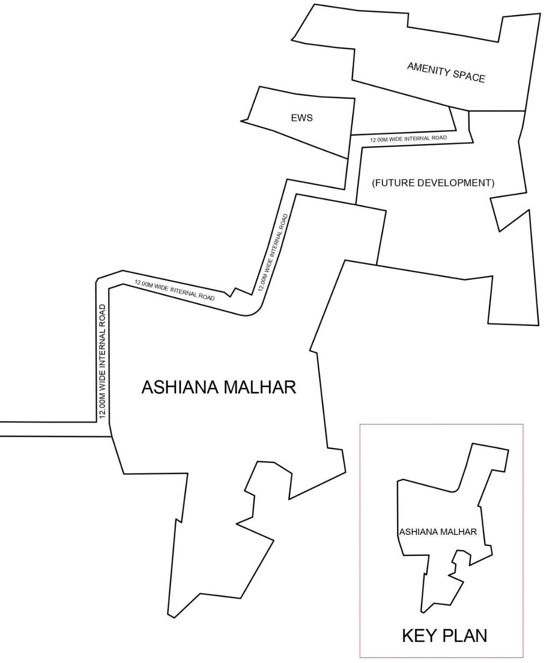
OWNERS RETAINED LAND

PART II OF SCHEDULE A
DESCRIPTION OF THE SCHEDULED LAND WITH DEMARCATION OF RESIDENTIAL BLOCK AND COMMERCIAL BLOCK
All that piece and parcel of land measuring 45,898 sq. mtrs, (11.34 Acres) approximately, situated at Marunji, Taluka Mulshi, District Pune (Maharashtra) and delineated in a below mentioned map or plan and the same is bounded as under:
On or towards the East : By Survey No. 75/5 (Part) and 78 (Part)
On or towards the South : By Marunji Road and Survey No. 76/2 (Part) On or towards the West : By 12 Mtr. wide Access Road and Bhor Wasti On or towards the North : By Survey No. 75 (Part)

Sr. No. | Survey No. | Area
Sr. No. | Survey No. | In Sq. Mtr. | In Hectare | In Acre
1 | 75/2 | 4,525 | 0.45.25 | 1.12
2 | 75/5/1 P | 4,443 | 0.44.43 | 1.10
3 | 76/1 P | 25,690 | 2.56.90 | 6.35
4 | 77/1/1/1C P | 6,920 | 0.69.20 | 1.71
5 | 78/1 P | 4,320 | 0.43.20 | 1.06
TOTAL |  | 45,898 | 4.58.98 | 11.34

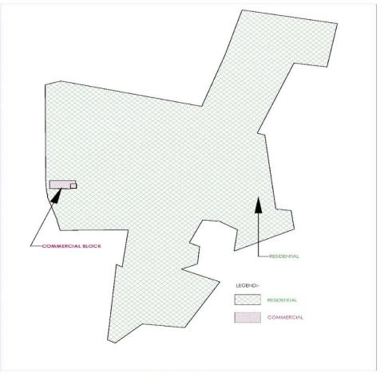

PART III OF SCHEDULE A

DEMARCATION OF SCHEDULED LAND WITH DEMARCATION OF ASHIANA MALHAR PHASE I AND ASHIANA MALHAR PHASE II AND COMMERCIAL BLOCK

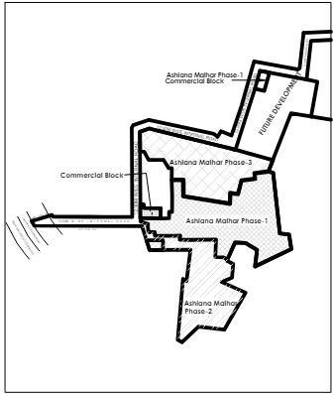

PART IV OF SCHEDULE A

DESCRIPTION OF PROJECT LAND WITH DEMARCATION OF ASHIANA MALHAR PHASE III
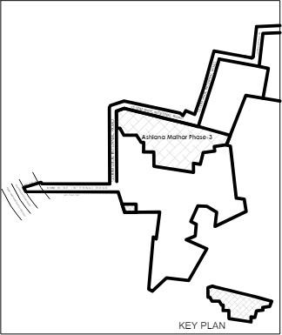

SCHEDULE B

(DESCRIPTION OF THE UNIT)

- Unit No.
Floor:
- Type:
- Carpet Area: sq. mtr. ( sq. ft.)
- Exclusive Balconies
  - Balcony one: sq. mtr. ( sq. ft.)
  - Balcony two: sq. mtr. ( sq. ft.)
- Terrace Area
- Type of Parking- (Layout attached as Annexure IX)

Note- The Whole Project/Said Project comprises of various type of vehicle parking like open, covered (stilt) with electric vehicle charging connection, covered (stilt) without electric vehicle charging connection, semi covered vehicle parking with electric vehicle charging connection, semi covered vehicle parking without electric vehicle charging connection. Type of parking earmarked with the above referred Unit is mentioned above in point f.

PART I OF SCHEDULE C TOTAL PRICE

(Total Price of the Unit)

The total price of the Unit is Rs. (Rs. only) is as follows:
- Price of the Unit Rs.

ii Additional Charges (if any)-
Covered Parking (if any with the Unit) Rs.
Less Discount: Rs.
Total Price: Rs.

PART II OF SCHEDULE- C (PAYMENT SCHEDULE)

The Allottee agrees to pay to the Promoter the Total Price towards the Unit in accordance with the payment plan as mentioned herein below or as agreed between the Parties-

“The Allottee has paid on or before execution of this agreement a sum of Rs (Rupees only) (not exceeding 10% of the total consideration) as advance payment or application fee and hereby agrees to pay to that Promoter the balance amount of Rs ............................( Rupees ) in the following manner :-
i. Amount of Rs......../-( ) (not exceeding 30% of the total consideration) to be paid to the Promoter after the
execution of Agreement xii. ii. Amount of Rs......./-( ) (not exceeding 45% of the total consideration) to be
paid to the Promoter on completion of the Plinth of the building or wing in which the said Apartment is located.
- Amount of Rs....../-( ) (not exceeding 70% of the total consideration) to be paid to the Promoter on
completion of the slabs including podiums and stilts of the building or wing in which the said Apartment is located.
- Amount of Rs......./-( ) (not exceeding 75% of the total consideration) to be paid to the Promoter on
completion of the walls, internal plaster, floorings doors and windows of the said Apartment. v. Amount of Rs........./- ( ) (not exceeding 80% of the total consideration) to be paid to the Promoter on completion of the
Sanitary fittings, staircases, lift wells, lobbies upto the floor level of the said Apartment. vi. Amount of Rs /-
( ) ( not exceeding 85% of the total consideration) to be paid to the Promoter on completion of the external
plumbing and external plaster, elevation, terraces with waterproofing, of the building or wing in which the said Apartment is located.. vii. Amount of Rs......./-( ) (not exceeding 95% of the total consideration)

Note- i) Amount reflected above is exclusive of GST, delay payment charges, stamp duty and registration charges.
- The Promoter offers various payment plans and the Allottee has the option to choose the plan he wishes to opt as per his convenience.

PART I OF SCHEDULE D
COMMON AREAS AND FACILITIES OF THE WHOLE PROJECT

  - The Scheduled Land
  - Sewer Treatment Plan and Sewer System
  - Electric Sub Station
  - Storm Water Drainage System
  - Water tanks
  - Firefighting system including underground fire tank, fire pumps

PART II OF SCHEDULE D
(DETAILS OF COMMON AREAS AND FACILITIES OF THE SAID PROJECT)
- Project Land(Part)
- Sewer System(Part)
- Electric Sub Station and Electrical Supply(Part)
- Fire fighting system including underground fire tank, fire pumps(Part)
- Storm Water Drainage System(Part)

PART III OF SCHEDULE D
(DETAILS OF LIMITED COMMON AREAS AND FACILITIES OF RESIDENTIAL BLOCK

DEVELOPED WITH SAID PROJECT AND WITHIN THE LIMITS OF ASHIANA MALHAR PHASE III)
- Open vehicle parking
- Podium vehicle parking
- Stilt vehicle parking
- Guard Room and Change Room and Toilet
- Part Podium
- Park (Part)
- Driveways, Roads, Entry Gate and walkways
- Solar Panels
- The staircases, lifts, staircase and lift lobbies, fire escapes, and common entrances and exits of T 2 and T 3 in Ashiana Malhar – Phase III

Note- The above referred Limited Common Areas and Facilities for Residential Block are to be developed with limits of Ashiana Malhar Phase -III as shown in Part IV of Schedule A. The Promoter further represents that common areas and facilities to be developed with Residential Block 1,2,3,6,7,8 and 9 like park, club, green area, parking, stair cases, lifts, staircase and lift lobbies, fire escapes, and common entrances and exits of Block 1,2,3,6,7,8 and 9 shall form part of Limited Common Areas and Facilities for Residential Block and located within the limits of Residential Block as shown in Part III of Schedule A and shall be used exclusively by the residents of Residential Block.

SCHEDULE E- SPECIFICATIONS ASHIANA MALHAR PHASE III

- Foundation
Reinforced cement concrete, isolated & combined footings/ strip foundation/ raft or load bearing rubble/ masonry or cast-in-situ bore piles and pile caps as per applicable Bureau of Indian Standards (BIS) codes. (Refer note 14-j)

Superstructure
Reinforced cement concrete frame structure or load bearing masonry structure in accordance with applicable earthquake zone and Bureau of Indian Standards (BIS) codes (refer note 14-j).

Walls
- Internal: RCC/Brick/Block wall of Clay Bricks/Fly ash Bricks/AAC Blocks/Solid concrete blocks/Hollow concrete blocks
- External: Same as above

Finishes - Wall
- Units
- Master and all other bathrooms: Ceramic tiles up to 2.0 to 2.1 M height from floor level and above the tiles a coat of POP with coating of emulsion paint.
- Kitchen: Ceramic tiles 0.60 meter from counter top and a coat of POP with coating of emulsion paint.

Common Areas — Internal Wall
Lift lobby in basement, stilt/ground floor and upper floors: Granite and/or marble and/or vitrified tiles and/or ceramic tiles and/or cement sand plaster and/or other local stone and/or combination of any two or more items with emulsion paint finish (wherever applicable).

Common Areas — External Wall
All external walls including roof terrace, open terrace, balcony: spray texture/coating and/or emulsion paint finish.

Finishes -Floor
- Units
- Living/Dining, entrance foyer, corridor leading to bedrooms: Vitrified Tiles or ceramic tiles of any size
- Bedrooms and study room: Vitrified Tiles or ceramic tiles of any size.
- Master and all other bathrooms: Ceramic Tiles (300X300 or other sizes up to 450X450) and/or combination
- Balcony: Ceramic Tiles (300X300 or other sizes up to 450X450 and/or combination) suitable quality glazed/matt finish
- Open Terrace: Kota stone/other local stone/ceramic tiles of appropriate quality.
- Internal staircase: Ceramic tiles (300X300 or other sizes up to 450X450 and/or combination) or Kota stone/marble/local stone or combination of tiles and stone
- Kitchen: Ceramic tiles (300X300 or other sizes up to 450X450 and/or combination) matt finish or vitrified tiles of any size.

Common Areas - Internal Floor
- Lift lobby in basement, stilt/ground floor and upper floors: Ceramic tiles (300X300 or other sizes up to 450X450 and/or combination) or Kota stone/other local stone of appropriate size or combination of ceramic tiles.
- Staircases and Staircase landing: Ceramic tiles of appropriate quality or semi polished kota stone or any other local stone or combination of tiles and mentioned stone
- Stilt area: Ceramic tiles of appropriate quality or semi polished kota stone or any other local stone or combination of tiles and mentioned stone
- Basement/Podium: Homogeneous cement floor/paver block of appropriate specification

Ceiling
- Units

a) Living/Dining, bedrooms, bathrooms, entrance foyer, study area/room, store, balcony corridor inside the units leading to bedrooms, kitchen & all bathrooms:
- Plastered with either- a) sand-cement mortar/ a coat of plaster of Paris or b) gypsum
- Pleasing shade emulsion paint (Plastic/Acrylic as per Architect's recommendation) finish of appropriate quality.

Common Area
- Lift Lobbies: same as 6(i)
- Staircase, Common lobby, Corridor, Stilt area: 1) Plastered with either- a) sand-cement mortar/ a coat of plaster of Paris or b) gypsum
2) Please shade cement paint /distemper/emulsion of appropriate quality (as per Architects recommendation)
- Basement/Podium car parks and ramp: Cement concrete surface finished with grey cement wash after appropriate chiselling/grinding/smoothening or exposed concrete finish

Notes:

Tiles are generally laid with spacers of suitable width as decided by Architect and joints are filled with cementitious grout.
Skirting of 75 to 100 mm wherever applicable No skirting underneath kitchen platform
No tiles in cupboard area
No tiling work on top surface of loft
Marble/black granite/quartz stone /same floor tiles in window cill inside the room. Outside the unit, window cill will be painted.

Allowable undulation in Wall/Ceiling Finishes
Wall and ceiling finishes shall have an appropriate appearance and surfaces should be reasonably uniform, although there may be minor textural differences.
The flatness of the Wall and ceiling finishes will depend on the accuracy to which the background has been constructed. Thinner applications of 2mm skim coats of POP and thin coats of paint, which we apply will only overcome minor irregularities or small deviations from the line of the background. In general, no tolerance can be laid down for these skim coats since this will closely follow the contour of the background (Cement plastered surface).
It is understood that plastering is a craft and it is not possible to achieve a completely smooth and true surface finish. Acceptable tolerance in flatness of a plastered surface is defined in IS 1661 (1972) as mentioned below.

TRUENESS OF PLASTERING SYSTEM
  - The finished plaster surface shall not show any deviation more than 4mm when checked with a straight edge of 2m length placed against the surface.
So allowable Undulation/Tolerance for any plastered wall finish is 4mm if measured in 2- meter straight edge length.

Windows
- Bedrooms, drawing/dining and kitchen: 2 to 3 track aluminium/UPVC framed window, with 2 to 3 sliding panels depending upon size with clear float glass.
- All bathrooms/powder room: Top hung/louvered with frosted glass. No flymesh shutter is being provided.
- 2 numbers well supported MS horizontal bar across the window opening at suitable height shall be provided as safety feature. Full grill covering is not being provided.

Door
- All door frames are folded steel sections/Stone frame/Wooden frame/or combination of any two.
- Main entrance: Laminated flush door or flush door with beading or moulded skin door shutter. Provision to fix mesh door (mesh door is not provided)
- Bedrooms, Study room, master and all other toilets: Flush door or moulded skin doors.
- Kitchen: No door is provided

Notes

All doors and door frames are enamel painted.
Fixture detail: Night latch, L drop & Door stopper in main door of standard make. Mortise lock with handle, Door stopper & tower bolt in all bedroom’s door. Mortise lock with handle in all bathroom and powder room

Bathrooms and kitchen
Sanitary wares and fixtures

All toilets except powder room
1 wash basin fitted under/over marble/granite/quartz stone counter or 1 recessed wash basin and a PTMT framed.450 X 550 mirror
1 floor/Wall mounted EWC with 6 litre capacity dual flush type concealed/exposed cistern with seat and seat cover.
A single lever or half/quarter turn CP basin mixer in wash basin, a single lever or half/quarter turn wall mixer with overhead shower and a spout in shower area.
- CP angle valve along with chrome plated PVC semi rigid/flexible health faucet of standard make. 1 CP angle valve of standard make for inlet of hot water geyser.
- angle valves for water connection to wash basin and 1 angle valve for water connection to flushing cistern and 1 bottle trap of standard make PTMT material.
1 towel rod, a PTMT framed 3 to 5 mm thick mirror of min size 450mmX600mm. 1 towel rack instead of towel rod shall be provided in master toilet only.

Staff toilet (wherever applicable)
1 floor mounted EWC with 6 litre capacity dual flush type PVC cistern with white/off white PVC/UPVC seat and seat cover
1 wash basin and a PTMT framed 400X500 mirror
1 pillar cock in wash basin for cold water only of standard make
1 bib tap for cold water of standard make are provided in bathing area
1 angle valve for water connection to wash basin and 1 angle valve for water connection to flushing cistern and 1 bottle trap of standard make PTMT material.

Powder Room (wherever applicable)
1 wash basin with 1 pillar cock for cold water
1 floor/Wall mounted EWC with 6 litre capacity dual flush type concealed/exposed cistern with seat and seat cover.
1 CP angle valve along with chrome plated PVC semi rigid/flexible health faucet of standard make.
1 angle valve for water connection to wash basin and 1 angle valve for water connection to flushing cistern and 1 bottle trap of standard make PTMT material.

Kitchen
1 stainless steel sink with one bowl of 160-200 mm depth and a drain board. 1 swivel type sink tap.
1 CP angle valve for water purifier unit/RO 1 CP angle valve for dish washer.
No tap is provided below sink.
Piped LPG gas with LPG meter will be provided.

Notes
Brand/make of bath fixtures
All Bathrooms except staff room toilet
Sanitary wares: Hindustan/Roca/Kohler/American Standard/Vitra or equivalent
Bath Fittings: A. basin mixer, wall mixer and shower of Jaquar/Roca/American Standard/Grohe or Equivalent
B. Other angle valve either of CP or PTMT of Standard make like Jal/Continental/Prayag or equivalent. Staff room toilet
Sanitary wares: Cera/Neysar/Parryware or equivalent
Bath fittings: A. CP basin mixer like JAL/Continental or equivalent, B. Other angle valve either of CP or PTMT of standard make like Jal/Continental/Prayag or equivalent

Kitchen
Water supply fittings: A. sink mixer of Jaquar/Roca/American Standard/Grohe or equivalent.
B. Other angle valve either of CP or PTMT of Standard make like Jal /Continental/Prayag or equivalent.

Electrical Installation and Fittings
- All electrical wiring in concealed conduits with copper wires. Convenient position & distribution of light and power plugs and provision for electrical chimney above platform and water purifier point in kitchen.
- Modular electrical switches with sockets and fan regulators of SSK/Anchor/Northwest/Legrand or equivalent

Cable TV and Telephone
Points will be provided in drawing /dining room and in all bedrooms. The intercom will be provided through the authorised phone company or EPABX. Facility of DTH antenna installation for each unit is allowed only on the terrace and not in front of individual units. Provision for wi-fi connection will be provided at suitable location.

Driveway and car park
- Surface Driveway. Stone and/or pavers and/or tarmac and/or concrete to external driveway at designated areas.
- Basement car parks and ramp to basement car park: Reinforced concrete slab

Additional items
Hot water supply: Hot water from solar heater panel shall be connected to inlet pipe of hot water geyser in one of the toilets. Provision for geyser installation in toilets.
Security: Boom Barrier for vehicular barrier, Closed Circuit Television System (CCTV) to project entrance, block Entrance and Club house.
Balcony and staircase railing: Stairs railing height is 950 mm and Balcony railing height is 1050 to 1100 mm. Power back up: Diesel Generator sets of appropriate capacity to provide full back-up into common areas and 750 watt to each unit with stack is provided to fulfil designed requirement.
Washing machine: Provision is provided in suitable location.

Notes/Disclaimers
- Wall: No tiles behind/below kitchen cabinets, Wall surface above the false ceiling may be left in its original bare condition.
- Marble, Limestone and granite: Marble: Limestone and granite are natural stone materials containing veins with tonality differences. There will be colour and markings caused by their complex mineral composition and incorporated impurities. While such materials can be pre-selected before installation, this non-uniformity in the marble, limestone or granite as well as non-uniformity between pieces cannot be totally avoided. Granite is pre-polished before laying and care has been taken for their installation. However granite, being a much harder material than marble cannot be re-polished after installation. Hence some differences may be felt at joints. The tonality and pattern of marble, limestone or granite selected and installed shall be subject to availability.
- External Paints: External surface of the buildings are painted of suitable quality as decided by the Architects. Paints are manufactured product from chemicals and specific grade of minerals/natural stone product. After application this paint is exposed to weatheric conditions. Ultra violet ray and weather conditions will affect life and sheen of the product and also would cause damages to the expected/designed protective properties of paints. Therefore, periodic maintenance including redoing of paints would be inevitable.
- Materials, Fittings, Equipment, Finishes, Installation and Appliances: The brand, colour and model of all materials, fittings, equipment, finishes, installation and appliances supplied shall be provided subject to architect's selection, market availability and the sole discretion of the vendor.
- Air Conditioning System: Provision for fixing of window/split air conditioner in drawing dining area & bedrooms are being provided. For Split A/C assigned spaces are earmarked on the elevation of the building for ease of access and to create uniformity for aesthetic purpose.
- Timber: Timber is a natural material containing grain/vein and tonal differences. Thus, it is not possible to achieve total consistency of colour and grain in its selection and installation. Timber has inherent property to react along with atmospheric changes, which results bending, twisting and cracking if not maintained well consistently.

- Internet Access & Cable Television: If the Purchaser requires internet access & Cable Television, the Purchaser will have to make direct arrangements with the Service Provider and/or such relevant entities/authorities for services to the Unit and to make all necessary payment.
- Glass: Glass, plain/clear/frosted, is widely used in residential developments and may break/shatter due to accidental knocks or other causes. In addition, glass is a manufactured material and the Purchaser may wish to note that it may not be 100% free from impurities. These impurities are not avoidable with quality checks and balances.
- Tiles: Tiles are manufactured from special kind of clay and other materials. Baking on very high temperature is an integral stage of manufacturing process and therefore, shades and flatness of each lot varies a little bit. Hence, selected tile sizes and tile surface flatness cannot be perfect. Different quality assurance organisations like ISO 10545-2/ Singapore standard SS483:2000 had mentioned acceptable ranges. We, at Ashiana, has been taking utmost care while receiving materials and while install them to minimise these issues but they can never be avoided completely due to inherent properties of the material and therefore excellence in flatness, sizes and minor chips on edges cannot be guaranteed. To minimize such issue tiles are laid with spacers.
- Design Experts: Professionally qualified practicing consultants in the field are deployed to design different functions in compliance to applicable norms and guidelines. These functions are a) Architecture b) Structure
c) Plumbing d) Landscape e) Fire Fighting and e) Power & Electrical. Design parameters set by such experts and applicability of their drawings and decisions are treated as final.
- As per structural design principles, structures are allowed to deflect in different allowable loading/atmospheric/ground settlement/seismic parameters. Since masonry and RCC members behaves differently in such situations, therefore hair cracks in different components of the building are inevitable. These cracks are more visible in plastered surface of the masonry work. While conventionally recognized precautionary measures will be undertaken diligently but complete dis-appearance of such cracks cannot be ascertained.
- Brick work, plaster and application of putty/POP over plastered surface are manual activities. As of date, no machines are found successful to execute these activities without extensive human involvement. Hence, despite all quality process in the job, undulation, out in plumb to certain extent cannot be avoided completely.
- While every reasonable care has been taken in preparing this brochure and in constructing the models and show flats, the Developer and the Marketing Agents cannot be held responsible for any inaccuracies or omissions. Visual representations, models, show flat displays and illustrations, photographs, art renderings and other graphic representations and references are intended to portray only artist's impressions of the development and cannot be regarded as representations of the fact. Floor areas are approximate measurements and are Subject to final survey.
- All information, specifications, renderings, visual representations, and plans are correct at the time of publication and are subject to changes as may be required by us and/or the competent authorities and shall not form part of any offer or contract nor constitute any warranty by us and shall not be regarded as statements or representation of fact. AII facts are subject to amendments as directed and/or approved by the building authorities. All areas are approximate measurements only and subject to final survey. The agreement to sell shall form the entire agreement between us as the Developer and the Purchaser and shall supersede all statements, representations or promises made Prior to the signing of the Agreement to sell and shall in no way be modified by my statements, representations or promises made by us or the Marketing Agents.

SCHEDULE- F

Stage Wise Time Schedule of Completion of Said Project – ASHIANA MALHAR PHASE III

SR. NO. | STAGE | DATE BY WHICH THE WORKS ARE TO BE  COMPLETED | DETAILS OF WORK TO BE COMPLETED
1. | Completion of Structure of the Building | 31st January, 2026 | Foundation, RCC Super Structure
2. | Completion of development works | 31st May, 2027 | Block Work, Internal Plaster, Tiles Work, External Plaster, POP Work, Door Shutter Fitting, Aluminum Window, Electrical Wiring & fittings and testing, Internal Painting, CP & Vitreous Fittings, External Painting, Fire Fighting, Lift, Solar
3. | Obtaining Occupation Certificate | 30th June, 2027
4. | Grace Period of Nine Months | 31st March, 2028
5. | Finishing and Handover | 31st March ,2028 | Hand Over

SCHEDULE G

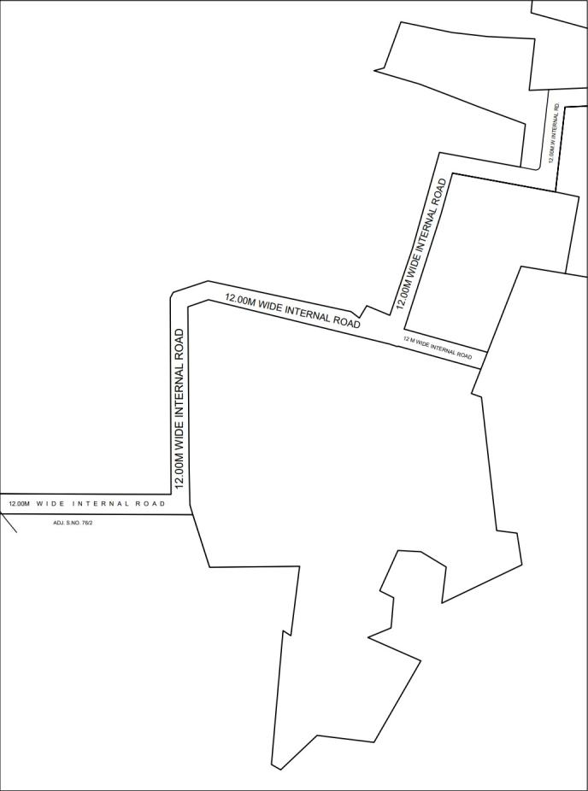

ANNEXURE- I - BOARD RESOLUTION

ANNEXURE- IA - BOARD RESOLUTION

ANNEXURE- II- N/A Orders
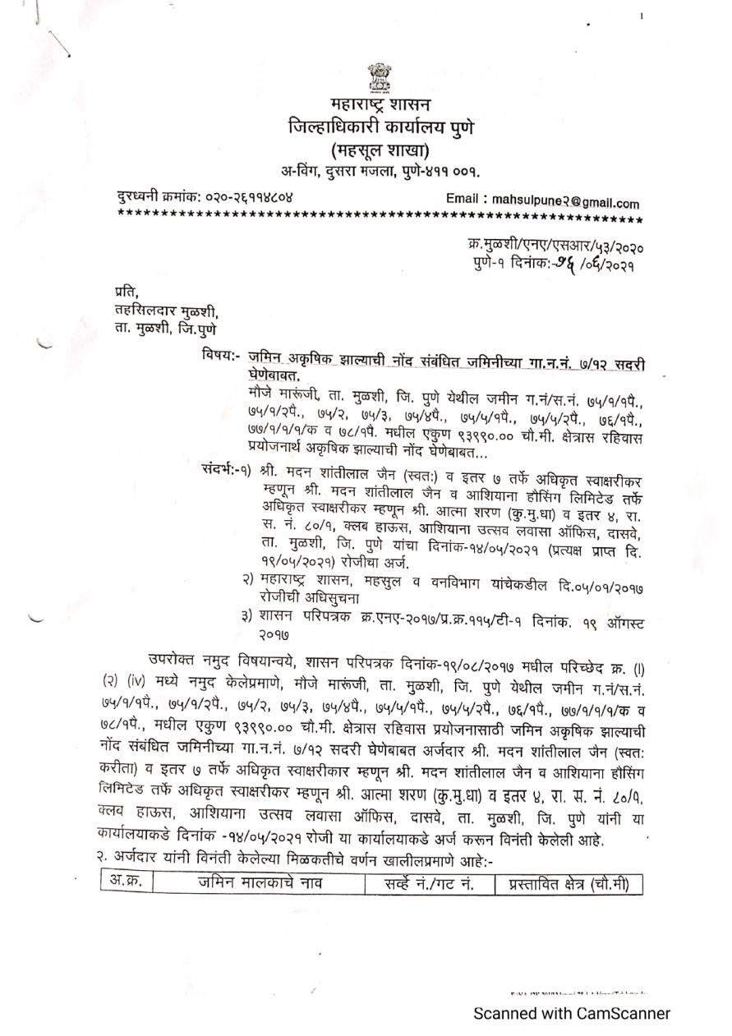

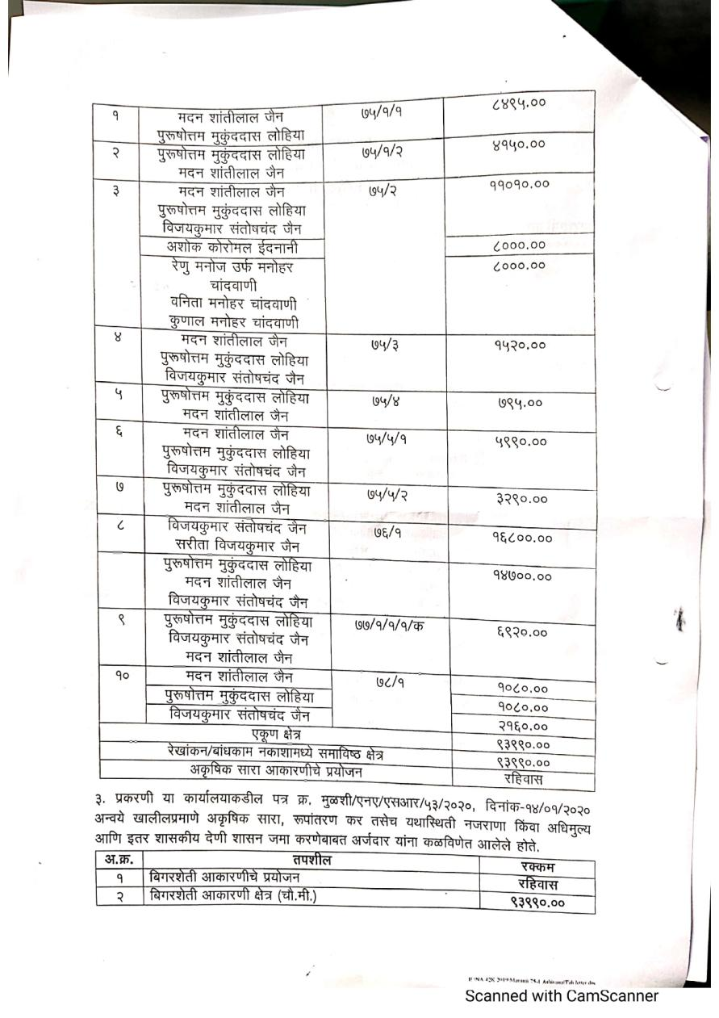

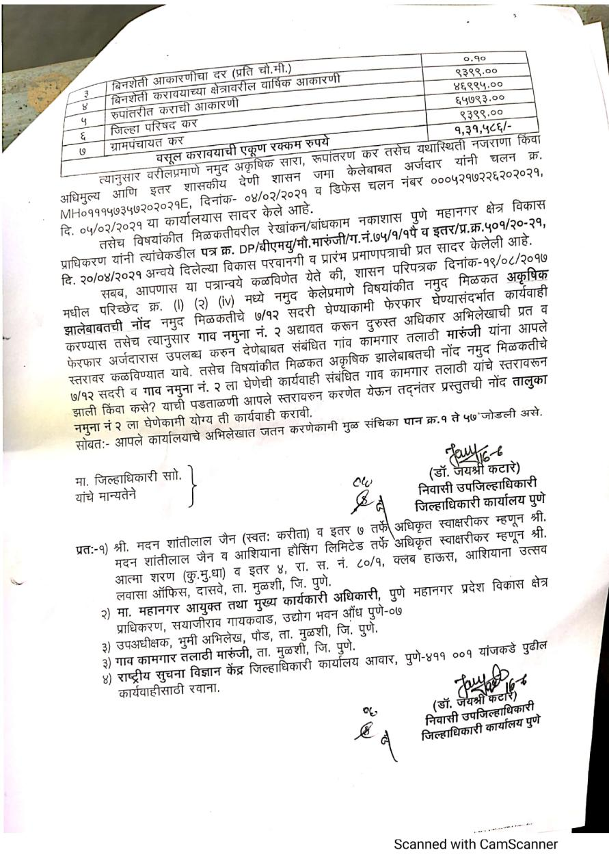

ANNEXURE-III- SITE LAYOUT
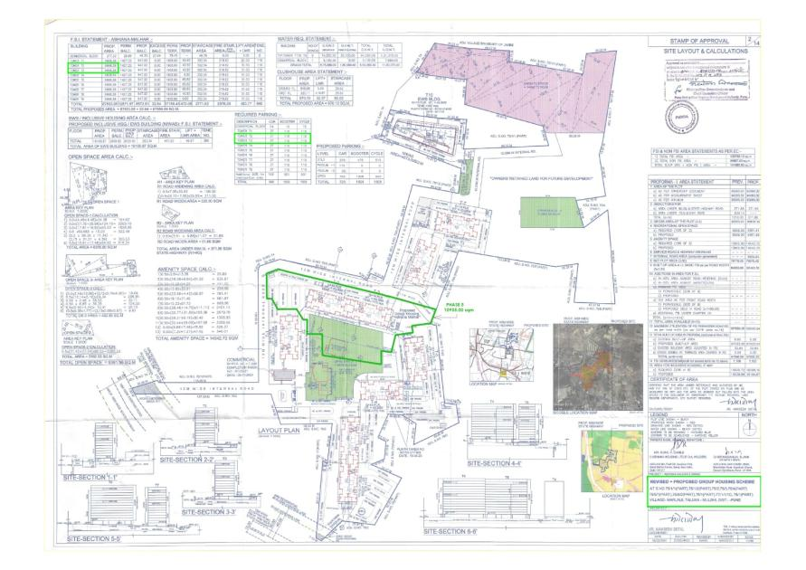

ANNEXURE- IV-BUILDING PLAN LETTER
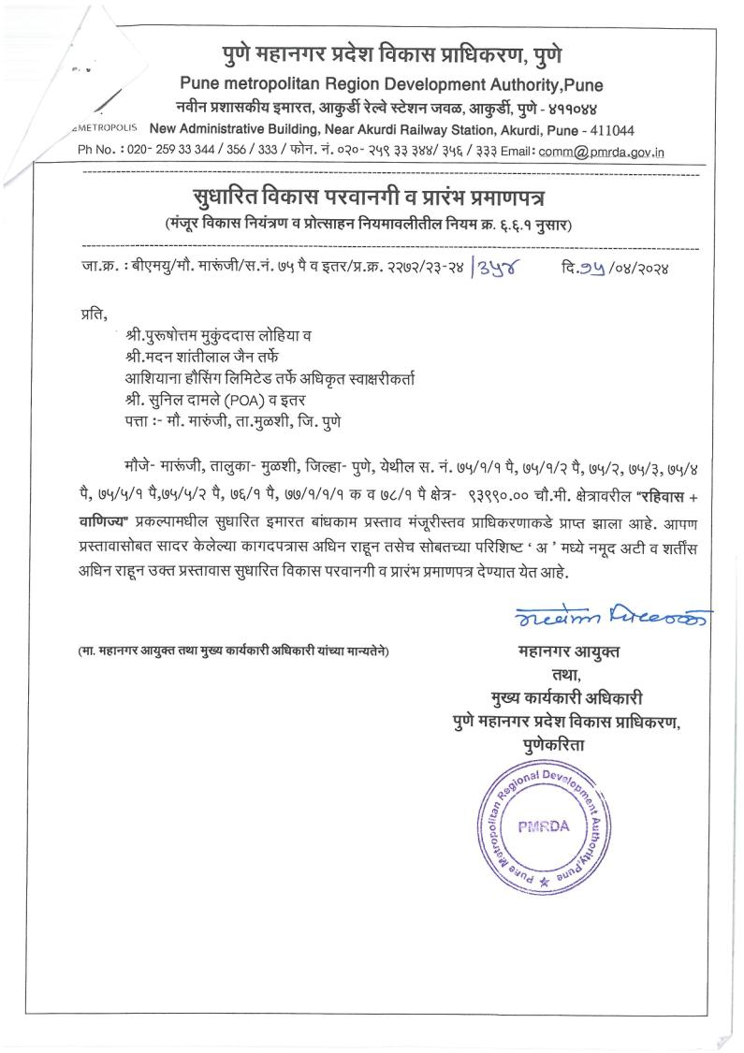

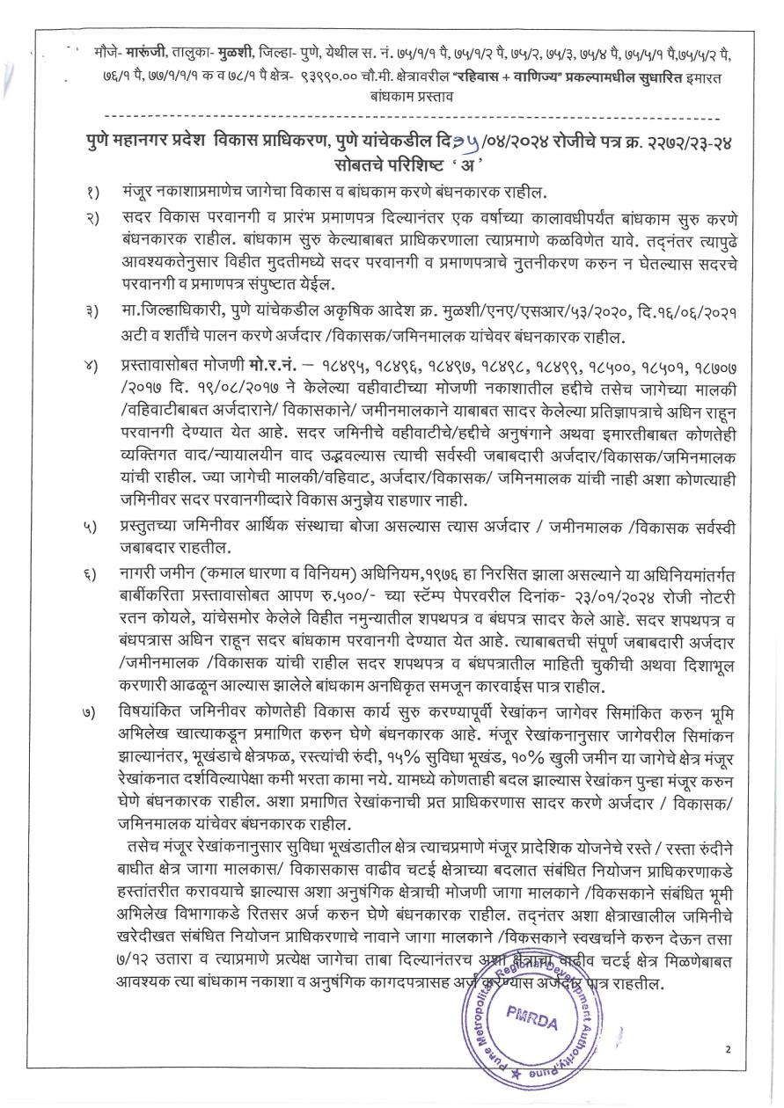

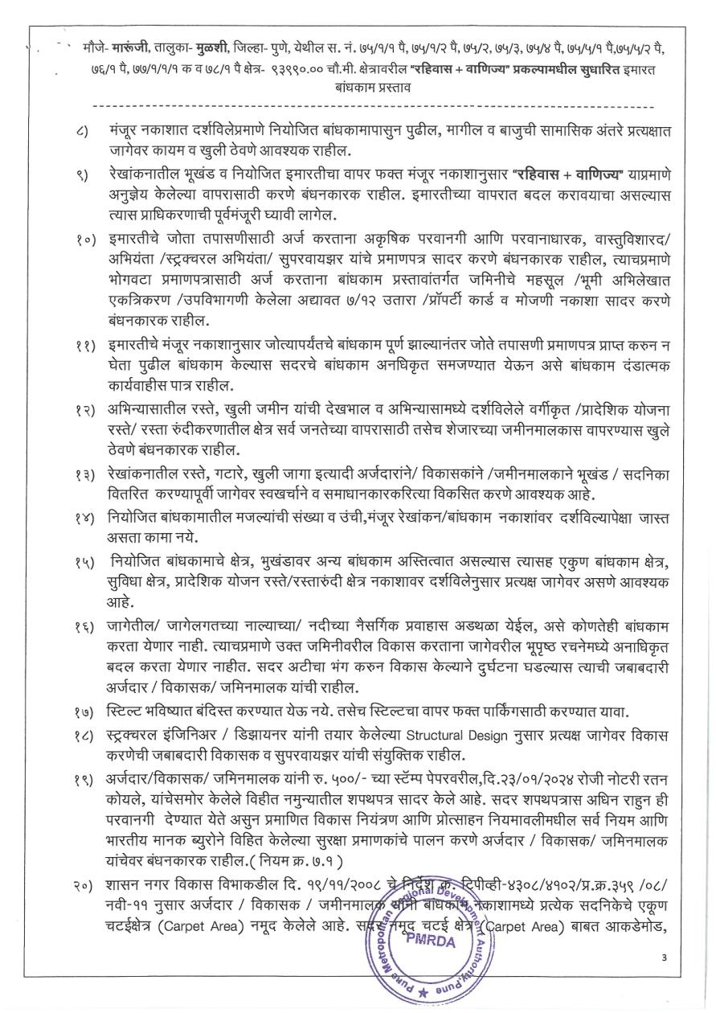

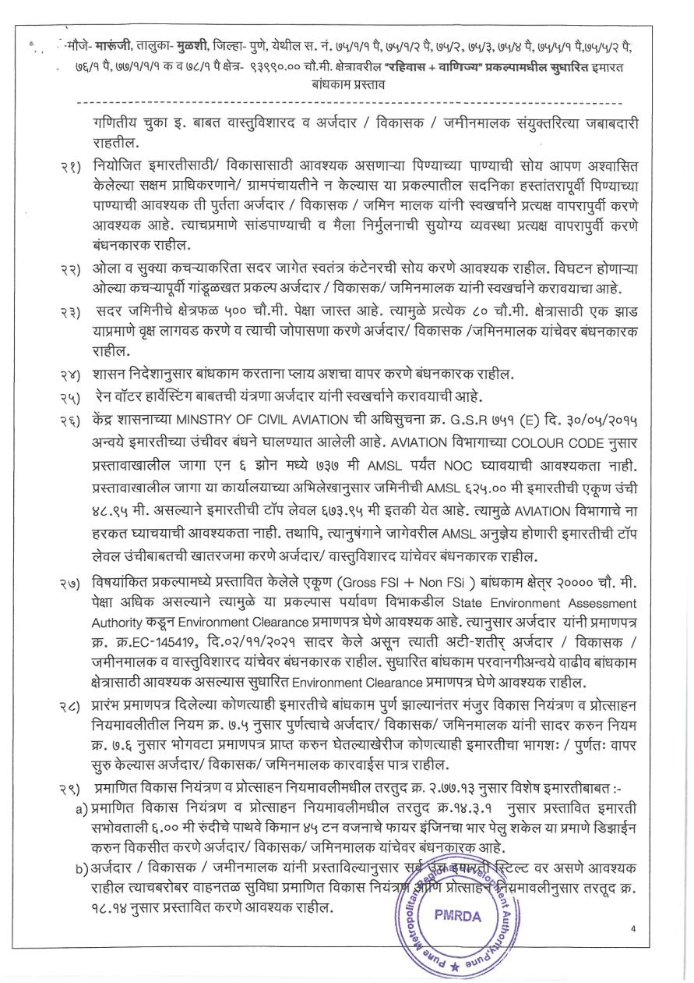

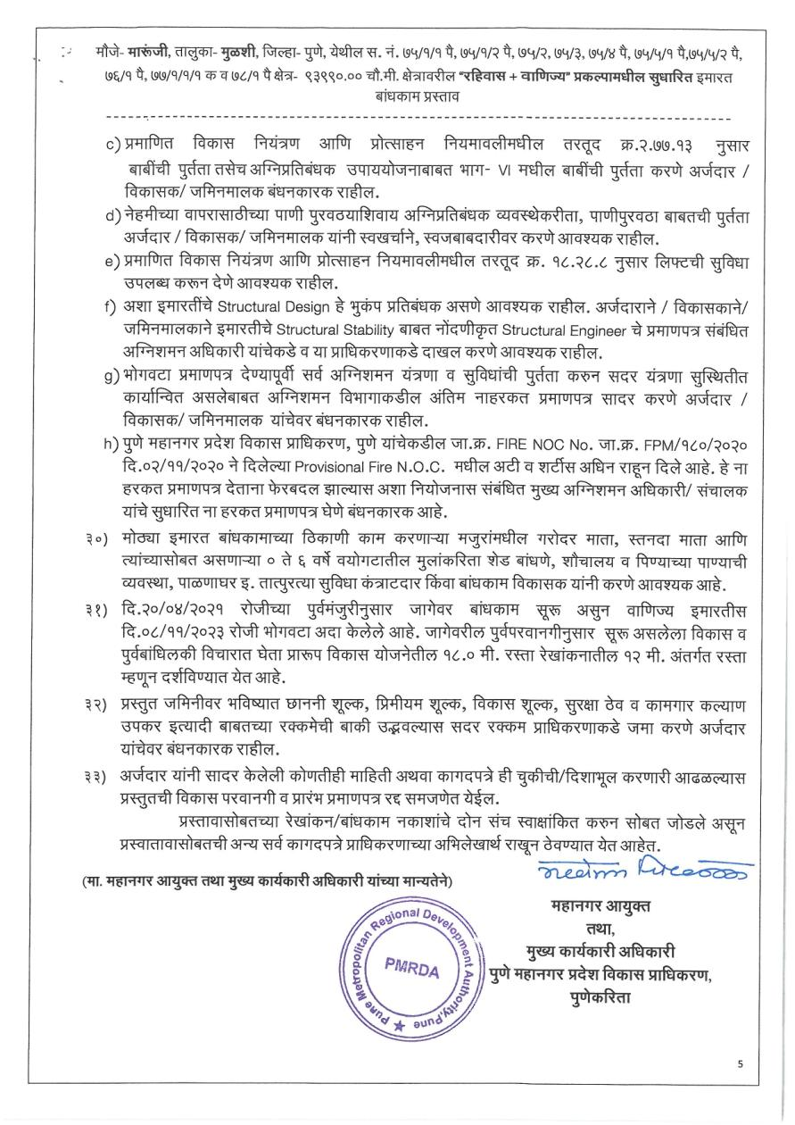

ANNEXURE- V- TITLE REPORT

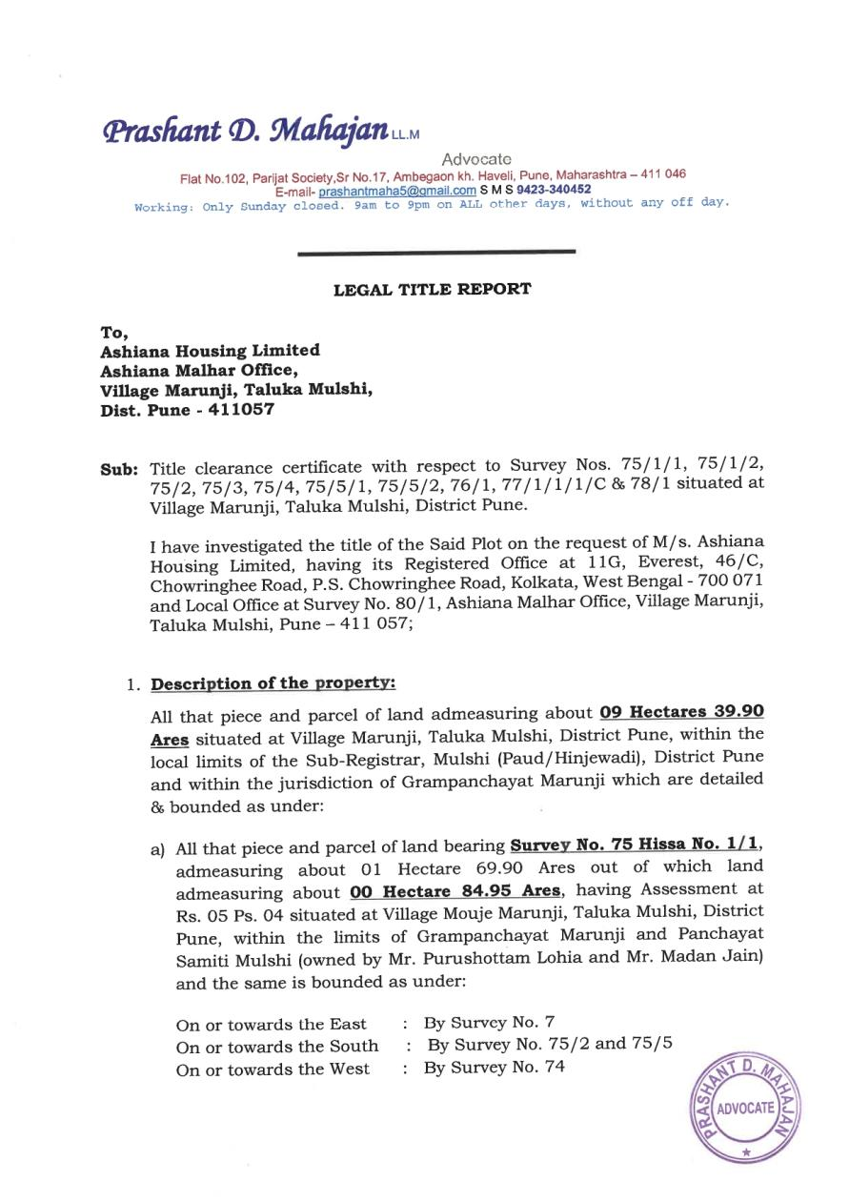

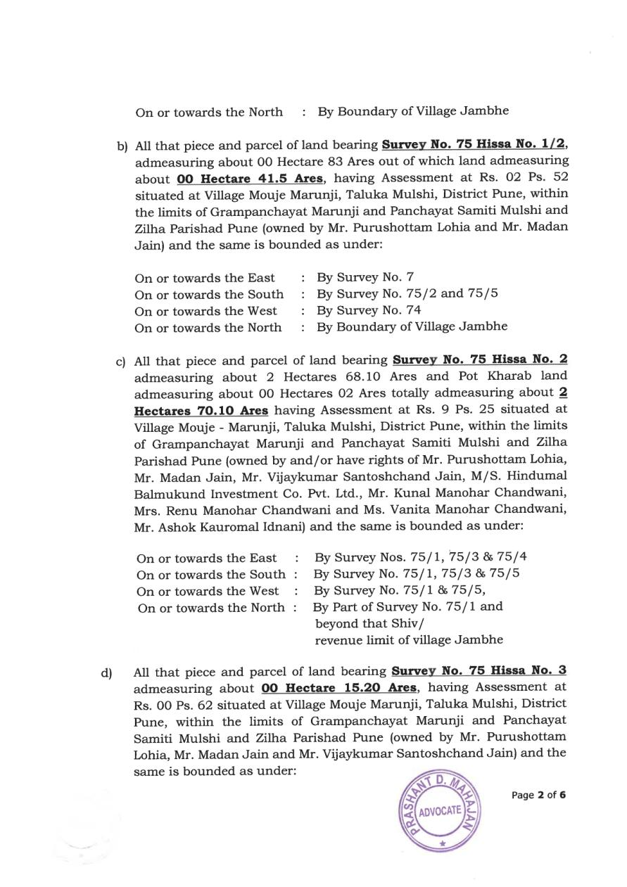

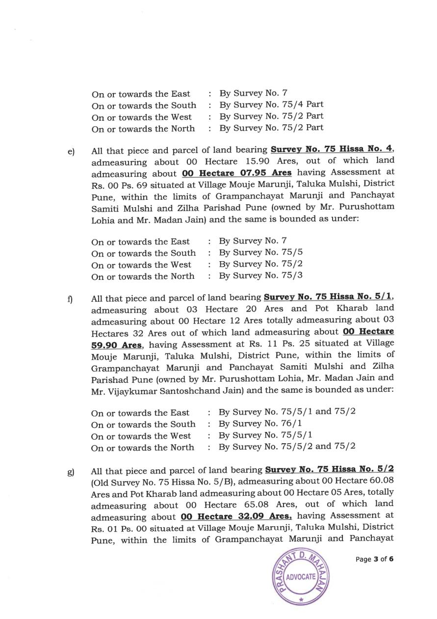

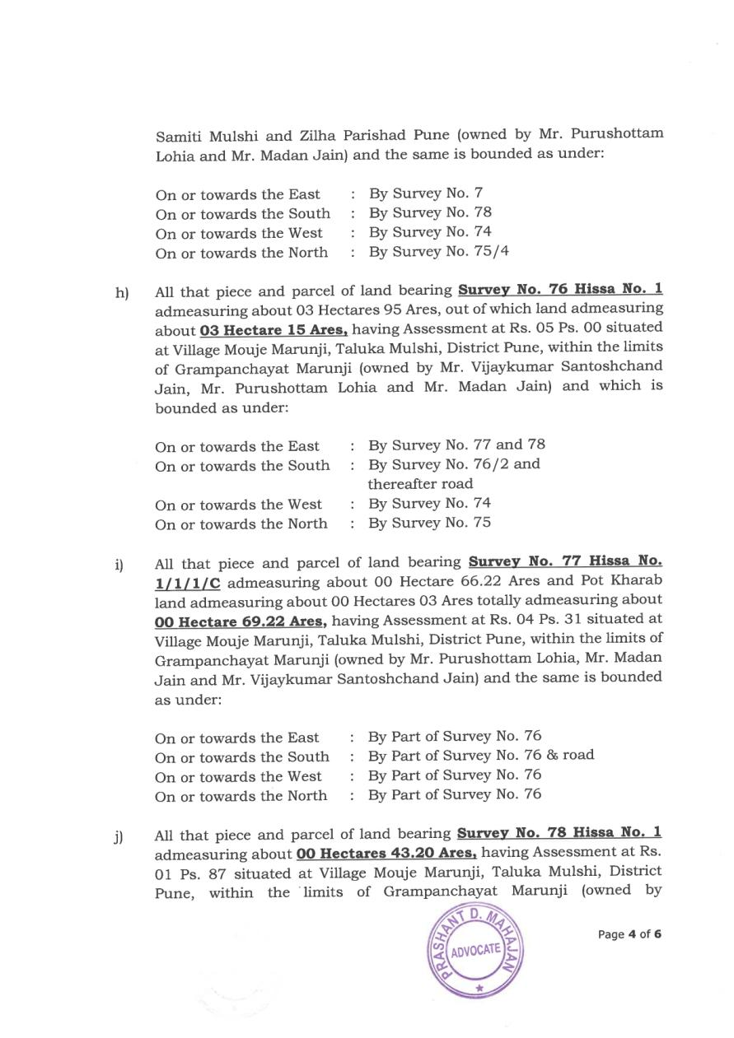

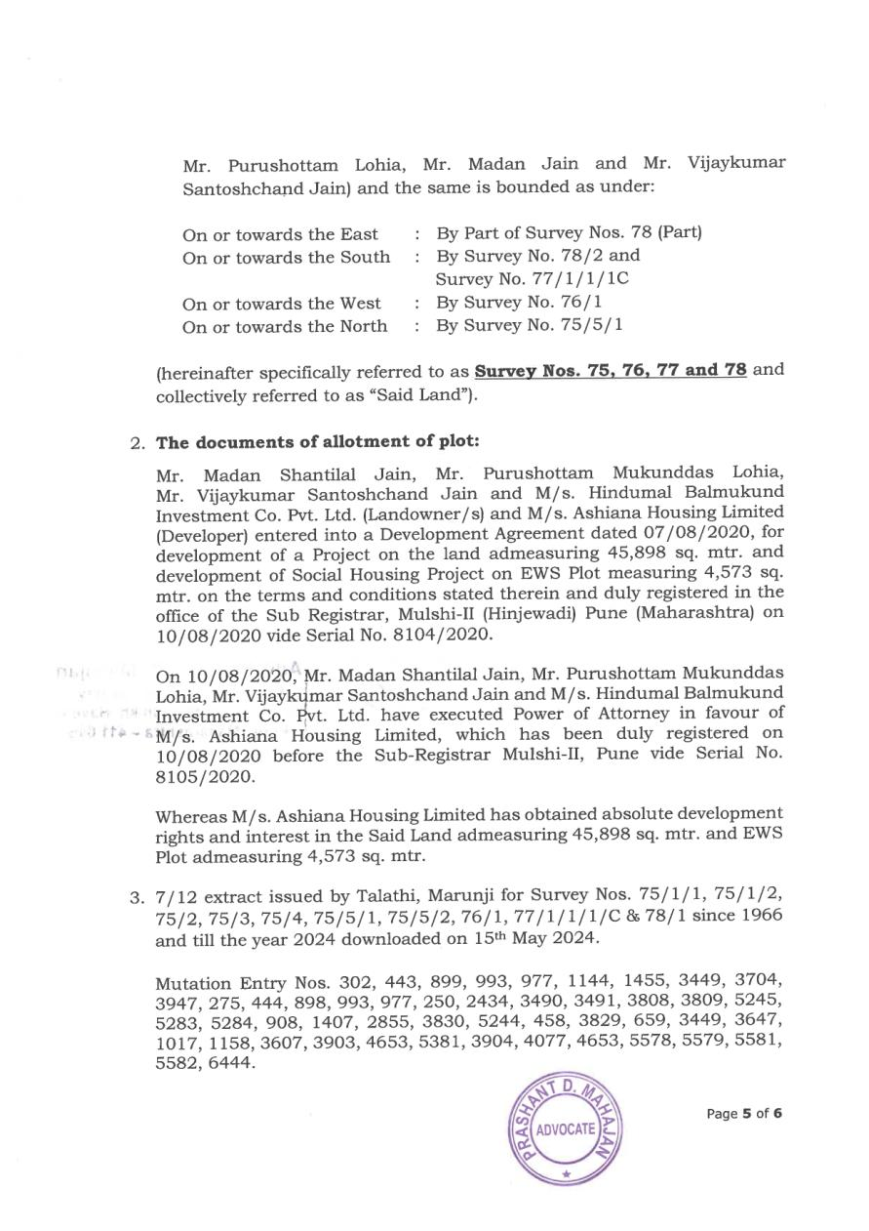

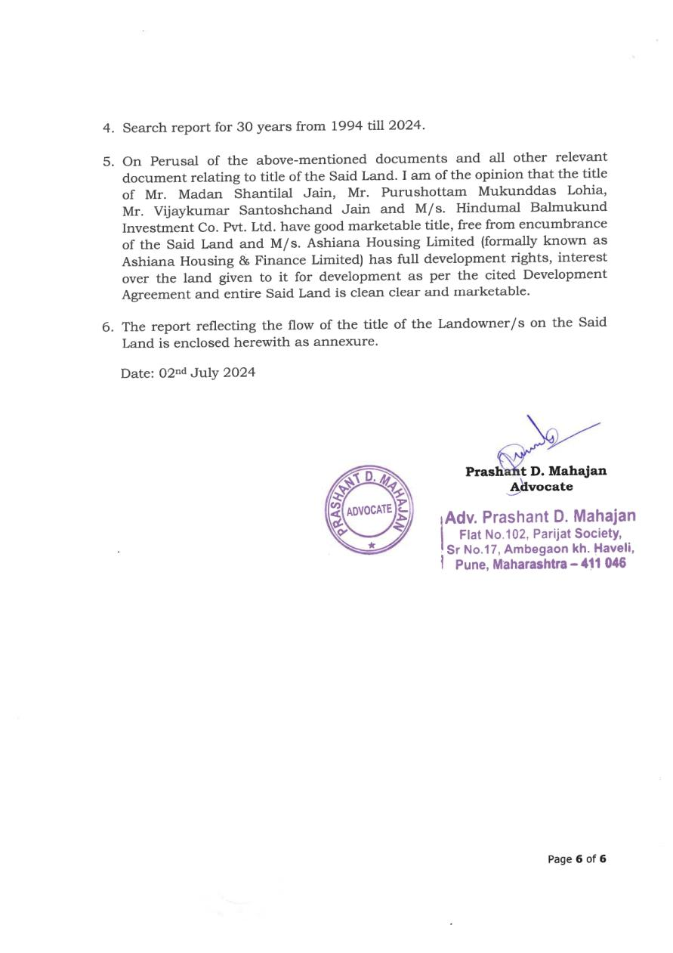

ANNEXURE- VI- 7/12

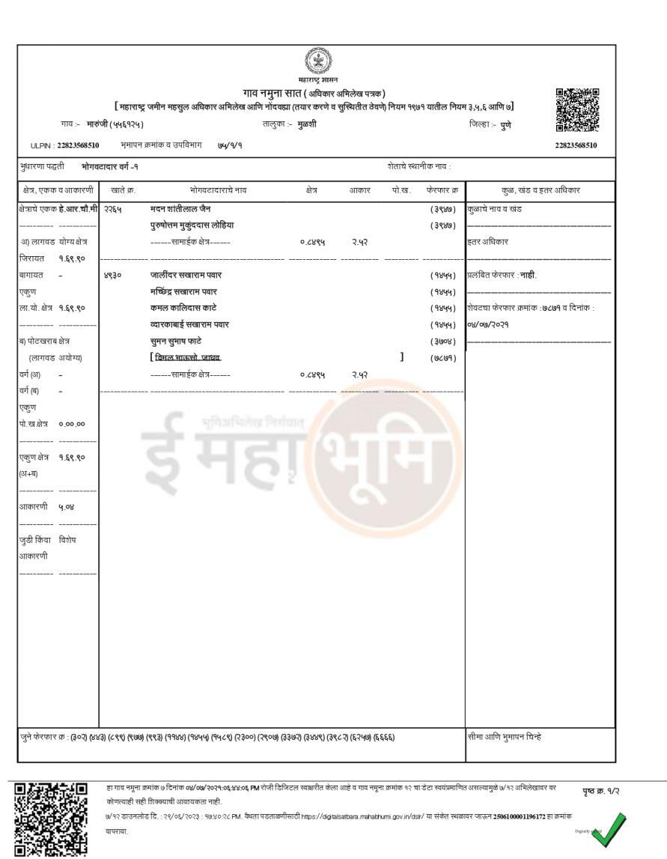

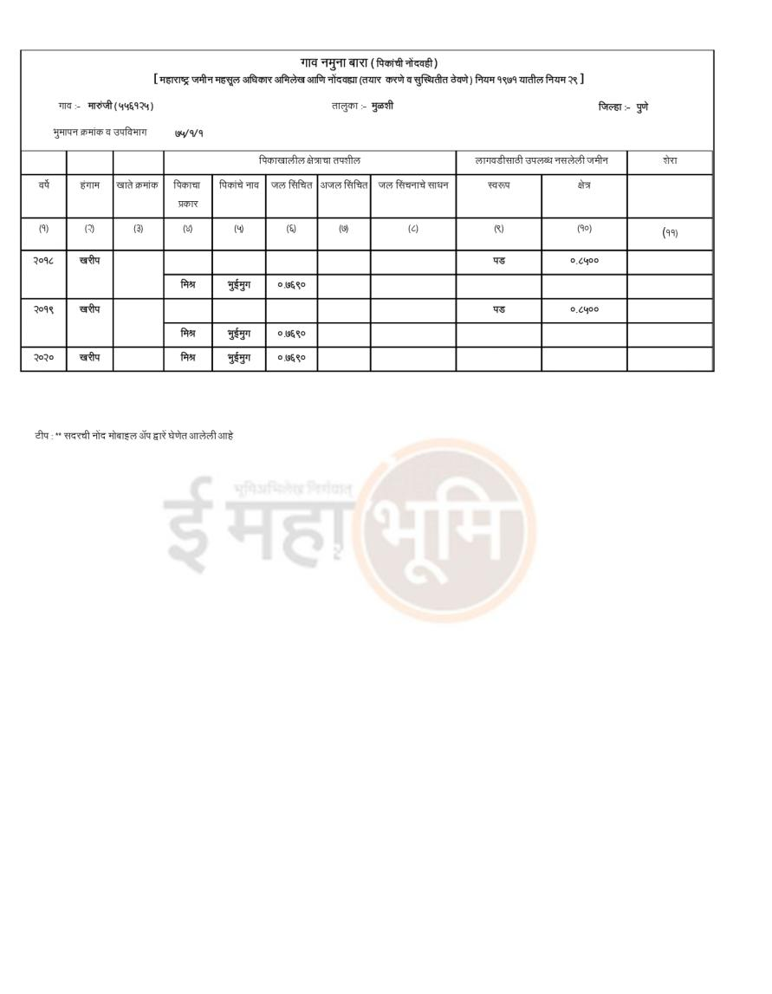

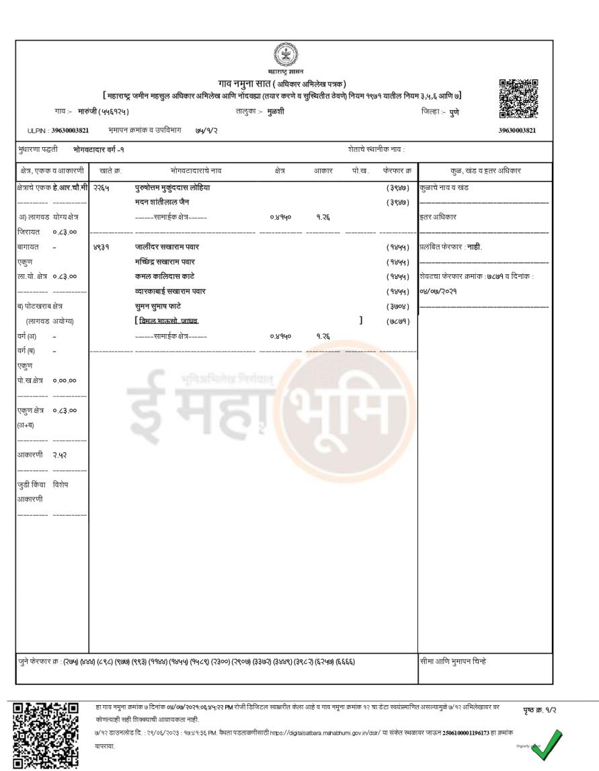

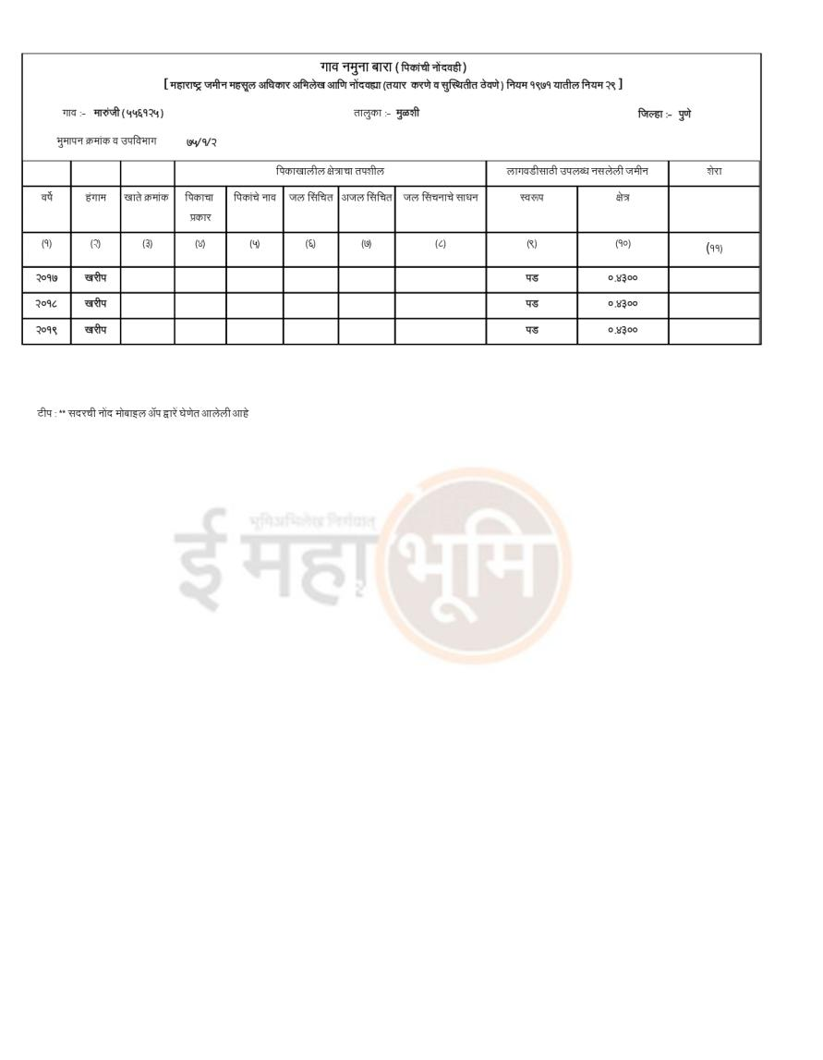

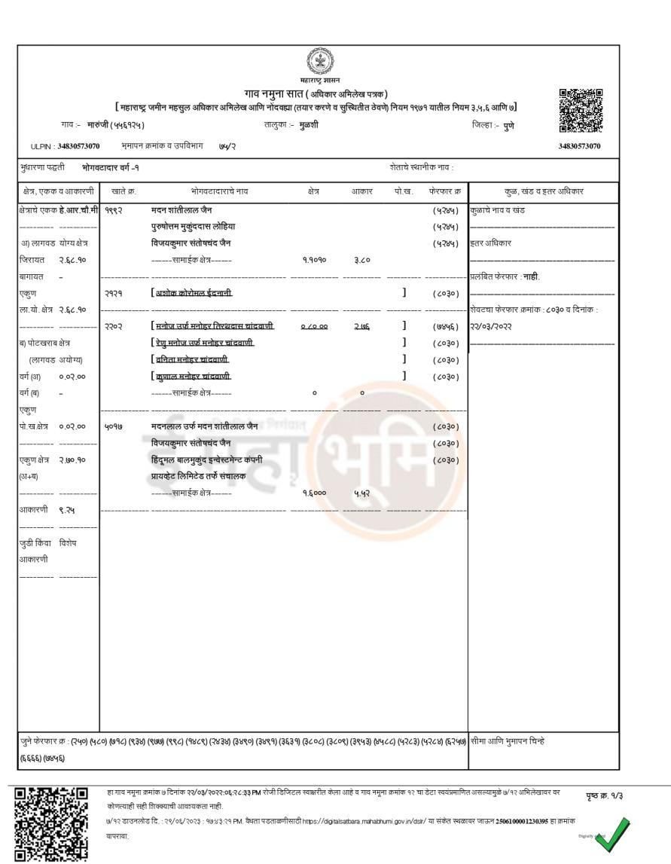

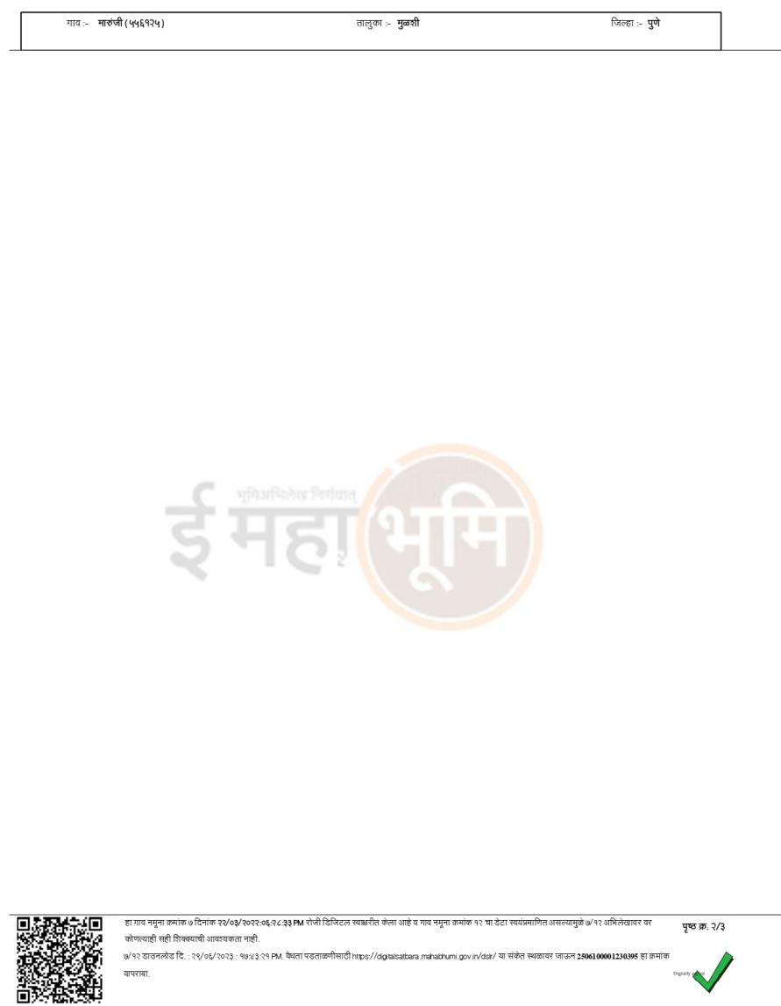

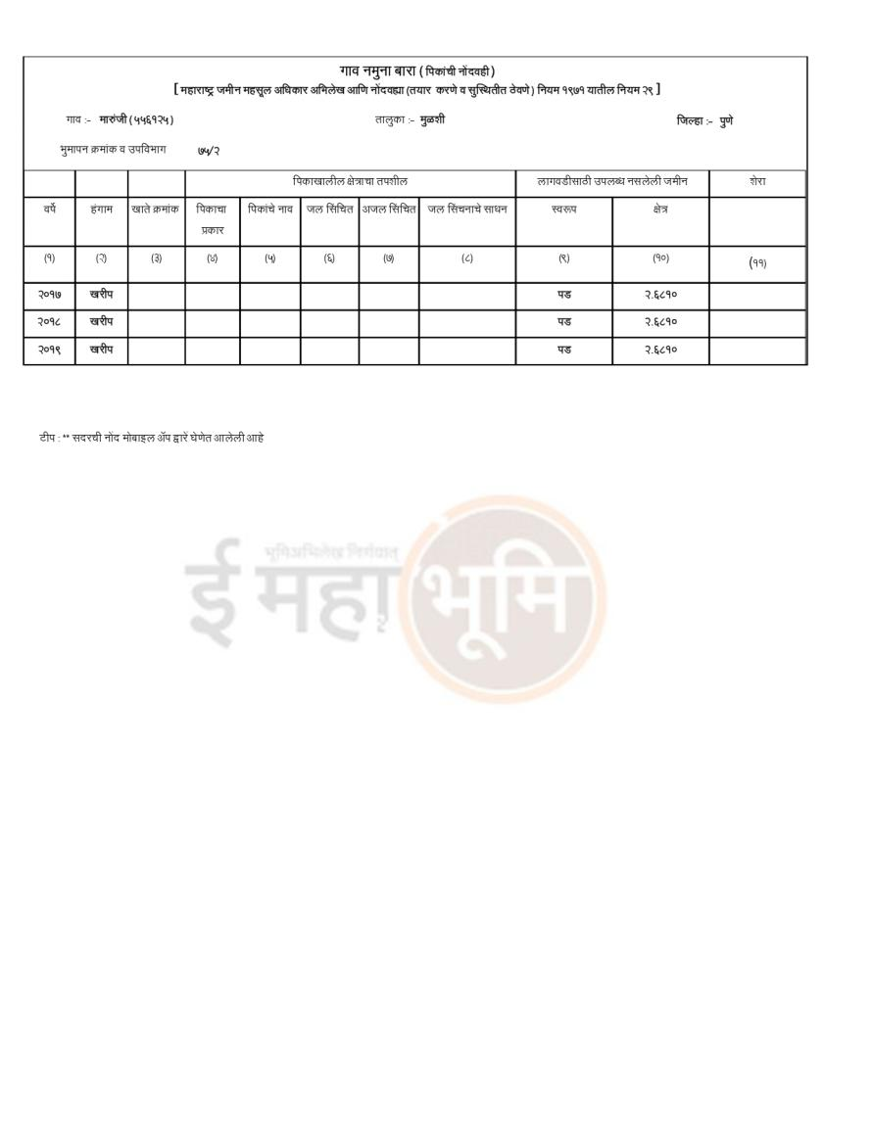

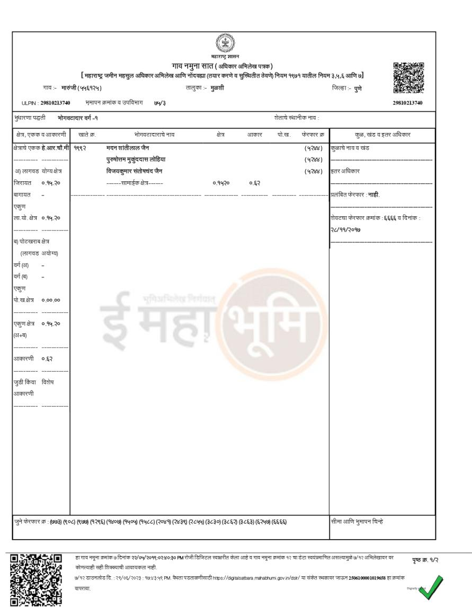

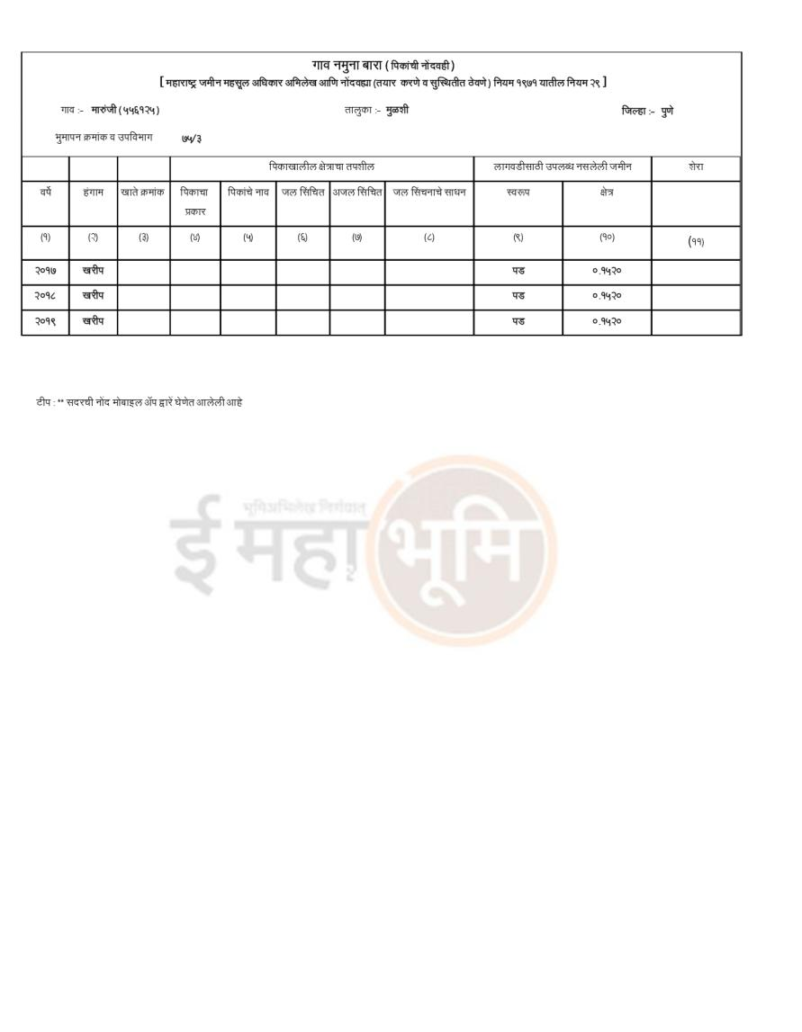

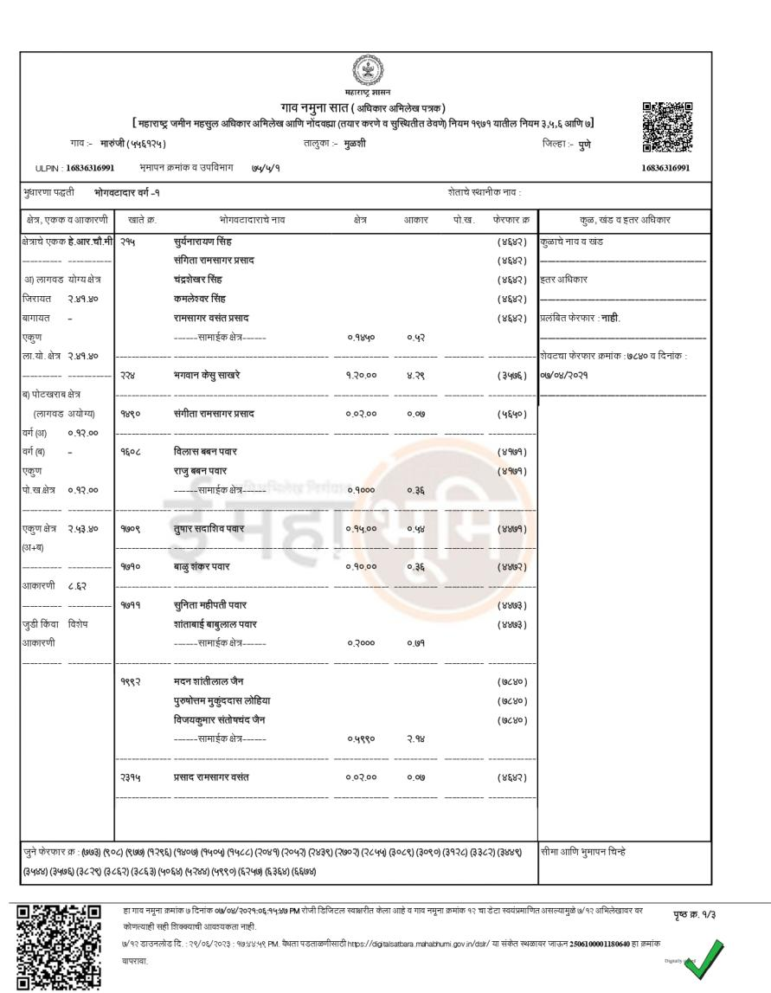

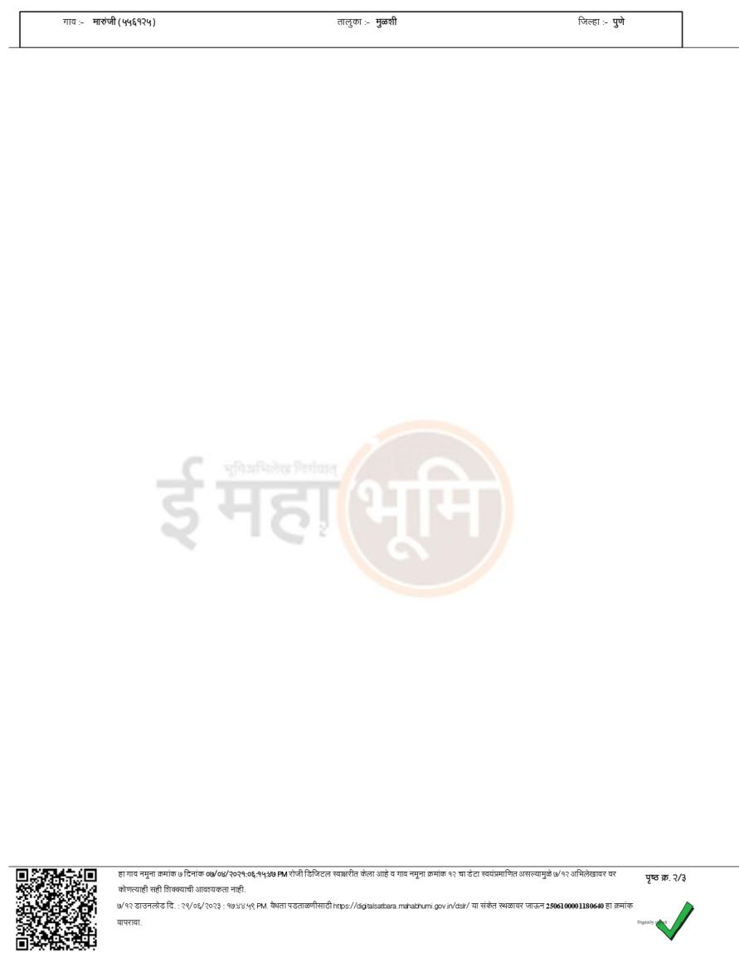

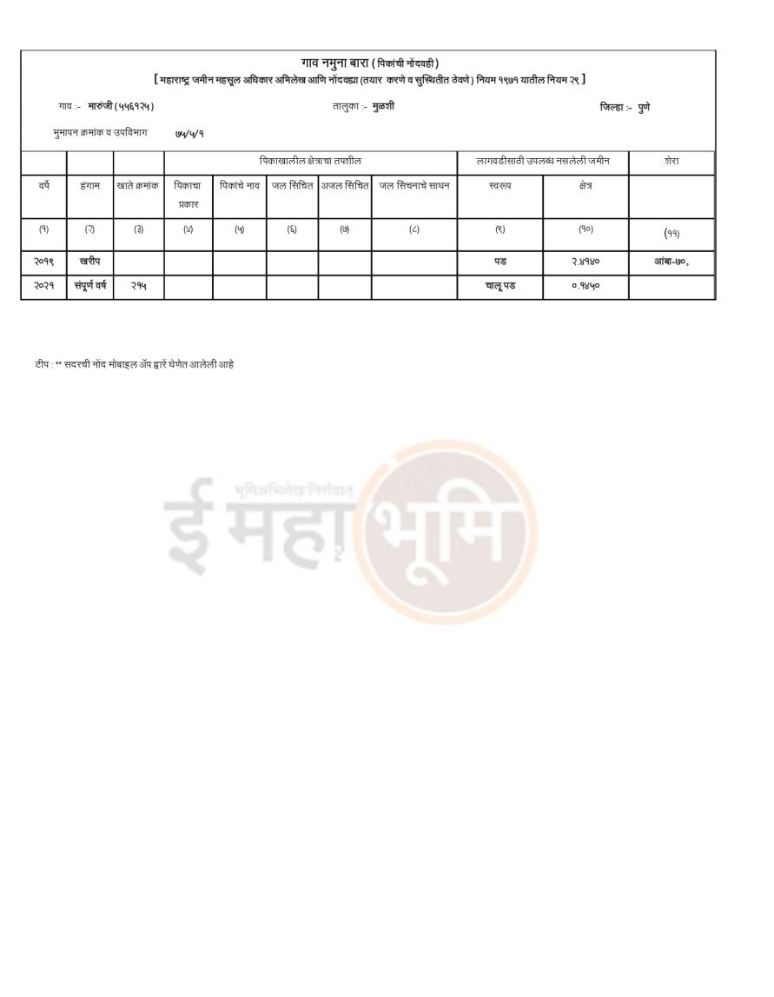

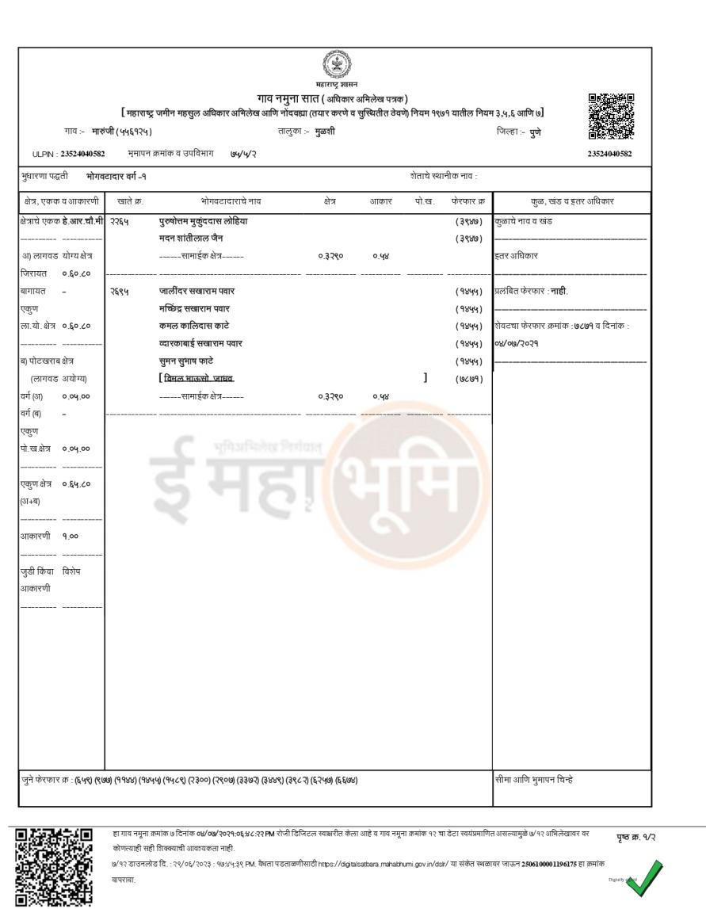

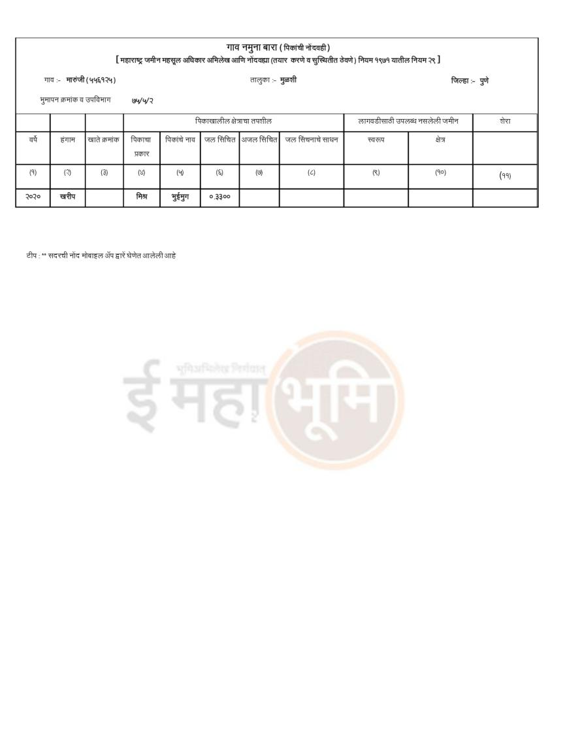

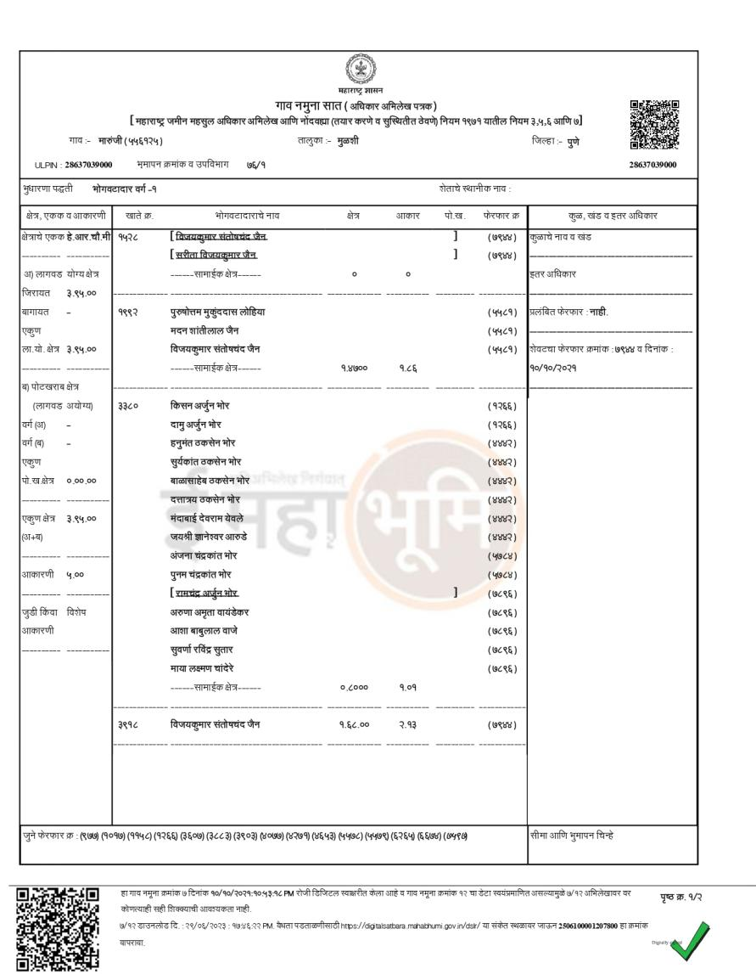

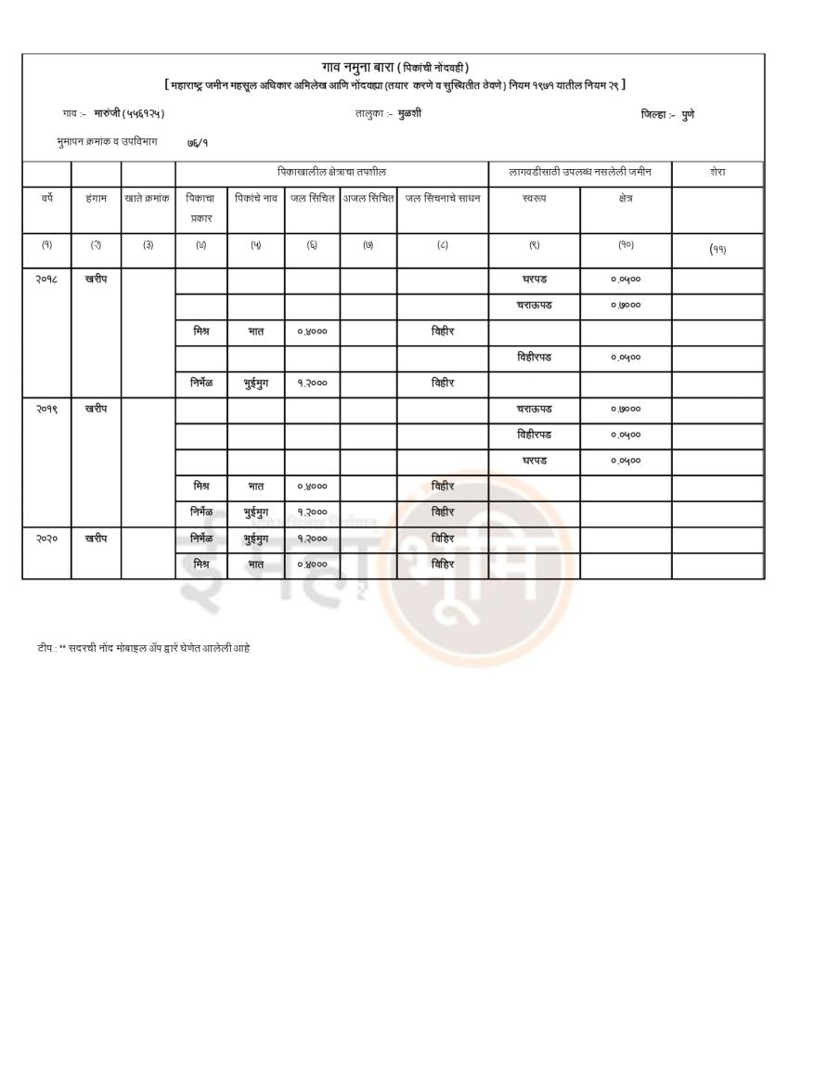

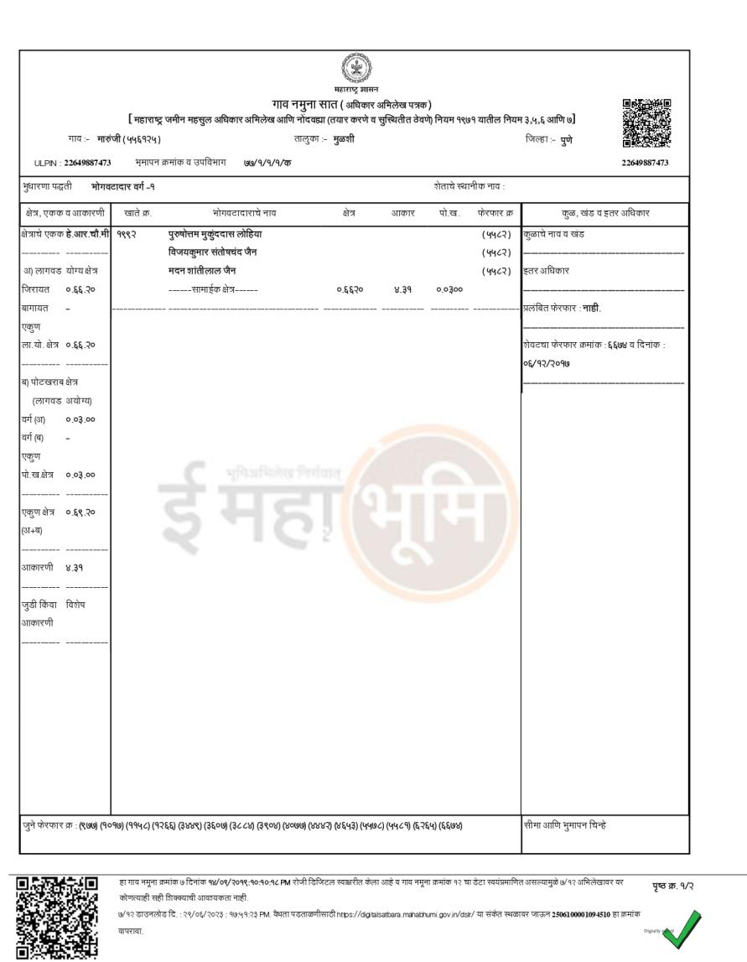

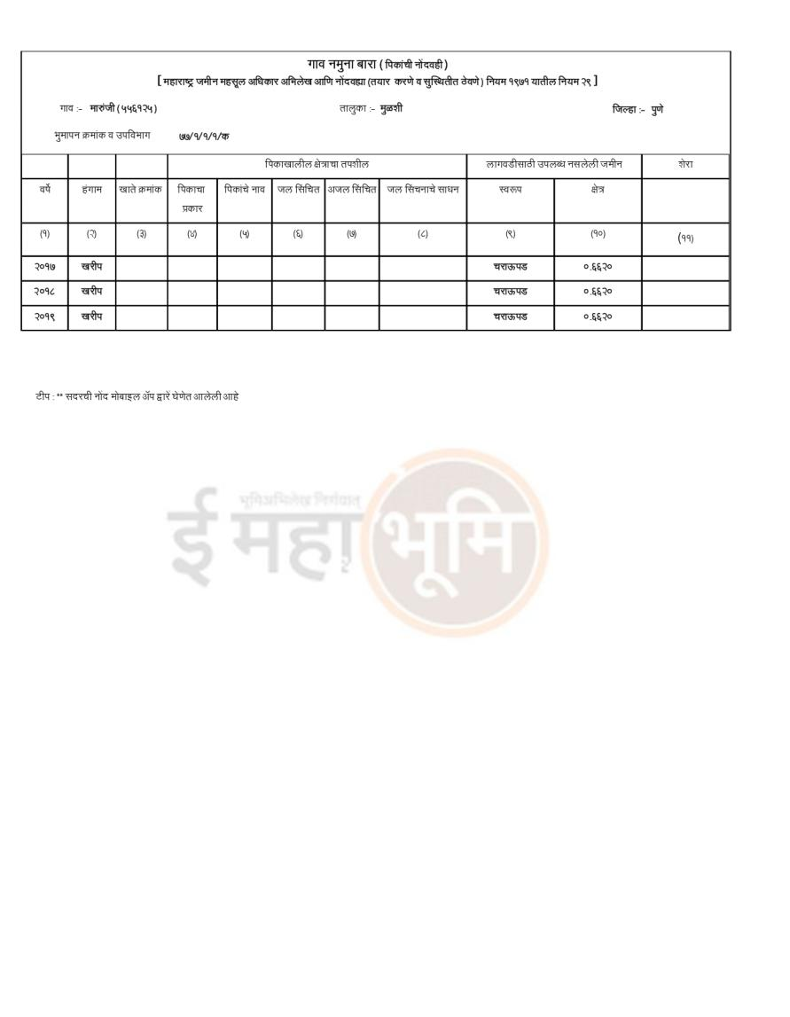
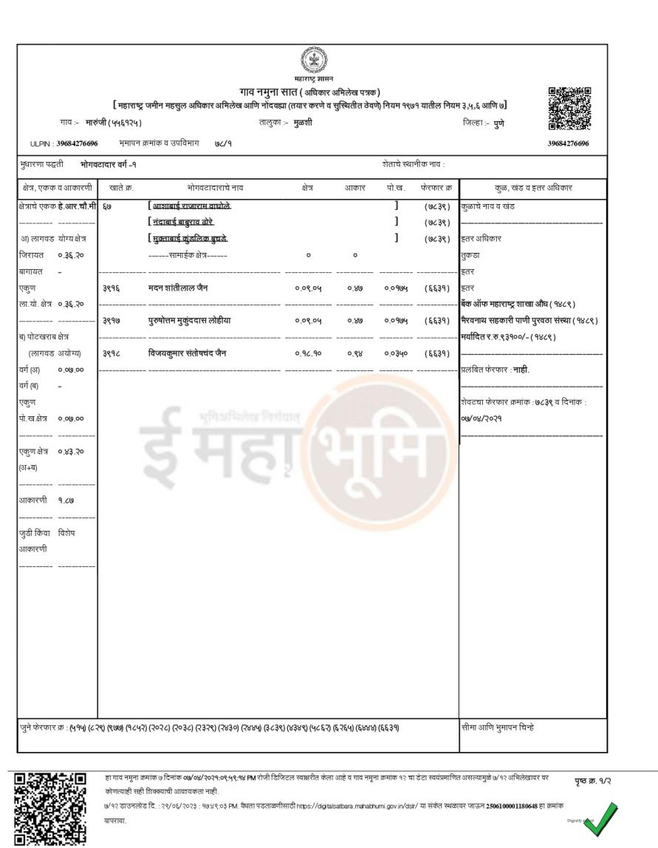

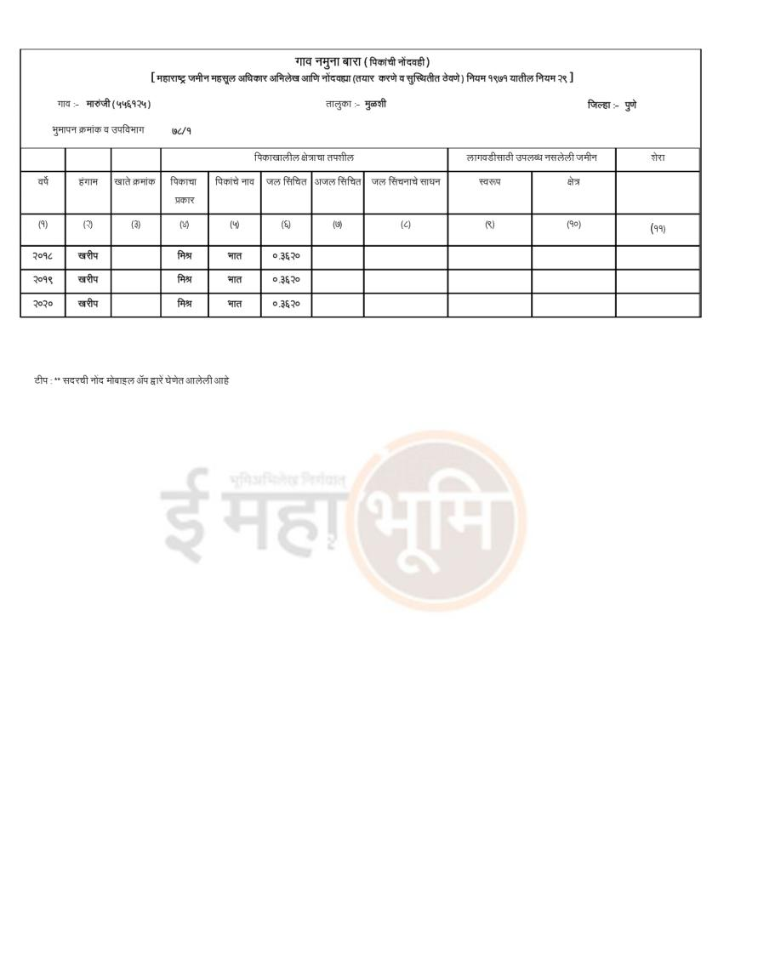

ANNEXURE- VII- RERA CERTIFICATE
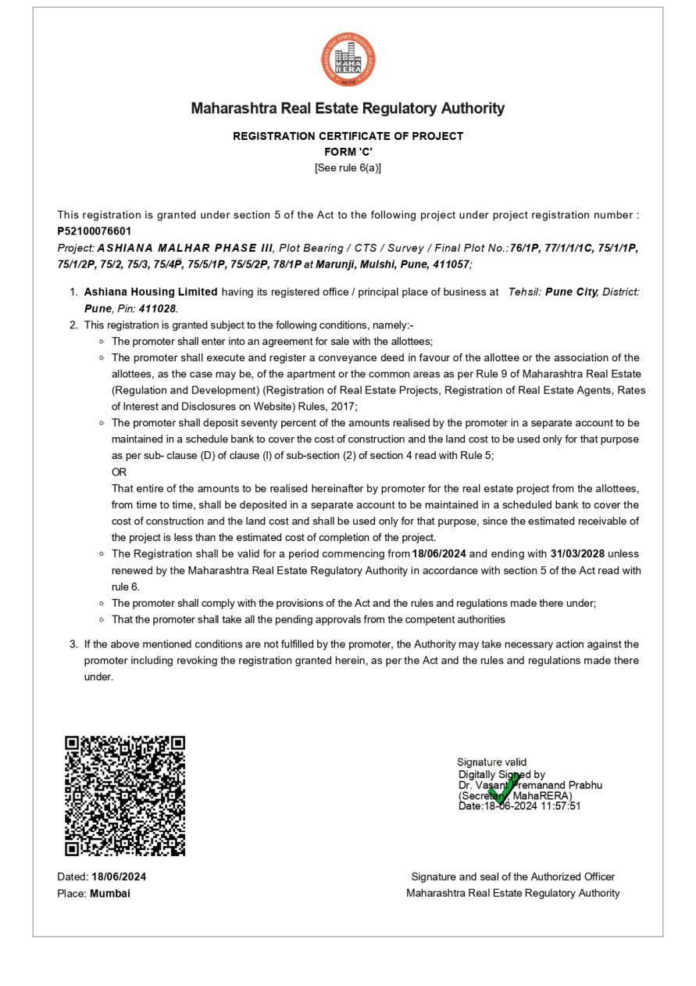

ANNEXURE- VIII- FLOOR PLAN

